

**DECLARATION OF THESIS CONFIDENTIALITY**

Author’s full name: Yam Chen Xi

IC No./Passport No.: 020910-14-1522

Thesis/Project title: Enhancing Financial Accessibility With Text-to-Speech For The Visually Impaired

I declare that this thesis is classified as:

CONFIDENTIAL

RESTRICTED

OPEN ACCESS

I acknowledged that Asia Pacific University of Technology & Innovation (APU) reserves the right as follows:

1. The thesis is the property of Asia Pacific University of Technology & Innovation (APU).
2. The Library of Asia Pacific University of Technology & Innovation (APU) has the right to make copies for the purpose of research only.
3. The Library has the right to make copies of the thesis for academic exchange.

|  |  |
| --- | --- |
| Author’s Signature: | A black background with a black square  Description automatically generated with medium confidence…………………………… |
| Date: | 15 April 2024 |
|  |  |
| Supervisor’s Name: | Aziah Binti Abdollah |
| Date: | 29 April 2024 |
| Signature: | …………………………… |

Library Form

|  |
| --- |
| **First Name:** Chen Xi |
| **Middle Name (only if applicable) :** |
| **Last Name:** Yam |
| **Title of the Final Year Project / Dissertation / Thesis :** Enhancing Financial Accessibility With Text-to-Speech For The Visually Impaired |
| **Abstract :**  In a digitally evolving financial landscape, this initiative leads the way towards greater financial inclusivity for individuals with visual impairment. "Finease" strategically utilizes advanced Text-to-Speech technology to tackle design discrepancies, security obstacles, and scalability issues in online financial services. The proposed integration encompasses on-screen content, navigation aids, and PDF documents, promising a transformative shift in accessibility from selective reading to comprehensive insights into financial products. Fueled by an Agile methodology and input from a dynamic survey, this endeavor envisions not only inclusive financial services but also societal transformation where access to financial empowerment is regarded as a right rather than a privilege. |
| **A few keywords associated with the work :**  Financial Accessibility, Text-to-Speech, Visually Impaired, Inclusive Design, Online Financial Services, Online Banking |
| General Subject: Computer Science |
| Date of Submission :30th April 2024 |

# Acknowledgement

First and Foremost, I would like to express my sincere gratitude to my supervisor, Ms. Aziah Binti Abdollah, for her unwavering support, valuable insights, and guidance throughout the entire duration of this project. Her expertise and mentorship have been instrumental in shaping the project's direction and ensuring its success. I am profoundly thankful to my family for their continuous support, encouragement, and understanding. Their belief in my abilities has been a constant source of motivation, and I am grateful for the unwavering support they provided during the challenges and triumphs of this endeavor. A special note of appreciation goes to my friends who stood by me, offering encouragement and understanding during moments of stress and uncertainty. Your camaraderie has made this journey more enjoyable, and I am thankful for the shared moments of both work and relaxation. I would like to express my gratitude to Asia Pacific University of Technology and Innovation for providing an environment conducive to learning and innovation. The university's resources and facilities have significantly contributed to the successful completion of this project. To everyone who contributed directly or indirectly to this project, your support has been invaluable, and I extend my heartfelt appreciation for being part of this significant undertaking.

# Abstract

In a digitally evolving financial landscape, this initiative leads the way towards greater financial inclusivity for individuals with visual impairment. "Finease" strategically utilizes advanced Text-to-Speech technology to tackle design discrepancies, security obstacles, and scalability issues in online financial services. The proposed integration encompasses on-screen content, navigation aids, and PDF documents, promising a transformative shift in accessibility from selective reading to comprehensive insights into financial products. Fueled by an Agile methodology and input from a dynamic survey, this endeavor envisions not only inclusive financial services but also societal transformation where access to financial empowerment is regarded as a right rather than a privilege.

*Keywords: Financial Accessibility, Text-to-Speech, Visually Impaired, Inclusive Design, Online Financial Services, Online Banking*

**Table of Contents**

Acknowledgement i

Abstract ii

List of Figures vi

List of Tables x

Chapter 1: Introduction 1

1.1 Introduction 1

1.2 Problem Background 2

1.3 Project Aim 3

1.4 Objectives 4

1.5 Scope 4

1.6 Potential Benefit 6

1.7 Overview of the Report 8

1.8 Project Plan 11

Chapter 2: Literature Review 12

2.1 Introduction 12

2.2 Domain Research 12

2.3 Similar Systems 19

2.4 Technical Research 24

2.4.1 Hardware 24

2.4.2 Programming Language 24

2.4.3 Front-end Development Stack 25

2.4.4 Integrated Development Environment (IDE) 26

2.4.5 Framework 26

2.4.6 Database Management System 27

2.4.7 Web browser 27

2.5 Summary 28

Chapter 3: Methodology 29

3.1 Introduction 29

3.2 Agile Methodology 29

3.3 Waterfall Methodology 30

3.4 Methodology Choice and Justification 30

3.5 Stages of Scrum Framework 32

3.6 Data Gathering 34

3.7 Analysis 39

3.7.1 Section A: Background of Respondent 39

3.7.2 Section B: Accessibility and User Preferences 42

3.5 Summary 53

Chapter 4: Design and Implementation 54

4.1 Introduction 54

4.2 System Design 55

4.2.1 Use Case Diagram 55

4.2.2 Activity Diagrams 66

4.2.3 Class Diagram 84

4.2.4 System Architecture Diagram 85

4.3 Database Design 86

4.3.1 Entity-Relationship Diagram 86

4.3.2 Data Dictionary 87

4.4 Interface Design 89

4.5 Execution 90

4.6 Screenshot of the completed system – Finease 93

4.6.1 User 93

4.6.2 Customer 97

4.6.3 Admin 103

4.7 Summary 110

Chapter 5: Result and Discussion 111

5.1 Introduction 111

5.2 Testing Plan 111

5.2.1 Unit Testing Design 112

5.2.2 User Acceptance Testing Design 113

5.3 System Testing and Discussion 115

5.3.1 Unit Testing 115

5.3.2 User Acceptance Testing (3 at least) 137

6.4 Summary 143

Chapter 6: Conclusion 144

6.1 Critical Evaluation 144

6.2 Limitation 145

6.3 Recommendation 145

References 146

Appendices 149

Appendix A – PPF 149

Appendix B – Ethics Form 158

Appendix C – Log Sheets 168

Appendix D – Poster 174

Appendix E – Gantt Chart 175

Appendix F – Sample Code Implementation 176

Appendix G – Respondence Demographic Profile 183

# List of Figures

Figure 1: Percentage of Heuristics Violations (Fatima et al., 2020) 13

Figure 2: Text-to-Speech Audio Description Preparation Process (Szarkowska, 2011) 15

Figure 3: Barclays' website (Barclays, n.d.) 19

Figure 4: BBC iPlayer website (BBC, n.d.) 20

Figure 5: Bank of America Website (Bank of America, n.d.) 21

Figure 6: Scrum Lifecycle (Sergeev, 2020) 32

Figure 7: Survey welcome page 34

Figure 8: Survey Information Sheet 35

Figure 9: Survey Consent Form 36

Figure 10: Survey Section A 37

Figure 11: Survey Respondent Age Chart 39

Figure 12:Survey Respondent Gender Chart 40

Figure 13: Survey Respondent Nationality Chart 40

Figure 14: Survey Respondent Current Educational Level Chart 41

Figure 15: Survey Respondent Employment Status Chart 41

Figure 16: Survey Respondent Vision Condition Chart 42

Figure 17: Survey Section B Q1 Result 43

Figure 18: Survey Section B Q2 Result 43

Figure 19: Survey Section B Q3 Result 44

Figure 20: Survey Section B Q4 Result 45

Figure 21: Survey Section B Q5 Result 45

Figure 22: Survey Section B Q6 Result 46

Figure 23: Survey Section B Q7 Result 47

Figure 24: Survey Section B Q8 Result 47

Figure 25: Survey Section B Q9 Result 48

Figure 26: Survey Section B Q10 Result 49

Figure 27: Survey Section B Q11 Result 49

Figure 28: Survey Section B Q12 Result 50

Figure 29: Survey Section B Q13 Result 51

Figure 30: Finease's Use Case Diagram 55

Figure 31: Activity Diagram for Bank Information 66

Figure 32: Activity Diagram for Register 67

Figure 33: Activity Diagram for Login 68

Figure 34: Activity Diagram for Logout 69

Figure 35: Activity Diagram for Screen Reader 70

Figure 36: Activity Diagram for Update Profile 71

Figure 37: Activity Diagram for Dashboard 72

Figure 38: Activity Diagram for Deposit 73

Figure 39: Activity Diagram for Withdraw 74

Figure 40: Activity Diagram for Transfer Fund 75

Figure 41: Activity Diagram for Transaction History 76

Figure 42: Activity Diagram for Manage User 77

Figure 43: Activity Diagram for Add User 78

Figure 44: Activity Diagram for Edit User 79

Figure 45: Activity Diagram for Delete User 80

Figure 46: Activity Diagram for Manage Bank Accounts 81

Figure 47: Activity Diagram for Activity Log 82

Figure 48: Activity Diagram for System Report 83

Figure 49: Finease's Class Diagram 84

Figure 50: Finease's System Architecture Diagram 85

Figure 51: Finease's Entity-Relationship Diagram 86

Figure 52: Finease's Home, Login and Register Page 89

Figure 53: Finease's Customer Pages 89

Figure 54: Finease's Admin Pages 90

Figure 55: Finease's Admin Activity Log and System Report Page 90

Figure 56: Screenshot of Finease’s project directory 91

Figure 57: Screenshot of application properties code 91

Figure 58: Screenshot of Finease’s Home Page 93

Figure 59: Screenshot of Finease’s Home Page, Activated Screen Reader 94

Figure 60: Screenshot of Finease’s About Page 95

Figure 61: Screenshot of Finease’s Services Page 95

Figure 62: Screenshot of Finease’s Login Page 96

Figure 63: Screenshot of Finease’s Register Page 96

Figure 64: Screenshot of Finease’s Dashboard Page 97

Figure 65: Screenshot of Finease’s Deposit Page 98

Figure 66: Screenshot of Finease’s Withdraw Page 98

Figure 67: Screenshot of Finease’s Transfer Page 99

Figure 68: Screenshot of Finease’s Transaction History Page 100

Figure 69: Screenshot of Finease’s Transaction History Page’s embed PDF view 100

Figure 70: Screenshot of Finease’s Profile Page 101

Figure 71: Screenshot of Finease’s Edit Profile Page 102

Figure 72: Screenshot of Finease’s Manage User Page 103

Figure 73: Screenshot of Finease’s Edit User Page 104

Figure 74: Screenshot of Finease’s Add User Page 104

Figure 75: Screenshot of Finease’s Delete User Page 105

Figure 76: Screenshot of Finease’s Manage User Page 106

Figure 77: Screenshot of Finease’s Admin Deposit Page 107

Figure 78: Screenshot of Finease’s Admin Withdraw Page 108

Figure 79: Screenshot of Finease’s Admin Transfer Page 108

Figure 80: Screenshot of Finease’s Activity Log Page 109

Figure 81: Screenshot of Finease’s System Report Page 110

Figure 82: Finease's A3 Poster 175

Figure 83: Gantt Chart 176

Figure 84: Screenshot of textToSpeech JavaScript code 177

Figure 85: Screenshot of shift key toggle screen reader JavaScript code 177

Figure 86: Screenshot of keyboard navigation JavaScript code 178

Figure 87: Screenshot of hoverEventListener JavaScript code 179

Figure 88: Screenshot of clickEventListener JavaScript code 180

Figure 89: Screenshot of focusEventListener JavaScript code 180

Figure 90: Screenshot of displayPDF JavaScript code 181

Figure 91: Screenshot of Deposit service Java code 182

Figure 92: Screenshot of Withdraw service Java code 182

Figure 93: Screenshot of Transfer service Java code 183

# List of Tables

Table 1: Comparison between Agile Methodology and Waterfall Methodology 30

Table 2: Use Case Specification for Bank Information 56

Table 3: Use Case Specification for Register 56

Table 4: Use Case Specification for Login 57

Table 5: Use Case Specification for Logout 57

Table 6: Use Case Specification for Screen Reader 58

Table 7: Use Case Specification for Update Profile 58

Table 8: Use Case Specification for Dashboard 59

Table 9: Use Case Specification for Deposit 59

Table 10: Use Case Specification for Withdraw 60

Table 11: Use Case Specification for Transfer Fund 60

Table 12: Use Case Specification for Transaction History 61

Table 13: Use Case Specification for Manage User 62

Table 14: Use Case Specification for Add User 62

Table 15: Use Case Specification for Edit User 63

Table 16: Use Case Specification for Delete User 63

Table 17: Use Case Specification for Manage Bank Accounts 64

Table 18: Use Case Specification for Activity Log 64

Table 19: Use Case Specification for System Report 65

Table 20: Data dictionary for Users Collection 87

Table 21: Data dictionary for Savings Account Collection 87

Table 22: Data dictionary for Savings Transaction Collection 88

Table 23: Data dictionary for Current Account Collection 88

Table 24: Data dictionary for Current Transaction Collection 88

Table 25: Sample unit test template 113

Table 26: Unit Testing for Accessibility widget 116

Table 27: Unit Testing for Home Page 118

Table 28: Unit Testing for About Page 119

Table 29: Unit Testing for Services Page 119

Table 30: Unit Testing for Login Page 120

Table 31: Unit Testing for Register Page 120

Table 32: Unit Testing for Customer Dashboard Page 122

Table 33: Unit Testing for Customer Deposit Page 123

Table 34: Unit Testing for Customer Withdraw Page 124

Table 35: Unit Testing for Customer Transfer Page 125

Table 36: Unit Testing for Customer Transaction History Page 126

Table 37: Unit Testing for Customer Profile Page 127

Table 38: Unit Testing for Admin Manage User Page 128

Table 39: Unit Testing for Admin Edit User Page 128

Table 40: Unit Testing for Admin Add User Page 130

Table 41: Unit Testing for Admin Delete User Page 131

Table 42: Unit Testing for Admin Manage Bank Accounts Page 132

Table 43: Unit Testing for Admin Deposit Page 133

Table 44: Unit Testing for Admin Withdraw Page 134

Table 45: Unit Testing for Admin Transfer Page 135

Table 46: Unit Testing for Admin Activity Log Page 137

Table 47: Unit Testing for Admin System Report Page 137

# Chapter 1: Introduction

## 1.1 Introduction

In the evolving digital economy, access to financial services is essential for economic inclusion and empowerment. The advancements in internet banking and financial technology have led to efficient management of personal finances. However, these developments have not been accessible to all, with visually impaired individuals facing significant barriers.

This project aims to address the urgent requirement of diminishing disparities and fostering inclusivity within the financial industry, in line with the goals set forth in Sustainable Development Goal 10. Visually impaired individuals, who constitute a significant portion of the population, face substantial difficulties when trying to access and use online financial services. Acknowledging this critical issue, a new proposal is suggested to improve financial accessibility for people with visual impairments through an innovative approach that combines technology, finance, and accessibility.

Digital financial services have become indispensable for managing personal finances, but there is a noticeable gap between those who can easily use these tools and those encountering significant barriers. The lack of inclusive design in online financial services is at the heart of this divide. These platforms are primarily designed for users without visual impairments, leaving individuals with visual disabilities facing substantial challenges and missing out on the advantages offered by the digital financial evolution.

However, the impact of this exclusion goes beyond mere inconvenience; it limits economic opportunities and worsens social inequalities. It is clear that the difficulties faced by visually impaired individuals are not just related to design challenges. Regulatory limitations within the financial sector add further complexity, especially in terms of utilizing external applications and third-party screen readers – essential tools for accessibility. In order to protect sensitive consumer information, financial institutions enforce rigorous security protocols. While crucial for data security, these measures inadvertently impede the functioning of third-party screen readers, worsening the accessibility disparity for blind or visually impaired individuals.

As a response to these difficulties, this initiative suggests strategically employing Text-to-Speech technology to overcome obstacles and offer inclusive access to digital financial services for individuals with visual impairments. The utilization of Text-to-Speech technology holds the capability to empower those with visual impairments by providing instant conversion of on-screen text into spoken words. This enables independent navigation of online financial platforms and access to important personal financial data, including PDF bank statements.

The effective implementation of Text-to-Speech in online financial services requires a comprehensive plan that considers security, accessibility, and user-centric design. This approach aims to create a robust solution aligned with industry standards and legal regulations, ultimately advocating for inclusive online financial services. The following sections of this report will explore the challenges encountered, the proposed solution, and the comprehensive strategy for successful integration.

## 1.2 Problem Background

**Lack of Awareness and Research on Accessibility in Online Financial Websites**

Despite advancements in technology, online banking and financial services are not easily accessible for individuals with visual impairments due to the heavy reliance on visual interfaces. This highlights a critical need for research into accessible banking and finance services, given the significant impact on visually impaired individuals (Abuaddous et al., 2016). Interestingly, there is a lack of published studies investigating how visually impaired individuals engage with internet banking and financial services. While previous research has focused on banking interface prototypes for those with cognitive disabilities, there is still a considerable gap in understanding the unique challenges faced by visually impaired users. Ramakrishnan et al. (2017) conducted a survey in the USA, which indicated that visually impaired individuals heavily utilize banking and finance websites as well as mobile apps. Nevertheless, they reported dissatisfaction and challenges with accessibility, underscoring the pressing requirement for thorough research in this domain. Individuals using inaccessible interfaces voiced apprehensions about personal control and privacy, emphasizing the crucial necessity for customized solutions (Wentz et al., 2018).

**Usability Challenges of Assistive Accessibility Tools in Online Financial Websites**

The practicality of assistive tools for accessibility presents a notable hurdle for individuals with visual impairments when navigating online financial platforms. Some financial websites implement restrictions on third-party apps or extensions to safeguard user privacy, inadvertently creating barriers for visually impaired users who rely on screen readers for website interaction and content comprehension. Despite following the guidelines for website accessibility, studies have found that individuals with visual impairments encounter usability challenges when using screen readers to browse the web (Ramakrishnan et al., 2017). These challenges lead to longer browsing times and difficulty in comprehending website structures due to excessive and irrelevant information. It is essential to address these usability issues to improve the non-visual online browsing experience for visually impaired individuals.

**Usability Disruptions Caused by Frequent Updates in Online Financial Websites**

Extensive efforts have been made to address the web accessibility challenges faced by the visually impaired community. However, despite meeting accessibility standards, online financial interfaces still present significant usability disruptions for blind users. The frequently updated and modified interface designs overlook the specific needs of blind or visually impaired users, requiring a more stable and accommodating system that takes into account their diverse demands and preferences. As highlighted by Babu and Singh (2009), these disruptions caused by these changes not only lead to discomfort but also require time-consuming adjustments, emphasizing the need for a more user-centric approach in designing and maintaining online financial interfaces.

## 1.3 Project Aim

The aim of this project is to develop an online financial platform that is inclusive and accessible to all users, regardless of their level of visual impairment, by incorporating Text-to-Speech allowing users to manage their finances independently and efficiently.

## 1.4 Objectives

The objectives of this project are:

1. To empower users to manage their finances independently and efficiently using the online financial platform that incorporates Text-to-Speech technology.
2. To educate users to be more aware of the importance of accessibility in online financial websites through the research conducted on the current state of accessibility for users with disabilities.
3. To enable users to access an online financial platform that is updated regularly with new features and functionality while maintaining a consistent level of usability.

## 1.5 Scope

The scope of this project encompasses a series of tasks designed to enhance financial accessibility for individuals with visual impairments.

1. Integration of Text-to-Speech Engine – Implementation of a Text-to-Speech engine to read on-screen content when the user interacts with the online banking website.
2. Navigation Aid with Text-to-Speech Engine – Development of a navigation aid that provides real-time auditory descriptions of interactive components on the website, enhancing overall accessibility.
3. Text-to-Speech for PDF Documents – Integration of Text-to-Speech technology to allow visually impaired users to browse and comprehend financial documents in PDF format.
4. Selective Reading – Implementation of a selective reading feature, providing users with the ability to choose specific sections of their financial documents for auditory presentation.
5. Detailed Information about Financial Services – Modification of the system to offer detailed information about financial services through the Text-to-Speech engine.

**Constraints**

While designing and implementing the project, certain constraints must be taken into consideration:

* Technology Compatibility –The project will align with the limitations of current technologies and compatibility needs, prioritizing compatibility with widely used web browsers and assistive technologies to guarantee a smooth user experience.
* Security and Compliance – The project needs to adhere to industry standards and regulations concerning data security and privacy, including compliance with financial industry regulations and guidelines.
* Scalability – The system's scalability will be considered to accommodate future enhancements and increasing user demands.

**Inclusions and Exclusions**

Clearly defining what will and will not be accomplished as part of the project in order to manage expectations and guarantee a focused implementation.

**Inclusions**

* Integration of Text-to-Speech technology into the online banking website.
* Development of features for real-time auditory feedback and navigation aid.
* Text-to-Speech functionality for PDF document accessibility.
* Implementation of selective reading features.
* Modification of the system to provide detailed information about financial products using Text-to-Speech.

**Exclusions**

* The project will not involve a complete overhaul of the entire online banking platform beyond the proposed enhancements. This specifically excludes major redesign or restructuring of non-accessibility-related components of the platform.
* Features not directly related to improving accessibility for the visually impaired are excluded. This includes any enhancements or changes that do not contribute to the primary goal of enhancing financial accessibility.
* Integration of technologies or functionalities outside the specified scope, such as unrelated third-party integrations or additional features that are not essential for improving accessibility for visually impaired users.

## 1.6 Potential Benefit

**Tangible benefits**

1. Increased Financial Inclusion – The integration of text-to-speech technology in digital financial services has the potential to significantly enhance financial inclusion, particularly for individuals with visual impairments. This broader accessibility may lead to increased participation in the financial system by a greater number of people.
2. Efficiency and Time Savings – Text-to-Speech technology empowers individuals with visual impairments to independently access essential financial information in real-time. This enhanced independence results in significant time savings, as users are able to conduct transactions and oversee their finances without relying on external help.
3. Compliance with Accessibility Regulations – The integration of Text-to-Speech technology ensures practical adherence to accessibility regulations and standards. This not only assists financial institutions in mitigating legal consequences but also demonstrates their commitment to social responsibility by prioritizing inclusivity.
4. Cost Reduction in Customer Support – The independent access to online financial services through Text-to-Speech for visually impaired users has the potential to decrease the demand for extensive customer support within this demographic.
5. Market Expansion and Customer Base Growth – By making online financial services more accessible, financial institutions employing Text-to-Speech technology may attract a broader customer base, including individuals with visual impairments.

**Intangible benefits**

1. Enhanced Corporate Reputation – The adoption of inclusive measures, such as Text-to-Speech technology, can lead to an intangible gain of enhancing corporate reputation. Financial institutions perceived as socially conscious and dedicated to accessibility may attract higher levels of trust and positive public perception.
2. Positive Customer Experience – Users can engage with online financial services seamlessly using Text-to-Speech, fostering a positive and inclusive brand perception.
3. Social Responsibility and Ethical Standing – Prioritizing accessibility for the visually impaired demonstrates a commitment to social responsibility and ethical business practices. This intangible benefit can strengthen relationships with existing customers while also attracting new ones who prioritize these principles.
4. Employee Morale and Engagement – Inclusive efforts enhance the work environment, boosting employee morale and involvement. Employees in companies that prioritize accessibility may take pride in contributing to a more inclusive financial landscape.
5. Innovation and Differentiation – By incorporating text-to-speech technology, financial institutions can showcase their dedication to innovation, setting themselves apart from competitors. This intangible advantage is especially significant in a competitive market, drawing in customers who appreciate technological advancements and inclusivity.

**Target User**

This initiative targets a diverse group of individuals with visual impairments, including those with varying degrees of visual acuity, aiming to improve financial accessibility. It acknowledges that visual impairments cover a spectrum from total blindness to individuals with high glasses prescriptions who may encounter difficulties in accessing online financial services.

* Visually Impaired Individuals: The initiative seeks to empower them by providing independent access to online financial services, making transactions and financial information more accessible.
* People with High Glasses Prescriptions: Individuals with high glasses prescriptions may face challenges related to their vision. The initiative acknowledges their specific needs, aiming to enhance usability and accessibility when interacting with online financial platforms.
* Customers of Financial Institutions: The initiative directly caters to individuals who are customers of financial institutions, encompassing a broad demographic that engages in various online financial activities.

## 1.7 Overview of the Report

**Chapter 1: Introduction**

This chapter emphasizes the significance of financial accessibility in the digital age and discusses the obstacles encountered by visually impaired individuals when using online financial services. The project strives to incorporate Text-to-Speech technology for improved inclusivity, setting clear objectives, scope, and strategic direction. It underscores the potential advantages of the project and provides a summary of the investigation report as a guide for readers. Additionally, it outlines timelines and milestones for the project plan, shaping future chapters' examination and execution.

**Chapter 2: Literature Review**

This section explores existing literature in the chosen domain, providing relevant context. It This section delves into prior research in the selected field, offering pertinent background information. It encompasses an examination of comparable systems and studies to glean insights for the present project. The chapter also addresses technical investigations, providing a rationale for the hardware and software selections essential for the proposed undertaking. This includes deliberations on IDE, libraries, operating system, web server, and web browser. A synthesis at the end of the chapter underscores pivotal discoveries while laying the groundwork for practical application in subsequent sections.

**Chapter 3: System Development Methodology**

In this section, a comprehensive explanation of the project's methodology is presented, commencing with an introductory overview. The chosen system development methodology is then deliberated upon and substantiated. A thorough description of the activities and processes encompassed within each phase of the methodology is provided to ensure a holistic understanding of the project's developmental progression. Emphasizing survey design as a pivotal means for data collection, its significance in steering the project is underscored. The critical role played by analyzing survey results in shaping forthcoming actions is also expounded upon. Lastly, a succinct synthesis unifies these methodologies, paving the way for subsequent implementation in later chapters.

**Chapter 4: Design and implementation**

Chapter 4 presents a thorough overview of the creation and application of Finease, an advanced banking system designed to meet the requirements of both customers and admin. It commences with an in-depth investigation into system design using use case diagram, activity diagrams, class diagrams, system architecture, and database design. The interface design is displayed through visuals depicting various user pages; meanwhile, the execution section discusses the construction process encompassing setup, front-end and back-end development, database integration as well as inclusion of accessibility features such as text-to-speech and keyboard navigation. In summary, Chapter 4 provides a comprehensive understanding of Finease's development journey while emphasizing its dedication to user-centric design principles and strong functionality.

**Chapter 5: Result and Discussion**

This chapter offers a thorough analysis of the testing processes and result for the Finease banking system, with a focus on various user interactions and features. The chapter is divided into several parts, each addressing specific aspects such as customer transactions, user management, activity logging, and system reporting. It presents a comprehensive framework for testing that includes meticulous documentation of test cases covering navigation, data input, error handling, expected outcomes for both customers and administrators. Furthermore, the inclusion of feedback from individuals with different demographic profiles and vision conditions in user acceptance testing provides valuable insights into the usability and accessibility features of the system.

**Chapter 6: Conclusion**

This chapter presents a thorough evaluation of Finease's efforts to improve financial access and usability. The Critical Assessment section recognizes the company's significant strides in advancing financial inclusivity by integrating Text-to-Speech technology, showcasing its dedication to eliminating obstacles for users with disabilities. Nonetheless, the limitation section identifies the constraints that Finease encounters, while the recommendation section proposes improvements that can be implemented on Finease for future enhancement and increased inclusivity.

## 1.8 Project Plan

The project plan unfolds across a meticulously structured timeline spanning 11 weeks, commencing on 8 September 2023, and concluding with the finalization of the Project Proposal Form. This timeline encompasses crucial milestones, beginning with the Ethics Form, allotted 16 days and due by 2 October 2023. Subsequently, the Investigation Report follows, with a duration of 26 days starting 24 October 2023. Within the report, Chapter 1, Introduction, extends over 26 days, intertwining essential components such as the project plan with Gantt chart planning, extending until the project's conclusion. Subsequent chapters unfold with specific focuses: Chapter 2, Literature Review, lasts 9 days starting 27 October; Chapter 3, Methodology, spans 15 days starting 7 November, with a 14-day survey information gathering phase; and Chapter 4, Conclusion and Reflection, encompasses 2 days starting 27 November. The entire first part of the project spans a duration of 55 days, from 8 September 2023 to 28 November 2023, encapsulating diverse stages from the initial Project Proposal Form to the conclusive wrap-up in Chapter 4.

The second phase of the project spans 77 days, from 15 April 2024 to 30 April 2024. It initiates with Chapter 4: Design and Implementation, extending over 67 days from 15 January 2024 to 16 April 2024. Subsequently, Chapter 5 unfolds over 9 days, from 17 April 2024 to 29 April 2024, focusing on detailed analysis and interpretation of findings. Finally, the project concludes with Chapter 6: Conclusion, a one-day endeavor on 30 April 2024, summarizing key insights and reflecting on the project's outcomes. This sequential plan ensures a systematic approach to project execution, facilitating comprehensive research, development, and analysis within the allocated timeframe.

This overarching plan, detailed in the Gantt chart found in Appendix E, provides a strategic and comprehensive framework for the systematic execution of the research project, ensuring a thorough exploration of each facet within the defined timeframe.

# Chapter 2: Literature Review

## 2.1 Introduction

This literature review investigates the intersection of accessibility, technology, and security in online financial services. It explores challenges faced by blind users, usability violations in banking websites, and innovations in Text-to-Speech technology. Additionally, it delves into security protocols addressing privacy and computing concerns for visually impaired users. This synthesis offers a concise overview of the key themes in this multifaceted domain.

## 2.2 Domain Research

**2.2.1 Accessibility in Online Financial Services**

Wentz et al. (2017) conducted a study on the difficulties faced by visually impaired individuals in accessing online financial services, providing valuable insights for research on accessibility in this area. The research identifies significant issues and emphasizes the importance of addressing these challenges to promote financial inclusivity. One key finding is related to interface design and navigation, highlighting their impact on the effective use of online financial systems by visually impaired users. Additionally, adherence to accessibility guidelines like WCAG 2.0 is stressed as crucial for ensuring clear labeling, readable content, and navigational structures that cater to the needs of visually impaired users. The study also emphasizes the reliance of blind individuals on screen readers, which makes evaluating the accessibility of online financial services particularly important. The research highlights the importance of seamless integration with screen reading technologies, addressing issues related to buttons, labels, and overall compatibility. It also explores security and privacy concerns, particularly regarding CAPTCHAs, revealing how these measures can inadvertently create barriers for blind users. The study further examines challenges associated with mobile banking, emphasizing the necessity of accessible mobile interfaces that empower blind users to make use of mobile financial services conveniently. The implications for future research emphasize the continuous need for advancements in accessibility features within online financial services. Collaborative efforts between the financial industry and accessibility advocates are encouraged to implement and enhance inclusive design practices. Moreover, investigating emerging technologies, such as voice biometrics, presents opportunities to enhance accessibility and security simultaneously in the realm of online financial services. Furthermore, the exploration of new technologies like voice biometrics offers potential to improve accessibility and security in online financial services simultaneously.

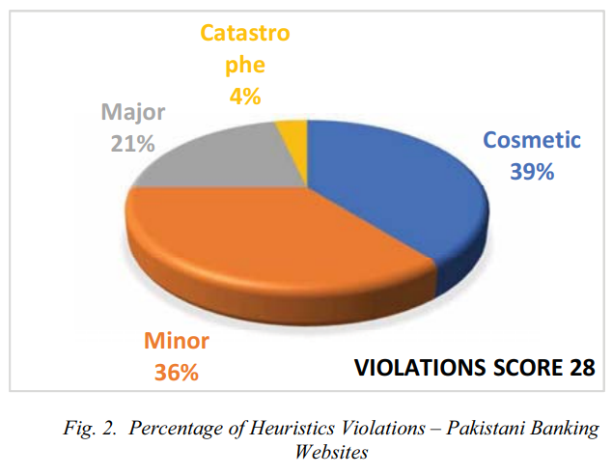

Figure 1: Percentage of Heuristics Violations (Fatima et al., 2020)

In the study conducted by Fatima et al. (2020), an extensive evaluation of online banking websites was performed, employing Jakob Nielsen's 10 Heuristics for User Interface Design and the Web Content Accessibility Guidelines 2.0. The results revealed substantial usability violations in Pakistani Banking Websites, with eight out of ten heuristics being violated, ranging from issues of system visibility to aesthetic design. Notably, 36% of violations were cosmetic, 36% were minor, 21% were major, and 4% were catastrophic, indicating a spectrum of severity. Conversely, International Banking Websites demonstrated superior usability, violating only four heuristics, all with minor or cosmetic severity. Recommendations emphasized improvements in informative system status, user-friendly language, consistent terminology, error prevention, and accessible help. The accessibility evaluation identified common errors in Pakistani websites, contrasting with fewer issues in international banking sites. The results indicate substantial accessibility challenges in Pakistani banking websites, with common errors identified. These issues, such as missing alternative text, low contrast, and keyboard traps, directly impact users with disabilities, hindering their ability to navigate and comprehend the content effectively. The violations of Web Content Accessibility Guidelines suggest that individuals with visual impairments, motor disabilities, or other accessibility needs may face barriers in accessing online financial services. Addressing these accessibility shortcomings is crucial for ensuring an inclusive and equitable user experience, enabling a wider range of users to navigate and interact with banking websites with ease and independence.

Study conducted by Ramakrishnan et al. in 2017 delves into the multifaceted realm of non-visual web browsing, with a primary focus on enhancing accessibility for individuals with visual impairments. Recognizing the pervasive role of the web in daily life, the study underscores the imperative for web developers to ensure inclusivity, referencing the Web Content Accessibility Guidelines as a pivotal guide. The review emphasizes the dominant reliance on Screen Readers for visually impaired users and identifies persistent usability challenges, ranging from information overload to the absence of semantic awareness. The exploration of segmentation-based techniques, including clutter-free browsing, online transaction modelling, and skimming and summarization, reveals strategies aimed at mitigating these challenges and fostering a more user-friendly experience. Additionally, the paper investigates the potential of speech-based browsing and introduces the innovative Web Screen Reading Assistant, driven by a Web Entity Model, as a transformative approach to interaction with web entities. Amidst the evolving landscape of smart devices, the study anticipates future research inquiries into the usability of apps for individuals with vision impairments, encapsulating a comprehensive narrative that underscores the importance of semantic awareness, streamlined navigation, and the reduction of information overload to advance the overall usability of the web for users with visual impairments.

**2.2.2 Text-To-Speech Technology**

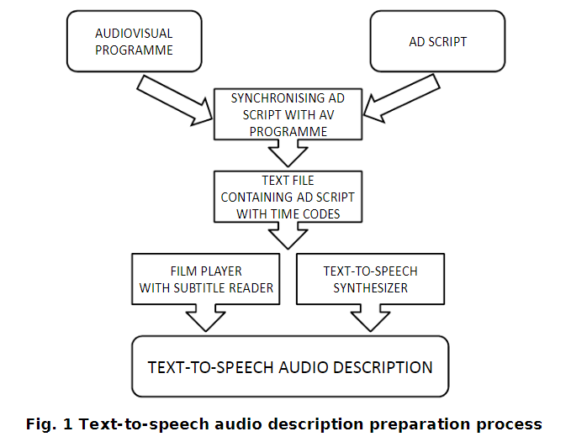

Figure 2: Text-to-Speech Audio Description Preparation Process (Szarkowska, 2011)

In Szarkowska's 2011 research on text-to-speech audio description as an innovative approach to traditional audio description, the study proposed a method where audio description scripts are converted into speech waveforms using speech synthesis software rather than relying on human narrators. This text-to-speech audio description process involves creating audio description scripts, segmenting them with precise time codes, and then utilizing speech synthesis software during film playback. Unlike conventional audio description, which can be limited by complex production processes and restricted distribution, text-to-speech audio description offers a more scalable and cost-effective solution. The text-to-speech audio description method was envisioned as a means to increase the availability of audio-described content, making it more accessible to visually impaired individuals, particularly those residing in areas without regular cinema screenings or live audio description events. The process allows users to enjoy audio-described films independently at home, leveraging their familiarity with speech synthesis software. While text-to-speech audio description does require a degree of media literacy, the study indicated positive attitudes toward the technology, with participants expressing preferences for choosing synthetic voices. The proposed text-to-speech audio description system was positioned not as a replacement for traditional audio description but as a complementary tool to enhance the overall accessibility of audiovisual content for individuals with visual impairments.

Podsiadło and Chahar's 2016 research delves into the nuanced requirements and preferences of visually impaired individuals relying on screen readers and text-to-speech technology. The study reveals that text-to-speech, often considered an auxiliary feature for many users, holds paramount importance for individuals with vision loss, shaping their interactions with digital content. Through a combination of focus groups and individual listening tests, the researchers identified distinct usage patterns, emphasizing the critical role of text-to-speech in both leisure-oriented and factual modes. The findings highlight a preference for lower-pitched, mature-sounding voices with neutral emotional expression, contributing to reduced listening fatigue and enhanced intelligibility. Notably, the study underscores the scarcity of research catering specifically to the needs of visually impaired users in the realm of text-to-speech technology. The researchers address this gap by providing valuable insights into the multifaceted considerations influencing text-to-speech preferences, encompassing factors such as purpose of action, length of text-to-speech experience, and the environment. Overall, the research not only advances our understanding of the unique requirements of visually impaired users but also sheds light on the imperative features for optimizing text-to-speech technology to meet the diverse needs of this user group, offering a comprehensive perspective crucial for future advancements in accessibility-oriented technology development.

Swain and Sahoo's 2021 research sheds light on the transformative role of text-to-speech technology in addressing educational challenges for visually impaired students. The study emphasizes the inadequacies of traditional curricula for sighted learners and underscores the pivotal role of text-to-speech in making visually complex scientific concepts accessible to the visually impaired. While the focus is on education, the broader implications of this research extend to various industries, including the banking sector. The use of text-to-speech in educational applications highlights its potential for enhancing accessibility in diverse contexts. In the banking industry, integrating text-to-speech into digital interfaces could significantly improve accessibility for visually impaired customers. Similar to the VI Learner application, a customized banking application could leverage text-to-speech as a foundational approach to provide audio-based information on account details, transaction history, and other financial services. This adaptation aligns with the inclusive ethos advocated by Swain and Sahoo, ensuring that visually impaired individuals can independently access essential banking services. Furthermore, the anticipation of future developments, such as the addition of a speech-to-text feature, suggests a dynamic approach that could further enhance user interaction in the banking realm. Overall, the insights from Swain and Sahoo's research provide a valuable foundation for considering text-to-speech solutions in the banking industry.

**2.2.3 Security Protocols in Online Financial Services**

In the research conducted by Ronchi et al. in 2011, the investigation centers on the pervasive insecurity characterizing Internet transactions, with a specific focus on Internet banking. The study underscores the role of end users in the security landscape, emphasizing the common challenge where theoretically robust security measures face undermining due to user behavior. The prevalent solution involving the isolation of security-critical elements from end-user devices is subject to critical examination. The paper delves into the principles and practices of Internet banking, considering the estimated number of users and the susceptibility of their devices to attacks. A holistic approach to security is advocated, acknowledging physical cracking, social engineering, and malicious software as interconnected attack vectors. A key point of contention is whether the primary design principle for Internet banking systems should solely be the prevention of financial fraud, or if equal emphasis should be placed on protecting end users' privacy and preventing identity theft. The paper critiques after-systems that detect fraud post-transaction, asserting their inadequacy in addressing key parameters like transaction efficiency. The proposed Attack Vector Activity Analysis (AVAA) metric is applied to evaluate security systems, including disconnected and connected devices and hardened web browsers. The study concludes by urging banks to prioritize end-user privacy, lower hacking return on investment, simplify usability, and maintain transparent communication with users about security risks.

Ahmed et al.'s 2015 research in the realm of security protocol privacy for accessibility places a noteworthy emphasis on computing privacy concerns and the security of computing devices for visually impaired individuals. The study delves into the challenges faced by participants in maintaining the privacy of their digital interactions. Key findings underscore the participants' awareness of visual eavesdropping risks, particularly in public spaces, leading to self-imposed limitations on device use. The research sheds light on the struggles with password management among visually impaired users, revealing practices such as recording passwords in computer files, which, though aiding accessibility, pose concerns about potential aural eavesdropping. Furthermore, the study highlights skepticism and challenges regarding the use of password manager software among participants. The research by Ahmed et al. provides critical insights into the security vulnerabilities specific to visually impaired individuals, including their susceptibility to hacking and difficulties in discerning security cues in web browsers. The study not only identifies these concerns but also emphasizes the need for more accessible security features, addressing the limitations faced by visually impaired users in ensuring the security of their computing devices. In doing so, Ahmed et al. contribute significantly to the literature on security protocols and privacy considerations in the context of accessibility for individuals with visual impairments.

In Napoli's (2018) research on accessible and usable security, the focus centers on visually impaired users' online security and privacy strategies. The literature review underscores the significance of addressing the unique challenges faced by visually impaired individuals in navigating security and privacy threats while browsing the web. Napoli emphasizes the field of usable security, emphasizing the need to integrate user behaviors into the design of security mechanisms to mitigate the severity of threats. The discussion delves into key security and privacy threats encountered during web browsing, such as password hacking, phishing, man-in-the-middle attacks, and malicious software. Design guidelines and frameworks proposed by Garfinkel and Lipford (2014) are highlighted, advocating for reducing security responsibility on users, enabling secure defaults, providing clear instructions, describing security contexts, and promoting user training in best practices. The review further explores the application of usable security principles, including visual representations of security indicators within browser chrome and novel solutions tailored to visually impaired users, such as accessible password managers and observation-resistant password schemes. Napoli identifies gaps in existing literature, noting the limited exploration of non-visual security mechanisms for visually impaired users, emphasizing the need for broader research to address this underserved population's specific usability and accessibility challenges in the realm of online security and privacy.

## 2.3 Similar Systems

**2.3.1 Barclays**

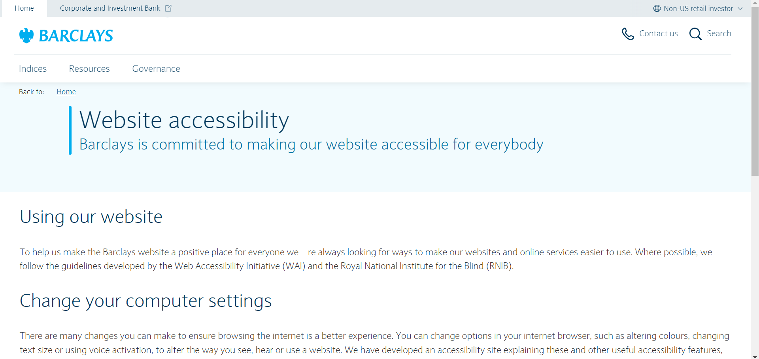

Figure 3: Barclays' website (Barclays, n.d.)

Barclays, as a financial institution, demonstrates a strong commitment to digital inclusivity and accessibility for individuals with visual impairments (Barclays, n.d.). The bank prioritizes compatibility with screen readers, crucial tools for the visually impaired, in line with industry standards and legal requirements. They enhance visibility through high contrast color schemes and distinct color choices while also providing alternative text for images to ensure a comprehensive user experience. In addition to supporting keyboard navigation, Barclays could further improve online form accessibility by offering clearer instructions and feedback for users relying on assistive technologies.

Strengths:

* Strong compatibility with screen readers.
* High contrast color schemes and distinct color choices.
* Support for keyboard navigation.

Weaknesses:

* Online forms may need clearer instructions and feedback for users with visual impairments.

**2.3.2 BBC**

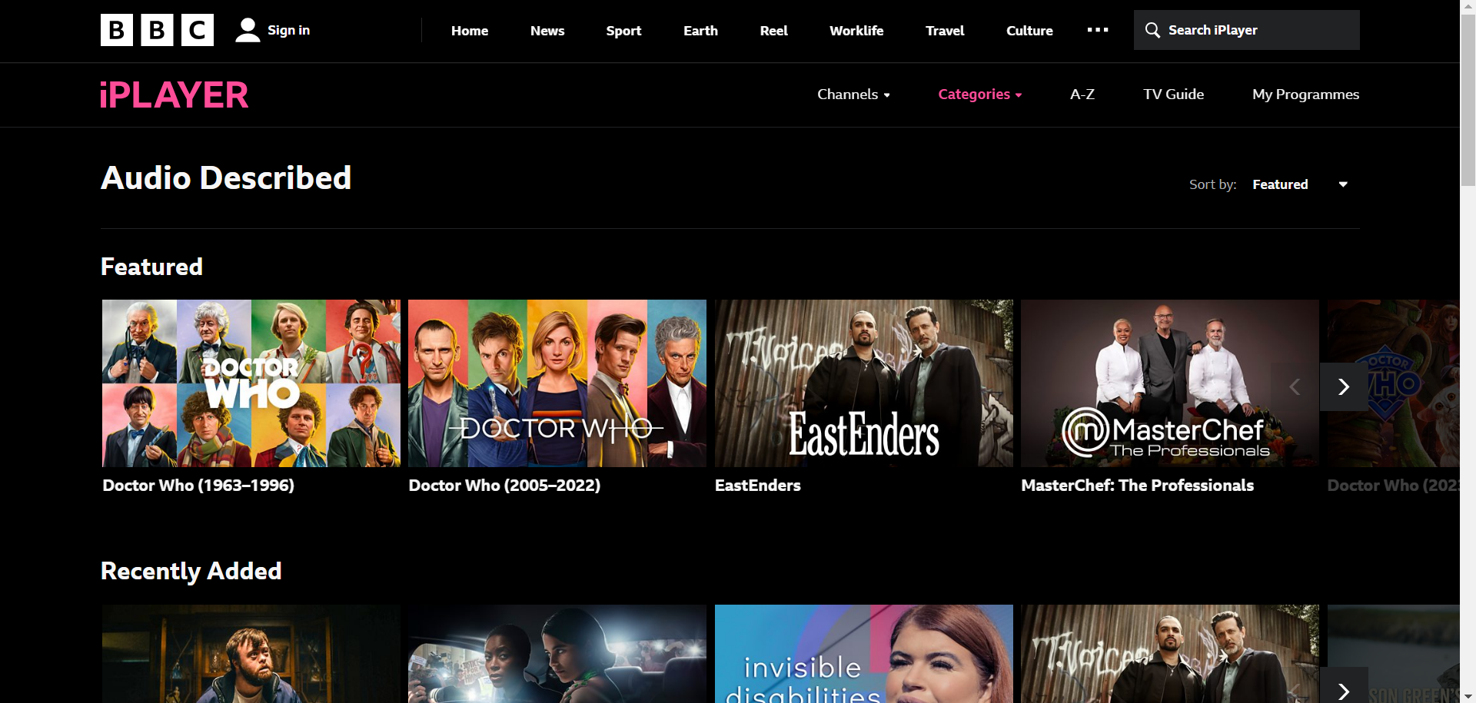

Figure 4: BBC iPlayer website (BBC, n.d.)

The BBC is well-known for its dedication to inclusivity and has taken significant steps to improve accessibility, especially for those with visual impairments. This includes offering audio description services for a wide variety of programs and using subtitles and closed captioning extensively. The use of high contrast, easily readable fonts, and clear typography in the website's design is praiseworthy. Additionally, responsive design principles ensure a consistent experience across different devices. However, ongoing user feedback and testing show a commitment to improvement despite occasional inconsistencies or areas that could be enhanced.nconsistencies or areas for enhancement.

Strengths:

* Comprehensive audio description services.
* Extensive use of subtitling and closed captioning.
* Prioritization of high contrast and clear typography.

Weaknesses:

* Difficult to set up accessibility features.

**2.3.3 Bank of America**

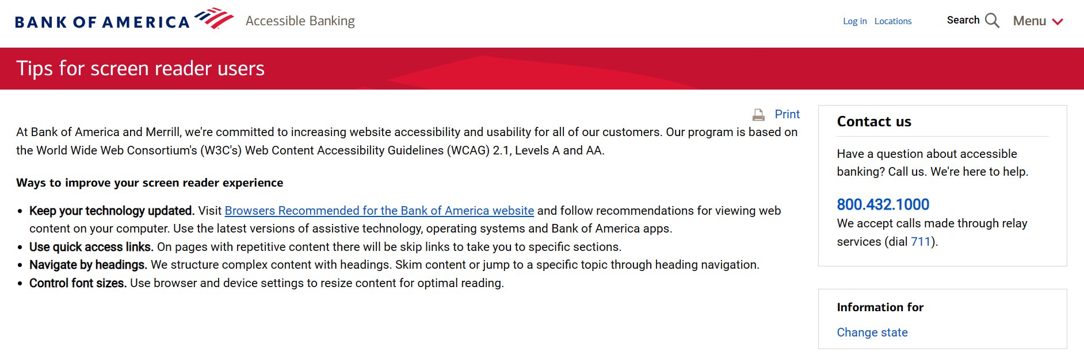

Figure 5: Bank of America Website (Bank of America, n.d.)

Bank of America is recognized as one of the leading international financial firms with a strong dedication to delivering comprehensive banking services. The bank guarantees excellent support for screen readers and provides easily accessible online statements, demonstrating a commitment to making financial information readily available to users with varying abilities. Customizing customer support services for inclusivity is a noteworthy advantage. Offering a " Tips for screen reader users" page serves as a valuable tool that empowers individuals who are visually impaired. However, providing more transparency about the regularity of updates to accessibility features would contribute further in boosting user assurance.

Strengths:

* Strong compatibility with screen readers.
* Accessible online statements.
* Quick access links.

Weaknesses:

* Website frequent updates.

**2.3.4 Comparison**

|  |  |  |  |  |
| --- | --- | --- | --- | --- |
| **Features** | **Barclays** | **BBC** | **Bank of America** | **Finease (Proposed System)** |
| Built in Text-to-Speech | X | X | X | ✓ |
| Compatible with External Assistive Tools | ✓ | ✓ | ✓ | ✓ |
| Alternative Text for Images | ✓ | ✓ | ✓ | ✓ |
| Guided Navigation | X | X | X | ✓ |
| Keyboard Navigation | ✓ | X | X | ✓ |
| Accessible Statements | ✓ | X | ✓ | ✓ |
| Audio Description | X | ✓ | X | ✓ |
| Quick Accessibility Link | X | X | X | ✓ |

Finease, the proposed system, sets itself apart from existing platforms such as Barclays, BBC, and Bank of America by offering a wide range of accessibility features designed to address the diverse requirements of users. Finease is distinguished as the only platform in comparison that includes integrated text-to-speech functionality. This feature allows users with visual impairments to have on-screen text read aloud, thereby improving accessibility through auditory prompts. Similar to other platforms, Finease ensures its compatibility with external assistive tools to accommodate users who rely on various assistive technologies for navigation. Additionally, Finease provides alternative text for images which is vital for enabling users with visual impairments to effectively understand visual content.

Besides, Finease stands out due to its guided navigation feature, which is not found in other platforms. This feature provides helpful prompts to assist users in efficiently navigating the platform. Additionally, Finease supports keyboard navigation, making it accessible for individuals who may have challenges using a mouse and thus promoting inclusivity for a broader range of users. Similar to Barclays and Bank of America, Finease ensures that financial statements are accessible, allowing users to access financial information in a format that complies with accessibility standards.

Finease also provides audio description features similar to BBC, offering extra narration to explain visual components, thereby improving the accessibility for individuals with visual impairments. Importantly, Finease incorporates a convenient accessibility link which is a feature absent in other platforms, it can enable users to quickly access and customize accessibility settings according to their requirements. Through the integration of these functionalities, Finease showcases its dedication to prioritizing inclusivity and accessibility, guaranteeing that all users can effortlessly access and make use of the platform's financial services regardless of their abilities.

## 2.4 Technical Research

### 2.4.1 Hardware

Audio Output Devices: For testing and experiencing the text-to-speech functionality, standard audio output devices such as headphones or speakers are essential. These devices ensure that developers can accurately assess the quality and performance of the text-to-speech system in various scenarios.

### 2.4.2 Programming Language

#### 2.4.2.1 Java

Java is recognized for its platform independence and "Write Once, Run Anywhere" concept, enabling applications to be executed on any device with a Java Virtual Machine (AWS, n.d.).  
This functionality enables developers to create applications that can run smoothly on any device with a Java Virtual Machine, regardless of the operating system underneath. In web development, Java is widely utilized in components such as controllers, services, models, and more, especially within the Spring Boot framework. Spring Boot takes advantage of Java's strength to simplify web application development by providing features like dependency injection, aspect-oriented programming, and effortless integration with other Java-based technologies.

Additionally, Java programmers frequently make use of template engines such as Thymeleaf to streamline the creation of dynamic web pages. Thymeleaf is recognized for its intuitive and refined syntax, which seamlessly integrates with Spring Boot applications and enables developers to dynamically generate HTML content (shubhamp338, 2022). This integration of Java and Thymeleaf empowers developers to design web applications with lively, data-influenced material while ensuring a seamless user experience across various devices and platforms.

#### 2.4.2.2 JavaScript

JavaScript is a versatile programming language widely employed for enhancing user interactivity and building dynamic content on the web. It serves a pivotal role in front-end web development, enabling developers to create engaging and responsive user interfaces that adapt to user actions and input. JavaScript operates seamlessly on the client side, ensuring compatibility with all modern web browsers, and its lightweight nature makes it ideal for delivering dynamic content directly to users' browsers without relying on server-side processing (MDN Contributors, 2019).

One notable feature that JavaScript facilitates is the integration of text-to-speech functionality through libraries like the Web Speech API. This browser-based API empowers developers to incorporate speech synthesis directly into web applications, allowing for the creation of accessible and interactive user experiences. By leveraging JavaScript and the Web Speech API, the developer can enhance the applications with text-to-speech features, enabling users to receive auditory feedback and interact with content more intuitively.

### 2.4.3 Front-end Development Stack

#### 2.4.3.1 HTML, CSS, JavaScript

Finease utilizes a blend of HTML, CSS, and JavaScript for front-end development to produce interactive and visually attractive user interfaces. These tools are crucial in shaping the visual aspect of web applications and guaranteeing a user-friendly and captivating experience.

Hypertext Markup Language, commonly known as HTML, plays a crucial role in web development by establishing the layout and substance of various components within web applications. Finease employs HTML to produce meaningful markup, arranging content into headings, paragraphs, lists, forms, and other essential elements. This language forms the basis for crafting web pages that are easy to access and optimize for search engines while also laying the groundwork for creating an adaptable and well-organized user interface (Kolowich, 2018).

CSS, or Cascading Style Sheets, is utilized to format and customize the visual representation of HTML components, enriching the overall display of the software. Finease utilizes CSS to tailor colors, fonts, arrangements, and other visual characteristics in order to maintain a uniform and visually pleasing interface. Through separating design from content, CSS empowers developers to produce flexible and attractive designs that can adjust for various screen dimensions and devices (Kolowich, 2018).

JavaScript brings interactivity and dynamic functionality to web pages, empowering Finease to develop engaging user interfaces. It is employed for client-side scripting, enabling developers to react to user interactions, modify DOM elements, and update content dynamically without the need for a complete page reload. Finease makes use of JavaScript frameworks and libraries for efficient development and improved user engagement by integrating capabilities including form validation, animated effects, and asynchronous data retrieval (Kolowich, 2018).

Finease creates a smooth and user-friendly interface by integrating HTML, CSS, and JavaScript. These front-end technologies are essential for providing an interactive and adaptable web experience that aligns with Finease's dedication to offering user-focused solutions.

### 2.4.4 Integrated Development Environment (IDE)

#### 2.4.4.1 Visual Studio Code

Visual Studio Code was chosen as the IDE for Finease's development due to its lightweight, yet robust features designed specifically for web and application development. With its user-friendly interface and wide range of extensions, VS Code provides a smooth coding experience for developers working with multiple programming languages such as Java, JavaScript, HTML, and CSS. Its integrated Git support, debugging capabilities, and compatibility with version control systems promote collaboration and streamline the development process (Turing, 2022).

### 2.4.5 Framework

#### 2.4.5.1 Spring Boot with Maven

Spring Boot with Maven as the framework for creating Finease because of its strong capabilities, widespread community backing, and efficient development workflow. Maven simplifies project administration by offering a systematic method to handle dependencies, compile source code, execute tests, and package applications. Through Maven, developers can conveniently set up project configurations and oversee dependencies using centralized repositories. The incorporation of Maven into Spring Boot improves project manageability, supports continuous integration and deployment processes and encourages the adoption of optimal software development practices (Spring, 2024).

### 2.4.6 Database Management System

#### 2.4.6.1 MySQL

Finease uses MySQL as its main database management system to store and handle application data. The decision to opt for MySQL was based on its reputation for reliability, scalability, and widespread use in the industry. As a relational database that is open-source, MySQL offers strong functionality for managing structured data while guaranteeing data integrity and facilitating complex queries (Oracle, 2019). Its compatibility with Spring Boot makes integration easier and enables smooth interaction with the application layer. Furthermore, MySQL's comprehensive documentation and community support offer developers valuable resources and help in enhancing database performance and resolving problems.

### 2.4.7 Web browser

#### 2.4.7.1 Google Chrome

Google released Chrome in 2008, and it has since been associated with speed, simplicity, and integration. Its streamlined design and quick rendering engine contribute to its effective performance, making it a popular option for users looking for a smooth browsing experience. Furthermore, Chrome's comprehensive developer tools enable developers to create and troubleshoot web applications effortlessly. With its compatibility across different devices and synchronization features, Chrome guarantees consistent browsing across platforms (Valeria, 2023).

#### 2.4.7.2 Microsoft Edge

Introduced in 2015 as the replacement for Internet Explorer, Microsoft Edge has seen substantial enhancements to improve its performance, flexibility, and adherence to web protocols. Based on the Chromium engine, Edge bears resemblances to Chrome in terms of speed and compatibility. Nevertheless, Edge sets itself apart with capabilities such as customizable start page choices and integrated Cortana assistance aimed at meeting users' desires for tailored and focused browsing sessions (Valeria, 2023).

## 2.5 Summary

This chapter presents a thorough examination of accessibility, technology, and security in online financial services. It is followed by an in-depth analysis of the technical elements involved in creating Finesse, a proposed system designed to improve accessibility and inclusivity within the financial industry.

The literature review examines the obstacles and advancements related to inclusivity in digital financial services, with a specific emphasis on the encounters of individuals with visual impairments. It also analyzes instances of non-compliance with usability standards in banking websites, developments in Text-to-Speech technology, and security measures. The analysis of comparable systems such as Barclays, BBC, and Bank of America illustrates the strengths and drawbacks of their accessibility features. Finease distinguishes itself by providing comprehensive solutions for various accessibility requirements, such as integrated TTS functionality, guided navigation, keyboard navigation, and an accessibility link.

The technical research section details the hardware, coding languages, front-end development tools, IDE, framework, database management system, and web browsers used in creating Finease. Major technologies include Java for backend programming, JavaScript for interactive front-end features and TTS integration, Spring Boot with Maven for streamlined development process,and MySQL as the primary database system.

# Chapter 3: Methodology

## 3.1 Introduction

A System Development Method is a structured and methodical approach used in creating information systems, software, or applications. It provides a comprehensive framework with guidelines, processes, and tools to facilitate the entire development lifecycle. The main aim of an system development method is to ensure that the development process is well-organized, effective, and in line with the project's objectives (Saravanan, 2017). The choice of a particular system development method depends on factors such as project complexity, organizational preferences, and required flexibility. Each system development method has its own strengths and weaknesses which influence the selection based on the unique characteristics and needs of each specific project.

## 3.2 Agile Methodology

Agile methodology is a flexible and iterative approach to system development, placing importance on flexibility and teamwork (vpadmin, 2023). Unlike traditional methods such as Waterfall, Agile does not follow a linear sequence of phases but instead utilizes short development cycles called sprints. These sprints involve the continuous development, testing, and delivery of small increments of a project. This iterative approach allows for ongoing reassessment and adaptation, enabling quick responses to changing requirements and stakeholder feedback. Agile prioritizes customer satisfaction by emphasizing early and continuous delivery of valuable software. It encourages collaboration among multidisciplinary teams and welcomes changes throughout the development process. Agile principles, as delineated in the Agile Manifesto, highlight the significance of personal interactions and collaboration, prioritizing functional deliverables over excessive documentation, adapting to change, and customer engagement. This methodology is especially suitable for endeavors that require adaptability and ongoing enhancement.

## 3.3 Waterfall Methodology

The Waterfall Model is a well-known example of a system development method, identified by its linear and sequential progression through distinct development phases. In this model, each phase must be completed before moving on to the next, providing a structured and well-defined path from initiation to deployment (vpadmin, 2023). The Waterfall methodology functions as an application development tool, flowing through the different stages of a project in a sequential manner, similar to that of a waterfall. However, it may encounter difficulties in accommodating changes once a phase has begun, making it more suitable for projects with clearly defined requirements.

## 3.4 Methodology Choice and Justification

Table 1: Comparison between Agile Methodology and Waterfall Methodology

|  |  |  |
| --- | --- | --- |
| **Criteria** | **Agile Methodology** | **Waterfall Methodology** |
| **Adaptability and Flexibility** | Agile offers great adaptability, allowing for changes even in the later stages of development. | Waterfall is inflexible, following a sequential process that necessitates finishing each stage before proceeding. Adapting to changes during the project can be difficult. |
| **Client Collaboration** | Agile prioritize continuous client collaboration throughout the development process to ensure regular feedback loops and alignment with changing client needs. | Waterfall primarily involves obtaining client feedback at the beginning and end, which may result in discrepancies between the final product and client expectations. |
| **Iterative Development** | Agile follows a cyclic approach with sprints, delivering smaller, incremental project updates at regular intervals. | Waterfall follows a linear progression, completing each phase fully before advancing, resulting in longer wait times for the final product. |

The project selection of the **Scrum framework** is carefully justified by the adoption of **Agile methodology**. This decision is based on the adaptability inherent in Agile, which enables dynamic adjustments during development which is a crucial factor for a project with evolving requirements and uncertainties. The inflexible nature of the Waterfall model is recognized, underscoring the necessity for flexibility, particularly in accommodating changes later in the project's lifecycle.

Scrum, a component of the Agile methodology, distinguishes itself through its strong focus on continual client involvement. Its iterative development method with short cycles closely matches the project's need for prompt and concrete results. The consistent delivery of smaller project segments in Scrum supports a responsive and customer-focused development process. This strategy encourages continuous stakeholder participation, offers regular progress updates, enhances communication effectiveness, and reduces the chances of discrepancies between delivered outcomes and client requirements (Sergeev, 2020).

In summary, Scrum, as a part of the Agile framework, is deliberately chosen for its adaptability to changing requirements, its emphasis on continuous client collaboration, and its iterative development approach. These characteristics collectively make Scrum the ideal choice for a project where flexibility, client engagement, and the timely delivery of tangible results are paramount to success.

## 3.5 Stages of Scrum Framework

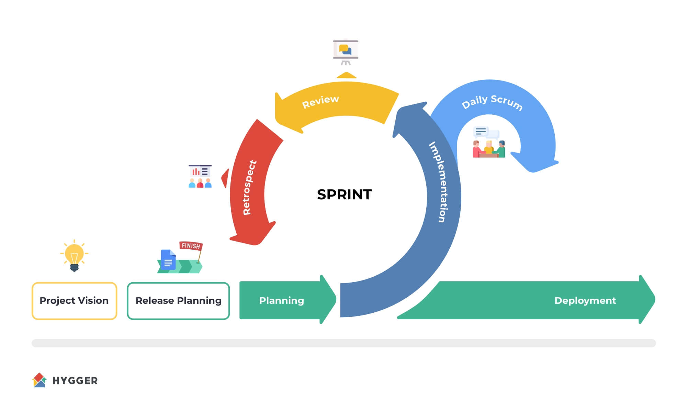

Figure 6: Scrum Lifecycle (Sergeev, 2020)

**Stage 1: Planning**

* The Product Owner identifies the need for financial accessibility for the visually impaired.
* Define challenges faced by visually impaired users in online financial services.
* Establish the vision and goals for the project to enhance financial inclusivity.

**Stage 2: Inception**

* Form a cross-functional team including developers, designers, accessibility specialists, and domain experts.
* Define overall project goals, scope, and objectives during the initial sprint.
* Create a product backlog prioritizing features for financial accessibility.

**Stage 3: Iteration**

1. Sprint Planning:

* Conduct detailed sprint planning meetings.
* Breakdown prioritized features into tasks for short development cycles or sprints.

1. Development:
   * Implements the integration of Text-to-Speech technology, develops features for real-time auditory feedback, navigation aid, and Text-to-Speech for PDF documents within short development cycles or sprints.
2. Testing:

* Conduct thorough testing of implemented features within each sprint.

1. Sprint Review and Demo:

* Complete and deliver increments of the product at the end of each sprint.
* Showcase implemented features to stakeholders, including visually impaired users.

1. Sprint Retrospective:

* Gather feedback from stakeholders and users.
* Iterate on features based on feedback, addressing usability issues and improving accessibility.

**Stage 4: Testing**

* Conduct comprehensive testing of the entire system, ensuring the stability and effectiveness of all accessibility features.
* Perform user acceptance testing with visually impaired users to validate the accessibility improvements.

**Stage 5: Production**

* Release increments of the product at the end of multiple sprints.
* Ensure that visually impaired users experience regular and tangible improvements.
* Incorporate user feedback iteratively to enhance features and meet evolving accessibility needs.

**Stage 6: Review**

* Continuously refine the product backlog based on changing requirements.
* Address emerging challenges and usability issues.
* Optimize the development process based on lessons learned from previous sprints.

**Stage 7: Retirement**

* Evaluate the overall success of the project in enhancing financial accessibility.
* Document lessons learned and best practices.
* Consider future improvements or additional features based on user feedback and changing needs.

## 3.6 Data Gathering

To gather data for this investigation, a survey methodology has been selected as the main method of information collection. Surveys are ideal for efficiently capturing various participant perspectives and providing quantitative data on user preferences, experiences, and opinions. The structured format of surveys enables standardized data collection, making it easier to analyze and interpret the gathered information systematically.

Upon entering the survey form, the participants of the survey are welcome to take part in the study with a brief explanation of its purpose and assurance that their responses will be kept confidential.

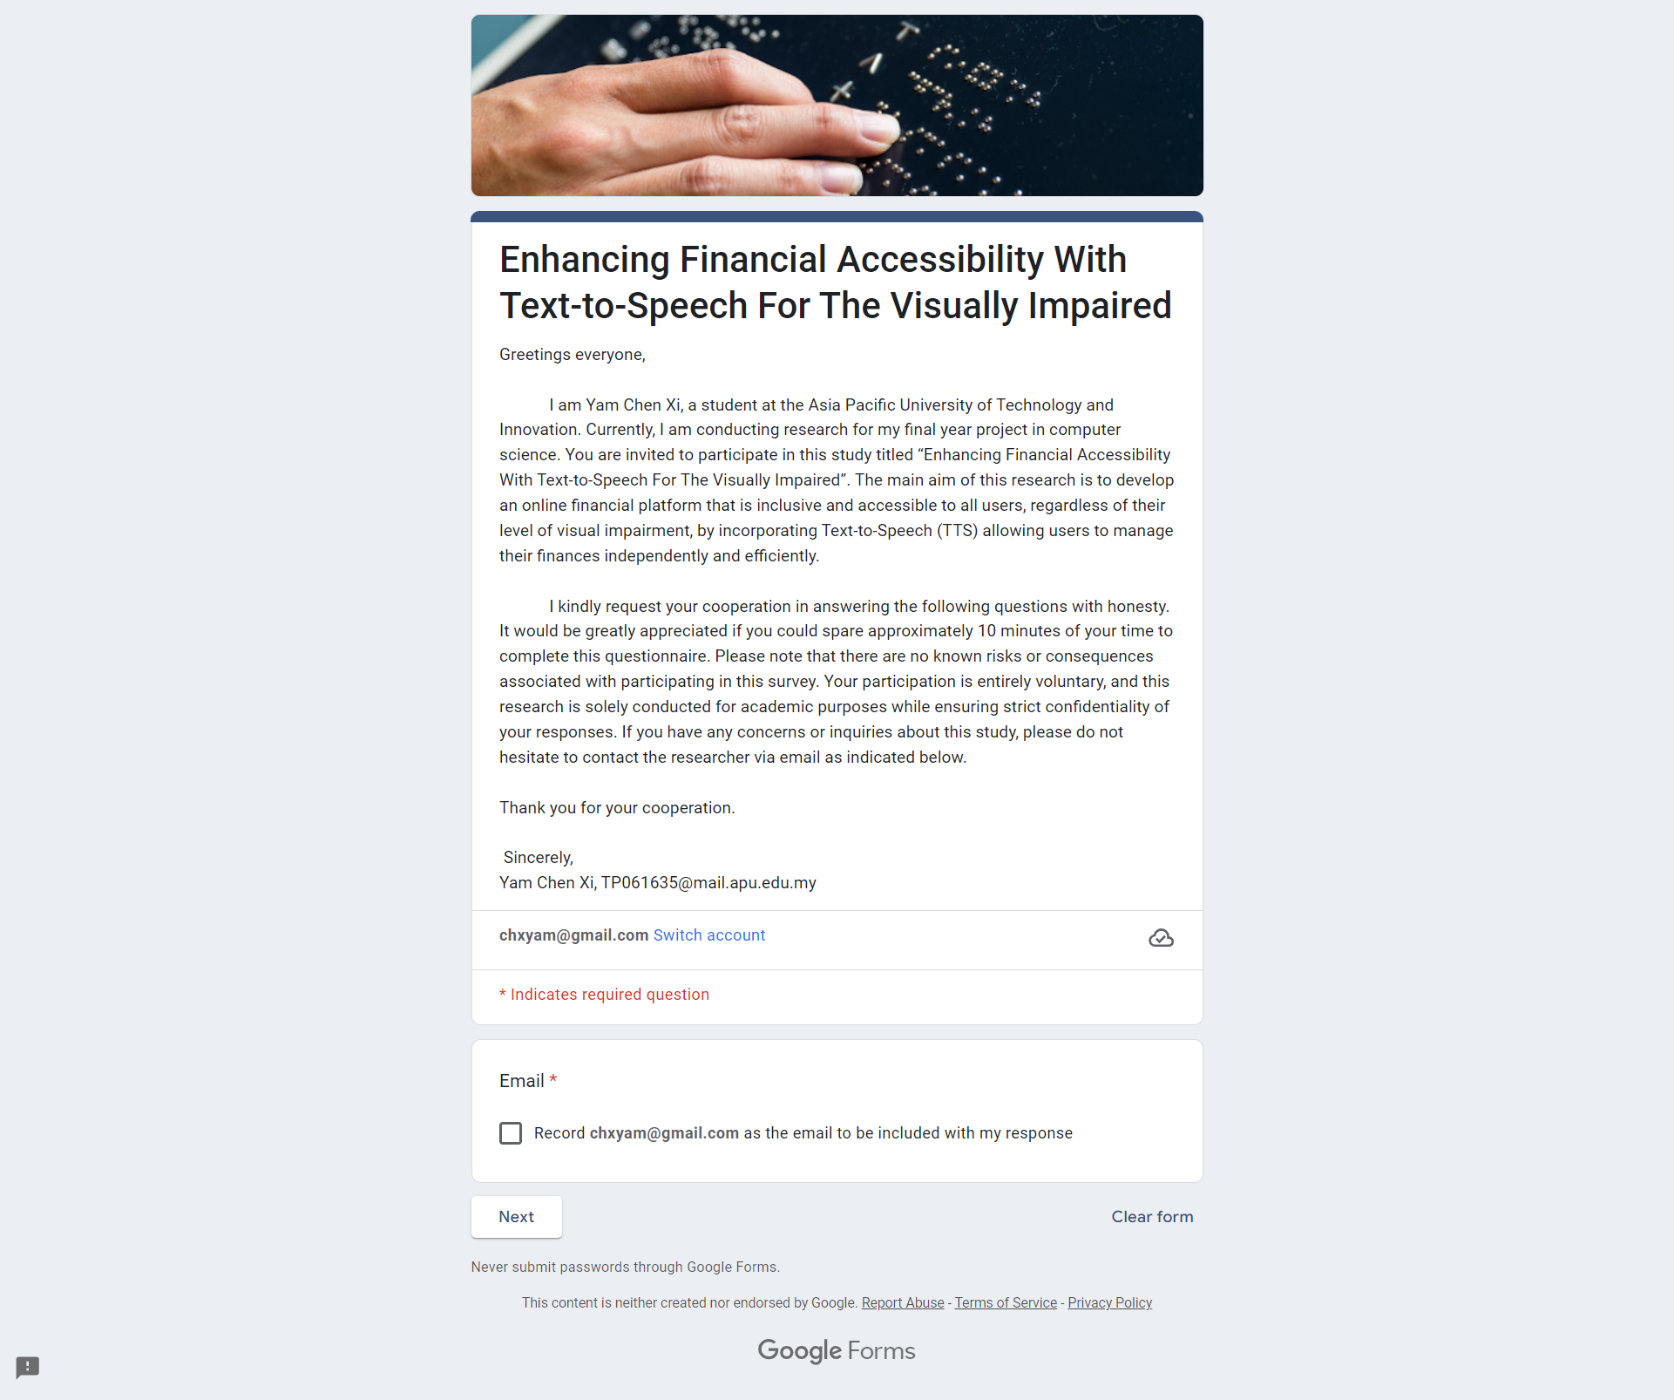

Figure 7: Survey welcome page

The attached **Information Sheet** to the survey provides an outline of the project's goals. Participants are notified about the gathering of demographic data and assured that their information will be kept confidential. Participants’ honest feedback is welcome to improve the system, and participant anonymity will be safeguarded during the study. Participants are reminded to obtain guardian supervision for the Online Finance Accessibility Study.

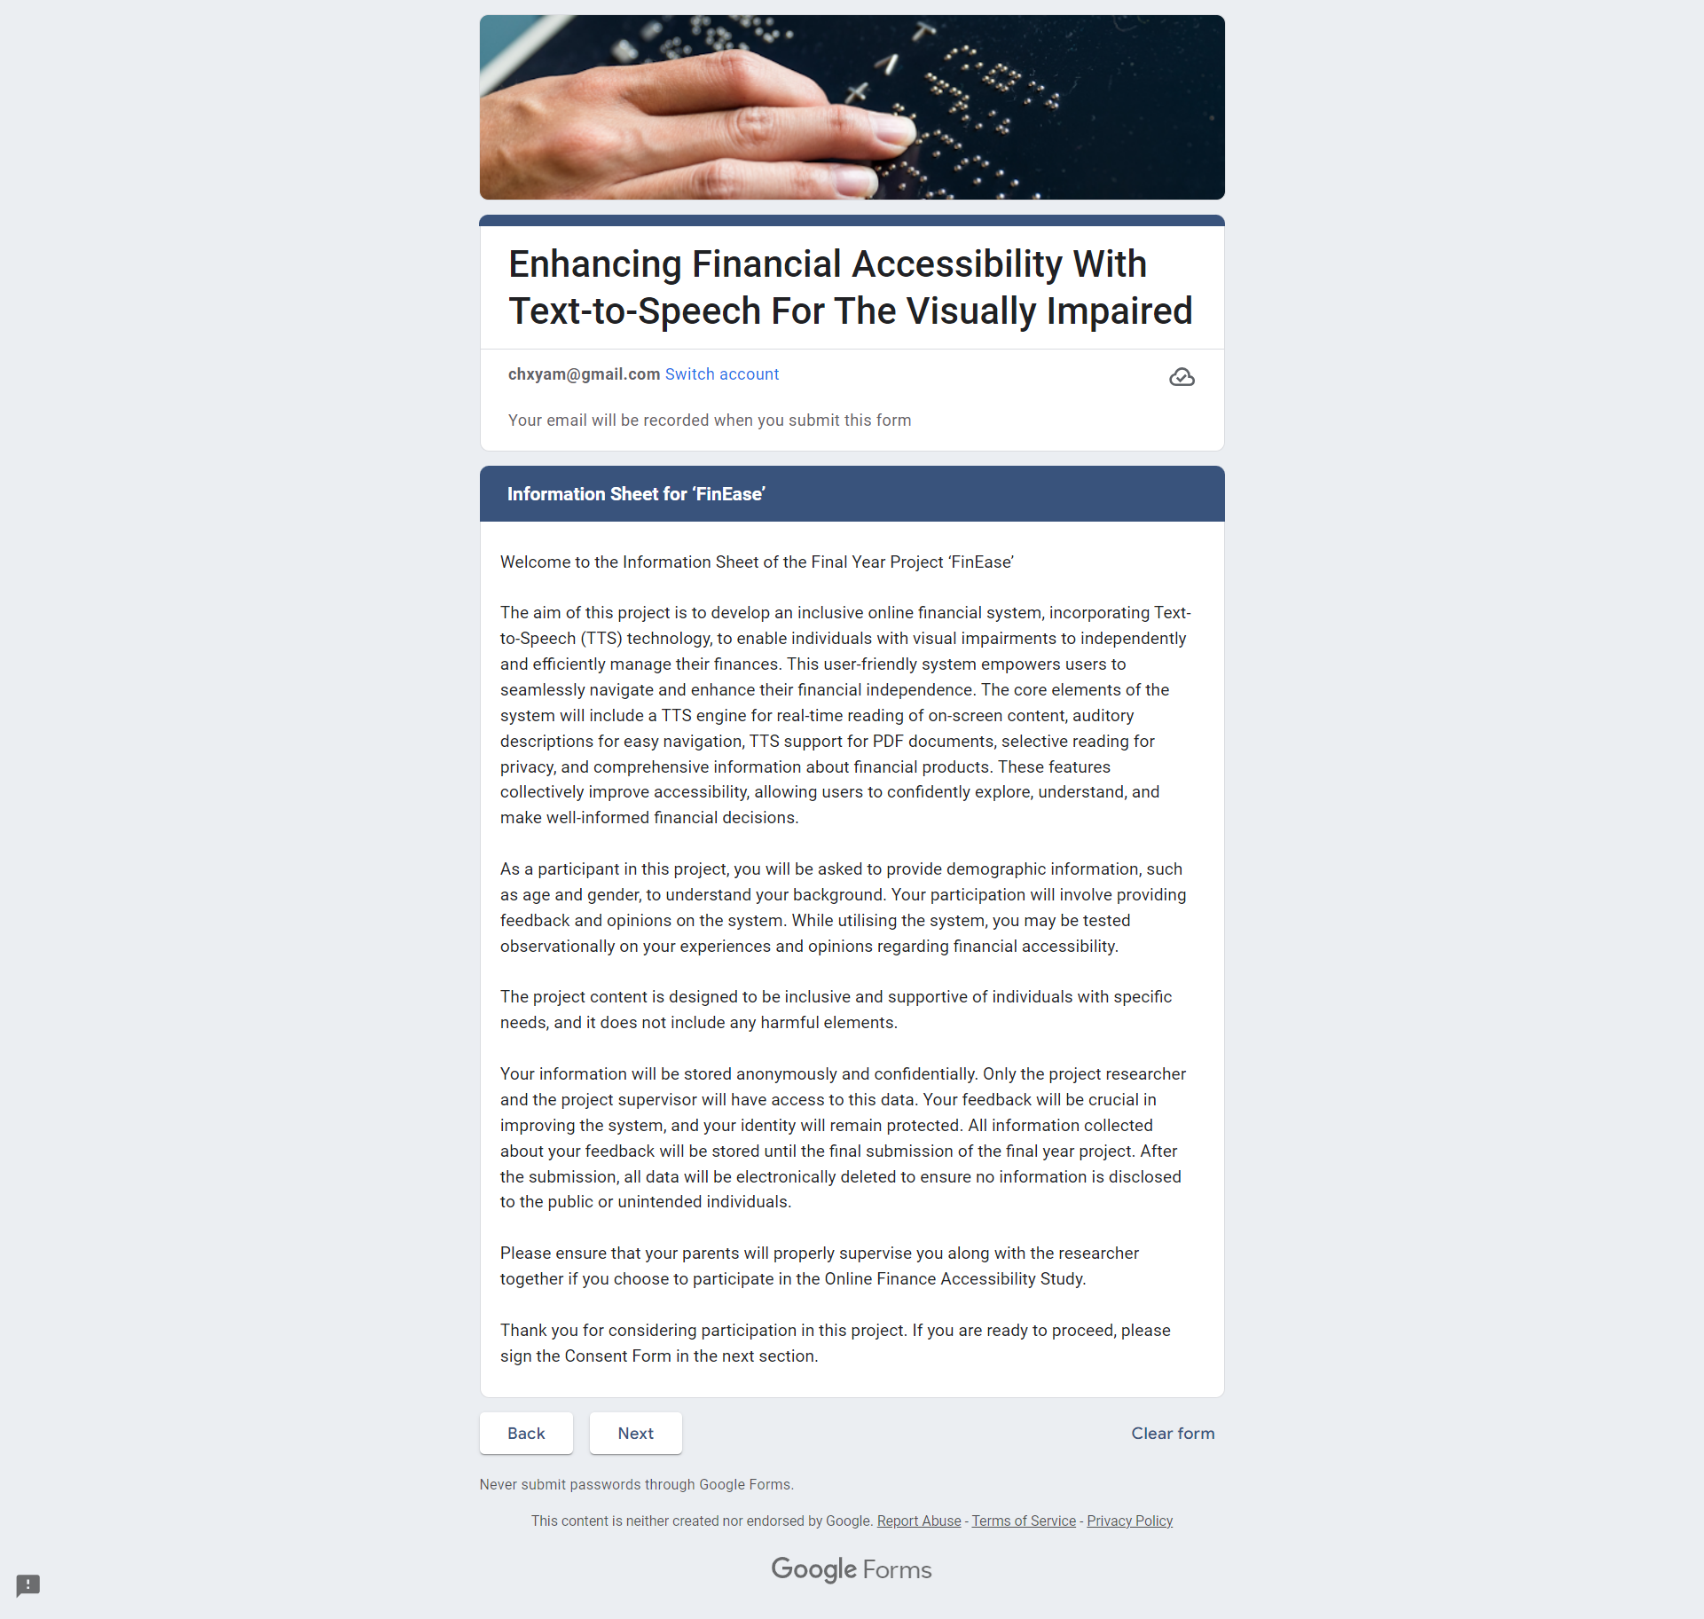

Figure 8: Survey Information Sheet

After reviewing the information sheet and agreeing to participate in the survey, participants are presented with a **Consent Form** that must be signed before they can proceed to complete the questionnaire.

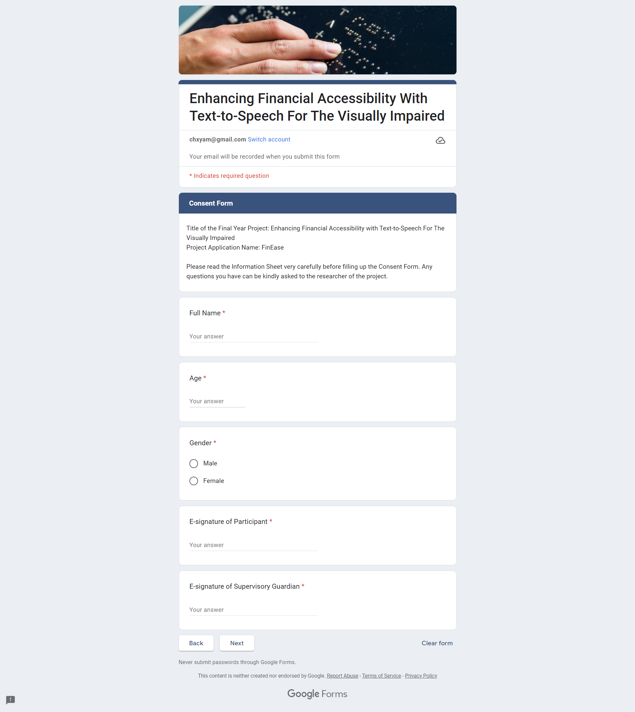

Figure 9: Survey Consent Form

**Section A** of the survey is designed to collect essential demographic information from participants. This includes details such as nationality, level of education, employment status and visual condition. By gathering this comprehensive data about participants' backgrounds and characteristics, researchers can gain a deeper insight into their perspectives and experiences throughout the remainder of the survey.



Figure 10: Survey Section A

**Section B** of the survey focused on gathering data about user preferences for accessibility in online financial platforms. With 15 questions, this segment aimed to explore participants' experiences and expectations regarding accessibility features. Questions 1-13 utilized a Likert-scale format. while **open-ended questions 14 and 15** allowed participants to provide qualitative insights. This structured survey approach was chosen for its efficiency in collecting valuable data that will inform further investigation stages. Below are the questions attached in the survey.

**5-point Likert scale questions (1 = Strongly Disagree, 5 = Strongly Agree)**

**Q1:** I am aware of the available external assistive technologies for accessing online platforms.

**Q2:** I believe that online financial platforms should prioritize accessibility improvements for users with disabilities.

**Q3:** I prefer to independently manage my financial affairs.

**Q4:** I am satisfied with the current accessibility features provided by online financial platforms for users.

**Q5:** I have encountered difficulties when accessing financial information or services online alone.

**Q6:** I often navigate online financial platforms using external assistive tools.

**Q7:** I have experienced compatibility challenges when using external assistive tools on online financial platforms.

**Q8:** I have privacy concerns when using external assistive tools.

**Q9:** I face challenges when adapting to frequent new updates of the online financial platform.

**Q10:** I am willing to switch to a more accessible online financial platform if available.

**Q11:** I have a positive perception of adapting internal assistive technologies built into online financial platforms.

**Q12:** I agree that technology like Finease can contribute to achieving SDG 10 (Reduce inequality).

**Q13:** I am confident that the adoption of Finease can significantly improve financial inclusivity.

**Open Ended Questions**

**Q14:** What do you consider the most significant challenges in accessing financial information online today?

**Q15:** What specific accessibility features do you believe are most crucial for online financial platforms to have for users with visual impairments?

## 3.7 Analysis

### 3.7.1 Section A: Background of Respondent

The demographic analysis offers important insights into the varied traits of the survey participants, which are crucial for understanding their viewpoints and inclinations towards internet-based financial services.

**Age**

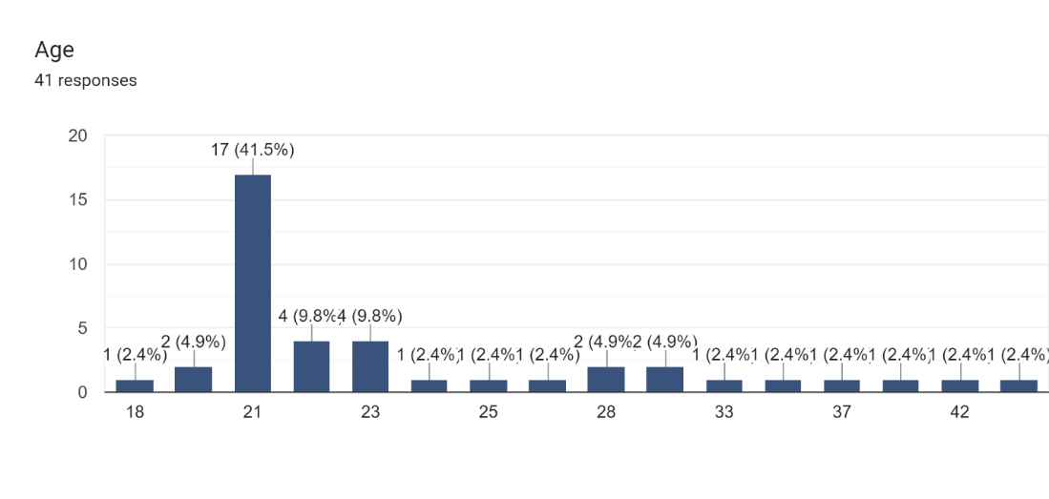

Figure 11: Survey Respondent Age Chart

The most common age range for survey respondents was 21 to 23, with the largest proportion of respondents being aged 21 at 41.5%. This indicates that the survey sample primarily consists of young adults, which may influence their preferences and behaviors regarding online financial platforms.

**Gender**

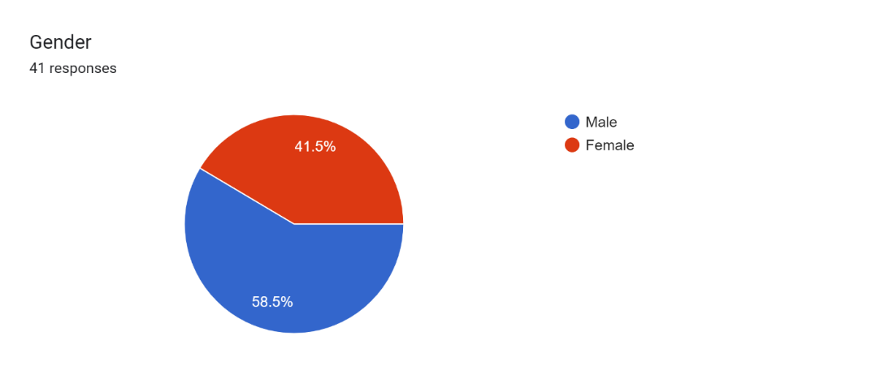

Figure 12:Survey Respondent Gender Chart

The survey respondents are distributed as 58.5% male and 41.5% female, respectively. This gender distribution suggests a relatively balanced representation, enabling insights into how both genders perceive and interact with online financial services.

**Nationality**

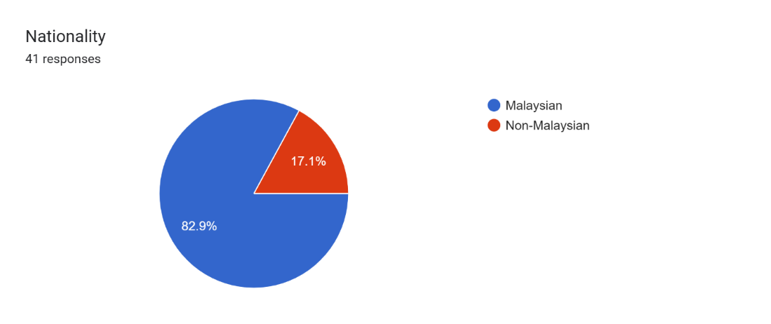

Figure 13: Survey Respondent Nationality Chart

The survey participants are distributed with 82.9% being Malaysian and 17.1% Non-Malaysian. This distribution provides context regarding the cultural and regional backgrounds of the respondents, which may influence their attitudes and preferences towards online financial platforms.

**Current Education Level**

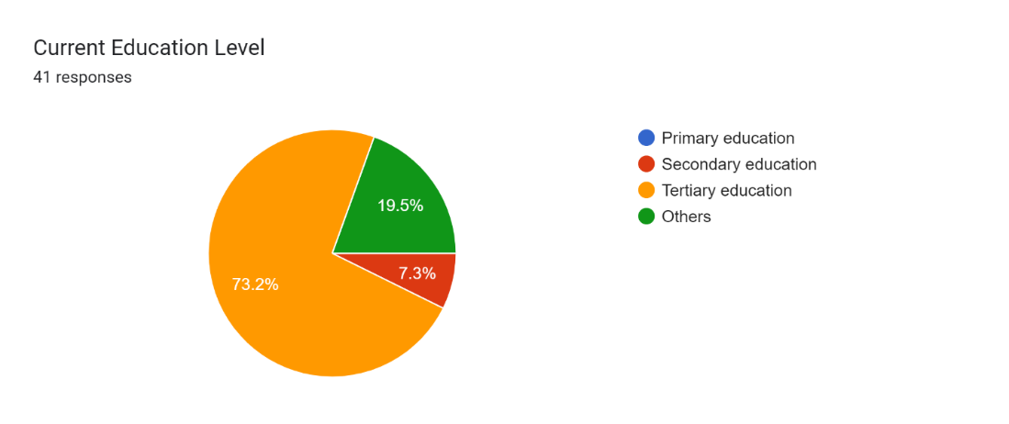

Figure 14: Survey Respondent Current Educational Level Chart

There are 73.2% of survey respondents who have completed tertiary education, 19.5% possess other types of education, and 7.3% have completed secondary education levels. This high percentage of respondents with tertiary education suggests a relatively educated sample, potentially impacting their level of financial literacy and understanding of online banking services.

**Employment Status**

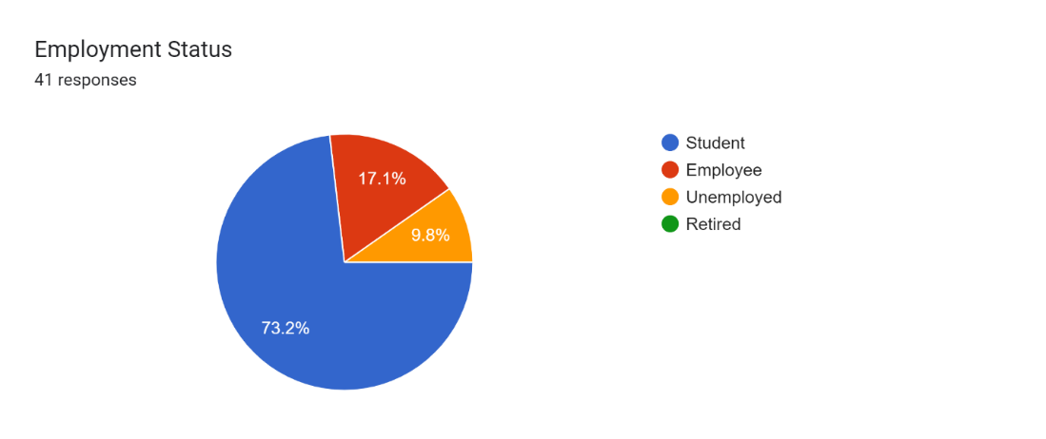

Figure 15: Survey Respondent Employment Status Chart

Employment status of the survey respondents: 73.2% are students, 17.1% are employed, and 9.8% are unemployed. This distribution sheds light on the economic status and lifestyle of the respondents, which may influence their financial needs and behaviors.

**Vision Condition**

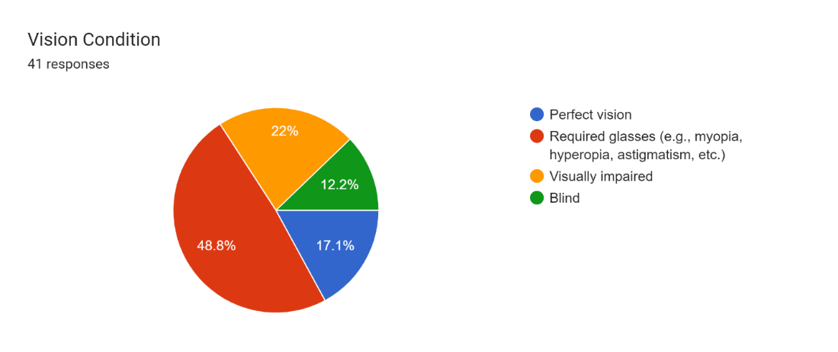

Figure 16: Survey Respondent Vision Condition Chart

The majority of survey respondents at 48.8% required glasses for daily life, followed by visually impaired individuals at 22% and blind individuals at 12.2%. This distribution underscores the importance of accessibility considerations in online financial platforms to accommodate users with visual impairments.

### 3.7.2 Section B: Accessibility and User Preferences

The analysis of Section B Accessibility and User Preferences provides important perspectives on the different views and choices of survey participants regarding accessibility and usability elements of internet-based financial services. These perspectives are essential for creating and executing functions that address the varied requirements of users, ultimately improving their experience and promoting inclusivity in online financial platforms.

**Question 1: I am aware of the available external assistive technologies for accessing online platforms.**

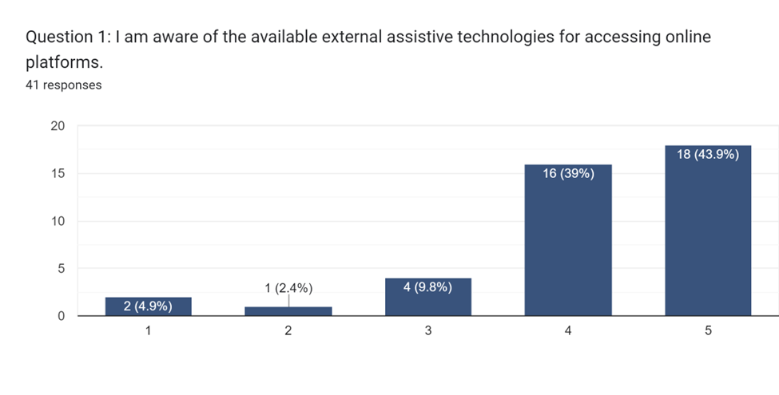

Figure 17: Survey Section B Q1 Result

A large number of participants, around 43.9%, gave the highest rating on their understanding of external assistive technologies, showing a strong grasp of the tools available. This increased awareness may be because there is more focus on promoting and educating about accessibility tools, highlighting their role in fostering inclusivity. The high rating indicates that users are knowledgeable about ways to access online platforms, signaling a positive shift towards greater awareness and empowerment for people with disabilities.

**Question 2: I believe that online financial platforms should prioritize accessibility improvements for users with disabilities.**

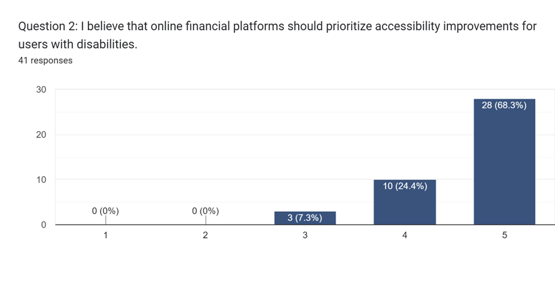

Figure 18: Survey Section B Q2 Result

Question 2 garnered significant response, with 68.3% of participants strongly advocating for the prioritization of making online financial platforms more accessible to users with disabilities. This widespread agreement emphasizes the increasing acknowledgment of inclusivity as a vital element in digital services. The support for prioritizing accessibility improvements mirrors a societal change towards greater inclusivity and fairness in online environments, emphasizing the significance of catering to diverse user requirements and guaranteeing equal access to financial services.

**Question 3: I prefer to independently manage my financial affairs.**

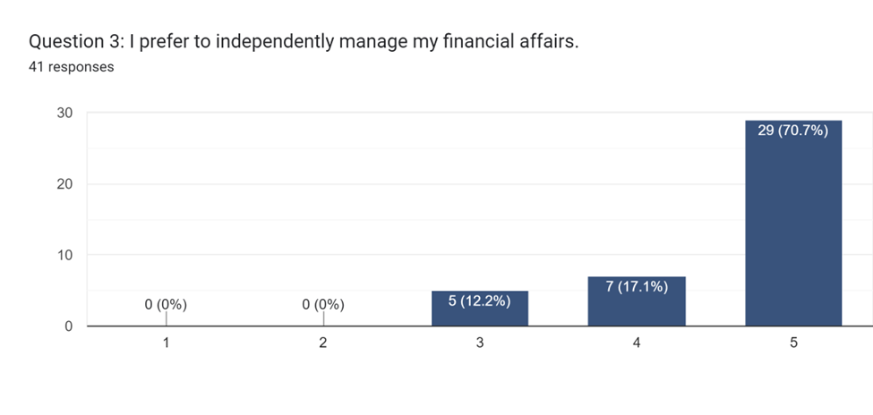

Figure 19: Survey Section B Q3 Result

Question 3 revealed a strong inclination towards independent financial management, as 70.7% of respondents gave it the highest rating of 5. This desire for autonomy highlights users' preference for control and self-sufficiency in handling their finances. The substantial percentage indicates that users prioritize making independent financial decisions, highlighting the need to offer accessible tools and resources that enable them to manage their finances independently.

**Question 4: I am satisfied with the current accessibility features provided by online financial platforms for users.**

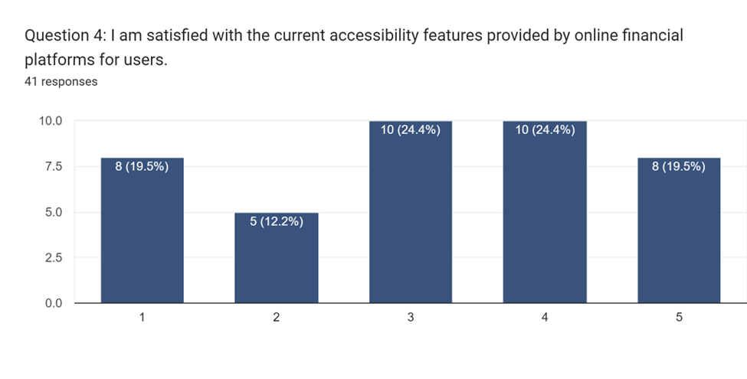

Figure 20: Survey Section B Q4 Result

Question 4 indicated a combination of opinions on satisfaction with current accessibility features, as about 24.4% of participants expressed neutrality and another 24.4% leaned towards contentment. This mixed sentiment highlights the necessity for enhancements in existing accessibility features to align more closely with user expectations and preferences. The feedback from users emphasizes the significance of improving accessibility features to guarantee a more inclusive and user-friendly experience for individuals, irrespective of their abilities.

**Question 5: I have encountered difficulties when accessing financial information or services online alone.**

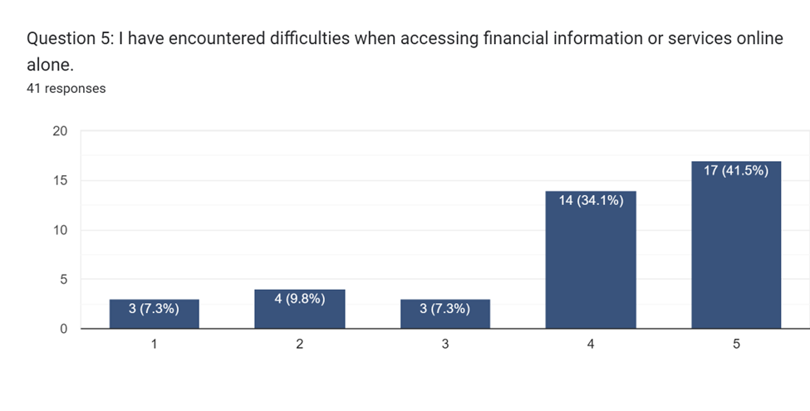

Figure 21: Survey Section B Q5 Result

Question 5 revealed that 41.5% of respondents encountered obstacles when trying to access financial information or services online on their own, indicating substantial difficulties in the current digital financial environment. This discovery emphasizes the importance of implementing better accessibility measures to overcome barriers experienced by individuals with disabilities. Improving accessibility features could help alleviate these hurdles, guaranteeing smooth access to financial information and services for all users, thereby promoting greater inclusivity and equal opportunity in the online domain.

**Question 6: I often navigate online financial platforms using external assistive tools**

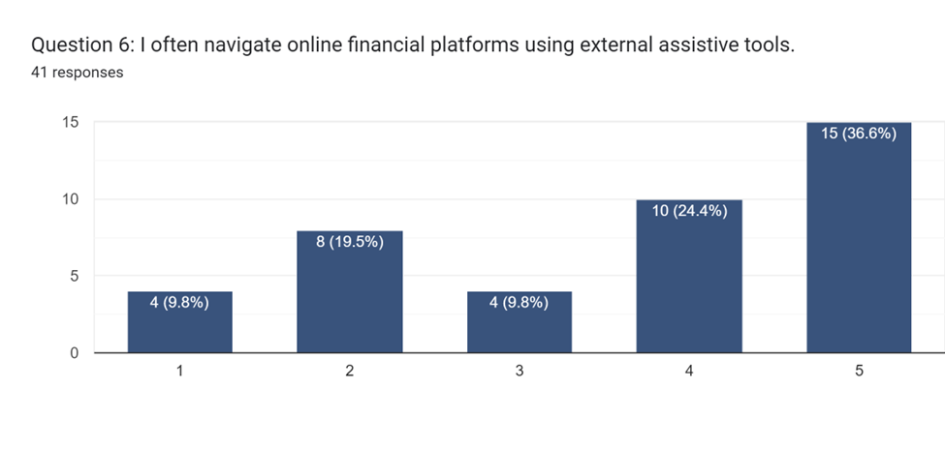

Figure 22: Survey Section B Q6 Result

In response to Question 6, 36.6% of respondents stated that they often use external assistive tools to navigate online financial platforms. This suggests different levels of dependence on external tools among users, underscoring the significance of offering adaptable solutions that meet a wide range of accessibility needs. Recognizing user preferences for assistive technologies is essential for creating inclusive platforms that address individual needs and choices, ultimately improving the overall user experience.

**Question 7: I have experienced compatibility challenges when using external assistive tools on online financial platforms.**

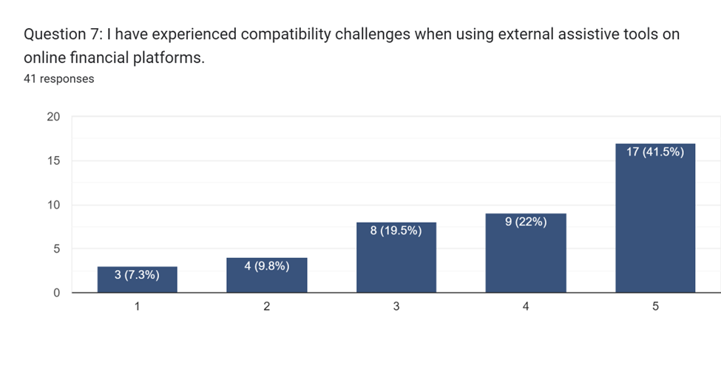

Figure 23: Survey Section B Q7 Result

Question 7 indicated that a substantial percentage of respondents, at 41.5%, faced issues with compatibility when employing external assistive tools on online financial platforms. This emphasizes the considerable obstacle to accessibility and emphasizes the importance of enhancing compatibility between assistive technologies and online platforms. Resolving these compatibility challenges is crucial for facilitating smooth user engagement and improving accessibility for people with disabilities, ultimately advancing greater inclusivity in online financial services.

**Question 8: I have privacy concerns when using external assistive tools.**

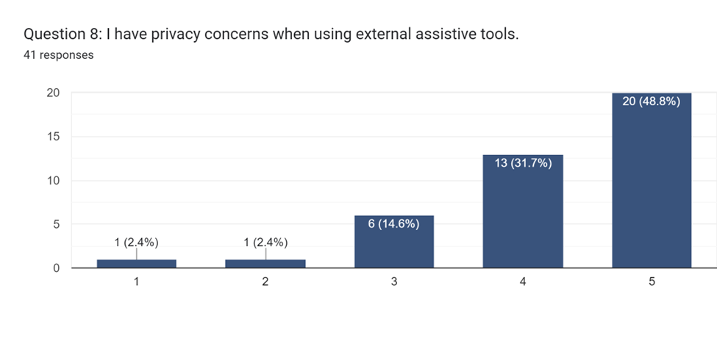

Figure 24: Survey Section B Q8 Result

In response to Question 8, 48.8% of the participants showed worries about privacy while using external aids on online financial platforms. This highlights the significance of giving preference to user privacy and data protection in creating and applying supportive technologies. Dealing with privacy apprehensions is crucial for building trust and assurance among users regarding these tools, ultimately guaranteeing a favorable and secure user interaction. Putting strong measures in place to protect privacy is vital for encouraging inclusivity and accessibility as well as safeguarding user data.

**Question 9: I face challenges when adapting to frequent new updates of the online financial platform.**

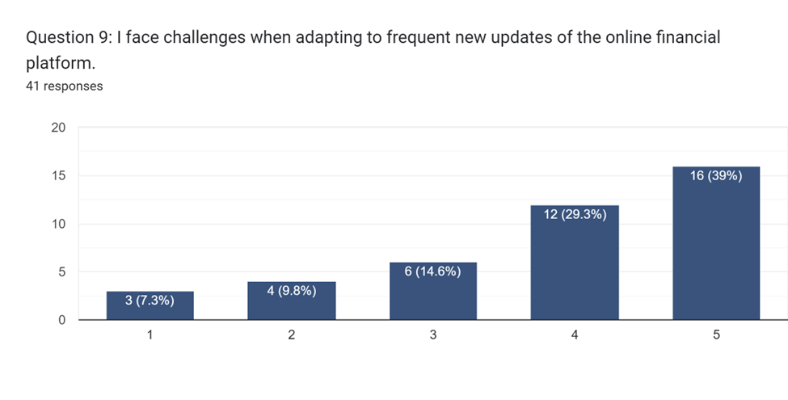

Figure 25: Survey Section B Q9 Result

The analysis of Question 9 indicates that 39% of participants encountered difficulties in adjusting to frequent updates on online financial platforms. This suggests a noteworthy level of struggle and reluctance among users. It underscores the significance of clear communication and user-friendly update procedures to facilitate smoother transitions for users. Offering sufficient support and resources for users to handle platform updates is crucial for ensuring a favourable user experience and reducing disruptions stemming from changes in the online financial landscape.

**Question 10: I am willing to switch to a more accessible online financial platform if available.**

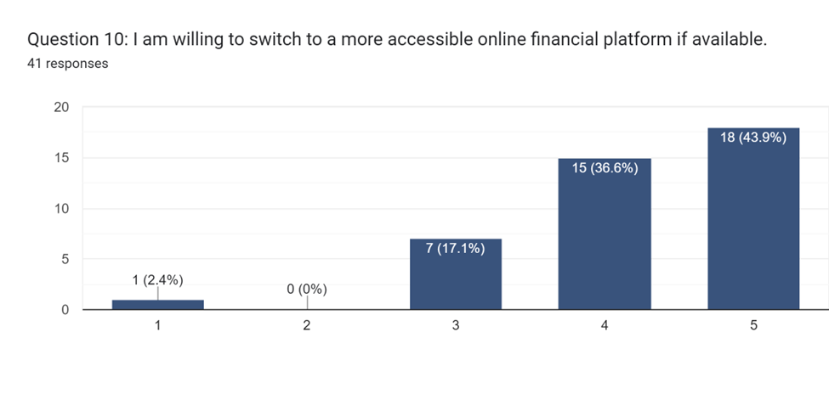

Figure 26: Survey Section B Q10 Result

Question 10 revealed a significant readiness among respondents, with 43.9%, to transition to an online financial platform that is more accessible if it were offered. This highlights the significance of accessibility as a critical element impacting users' choices when selecting a platform. The proactive stance of users in seeking out platforms that prioritize accessibility reflects an increasing need for digital services that are inclusive. Developing accessible platforms has the potential to appeal to users looking for greater inclusivity and address their individual requirements, ultimately improving user satisfaction and loyalty.

**Question 11: I have a positive perception of adapting internal assistive technologies built into online financial platforms.**

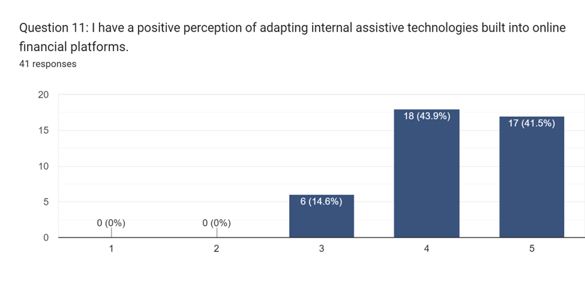

Figure 27: Survey Section B Q11 Result

Question 11 showed that 43.9% of respondents expressed a favorable attitude towards utilizing internal assistive technologies integrated into online financial platforms. This demonstrates a significant level of acceptance and positive outlook among users in relation to incorporated accessibility solutions. The willingness of users to embrace built-in assistive technologies highlights the capacity for internal solutions to improve accessibility and user-friendliness, thus fostering a more cohesive and comprehensive user experience. The integration of internal assistive technologies has the potential to empower individuals with disabilities and advance greater accessibility within online financial services.

**Question 12: I agree that technology like Finease can contribute to achieving SDG 10.**

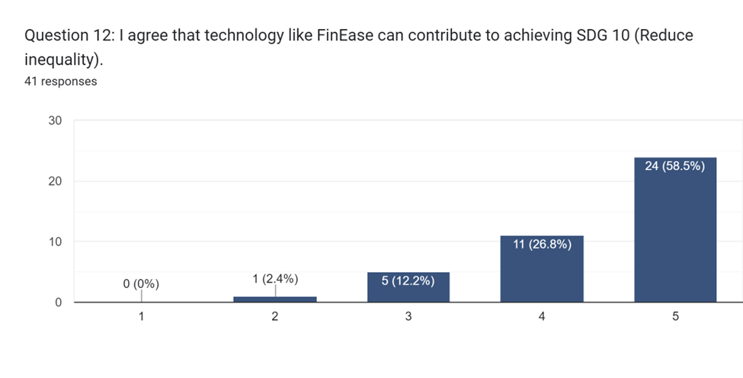

Figure 28: Survey Section B Q12 Result

Question 12 revealed a significant agreement among respondents, with 58.5% indicating that technology such as Finease can play a substantial role in advancing Sustainable Development Goal 10. This illustrates the acknowledgment by users of the impactful potential of technology in enhancing financial inclusivity and diminishing inequality. The respondents' support for wider societal objectives highlights the significance of endeavors like Finease in addressing social issues and cultivating improved financial access and fairness.

**Question 13: I am confident that the adoption of Finease can significantly improve financial inclusivity.**

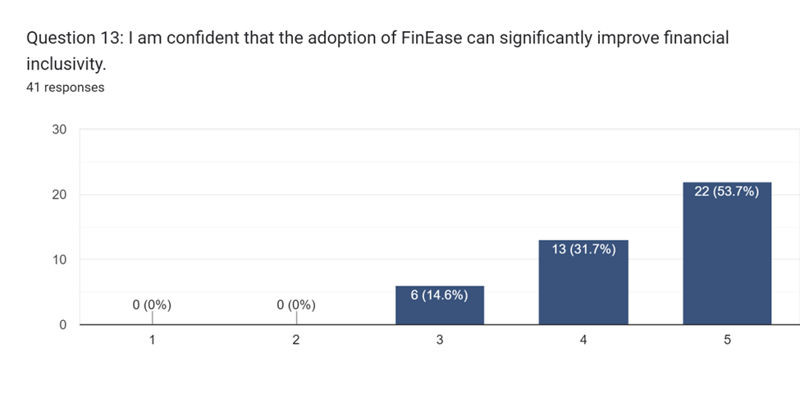

Figure 29: Survey Section B Q13 Result

The analysis of Question 13 indicates a high level of confidence among participants, with 53.7%, about the potential for Finease to enhance financial inclusivity significantly. This demonstrates their optimism regarding the transformative effects of technology on creating a more inclusive and accessible financial environment. Their belief in Finease's effectiveness to address barriers to access and promote equal opportunities for financial services is evident from this high level of confidence. This positive perspective highlights the significance of technological advancements in driving positive social change and advancing financial inclusivity.

**Question 14: What do you consider the most significant challenges in accessing financial information online today?**

Based on the survey results, the summarized data highlights the challenges that emphasize the importance of developing inclusive and accessible online financial platforms. These challenges pertain to issues related to both usability and security for visually impaired users.

1. **Limited Accessibility Features**: Visually impaired individuals face challenges accessing financial information due to insufficient accessibility features on websites. Key issues include the absence of screen reader compatibility and difficulties in navigating interfaces designed primarily for visual users.
2. **Security and Privacy Concerns**: The fear of cybersecurity threats and scams is a significant barrier. Users express concerns about weak passwords, potential fraud, and privacy issues when relying on online platforms to access financial information.
3. **Educational Barriers**: Limited financial literacy poses a hurdle, as navigating complex financial information often requires specialized knowledge. The lack of user-friendly guidelines makes it challenging for individuals without formal finance education to comprehend and utilize online financial resources effectively.
4. **Unfriendly User Interfaces**: Some financial platforms present unfriendly user interfaces, featuring small text that is challenging for visually impaired users to read. The difficulty in adapting to constant changes in the user interface further complicates the user experience.
5. **Dependency on Others**: Visually impaired individuals often rely on others for interpretation or assistance in accessing financial information online. This dependency raises privacy concerns and highlights the need for more user-friendly and independent accessibility features.

**Question 15: What specific accessibility features do you believe are most crucial for online financial platforms to have for users with visual impairments?**

According to the survey results, the specific accessibility features deemed crucial for online financial platforms to accommodate users with visual impairments include:

1. **Text-to-Speech Functionality**: Enabling text-to-speech features helps users by audibly conveying financial information, facilitating comprehension through spoken content.
2. **Screen Reader Compatibility**: Ensuring compatibility with screen readers enhances accessibility, allowing visually impaired users to navigate and interact with the platform effectively.
3. **User-Friendly Interface Design**: Implementing a user interface that avoids relying on color alone for conveying information is vital. Additionally, considering font style, size, and color contrast caters to various visual impairments, enhancing user engagement.
4. **Hot Keys and Shortcut Keys**: Providing hot keys for easier access to features enhances efficiency in navigating the platform, allowing users to perform actions more quickly.
5. **Guided Navigation**: Offering guided navigation contribute to a more tailored and user-friendly experience. This includes proper descriptions for images, PDFs, graphs, and charts, as well as high contrasts and large text for improved visibility.

## 3.5 Summary

The methodology section thoroughly explains the idea of System Development Methods as organized structures that direct information system development. The reasoning for choosing the Scrum framework within the Agile methodology over the Waterfall model is elaborated, highlighting Scrum's adaptability, ongoing client collaboration, and iterative development to match with the project's dynamic characteristics. The survey methodology is employed for data collection, ensuring effectiveness in gathering varied viewpoints and quantitative data on user preferences. The ensuing data analysis offers insights into participant demographics and showcases important discoveries from the Likert-scale queries, providing understanding of user awareness, preferences, obstacles, and perceptions. Prominent patterns encompass a firm belief in giving importance to accessibility enhancements, an inclination towards autonomous financial management, and concerns about privacy when utilizing external assistive tools. Ultimately​ examining the open-ended questions reveals significant challenges and essential accessibility features critical for shaping the project's direction.

# Chapter 4: Design and Implementation

## 4.1 Introduction

Finease is a robust internet banking platform that caters to the needs of both clients and administrators. Clients have the ability to oversee their accounts, access financial information, and conduct transactions, while administrators are responsible for supervising user accounts and financial activities. The system is designed with user-friendly features such as accessibility options and secure login sessions. By providing detailed use case specifications, Finease ensures effective system behavior and interaction with users. Its architecture consists of layers including Client, Server, and Model which allows for scalable development and maintenance. Class as well as entity-relationship diagrams contribute to efficient data management. Finease emphasizes intuitive interface design by utilizing tools like Figma for visual appeal and usability enhancements. This innovative platform operates on a Maven Spring Boot environment it facilitates seamless transaction processing, including text-to-speech integration for accessibility. Finease sets out to revolutionize online banking by offering a secure, accessible, and efficient platform for managing finances.

## 4.2 System Design

### 4.2.1 Use Case Diagram

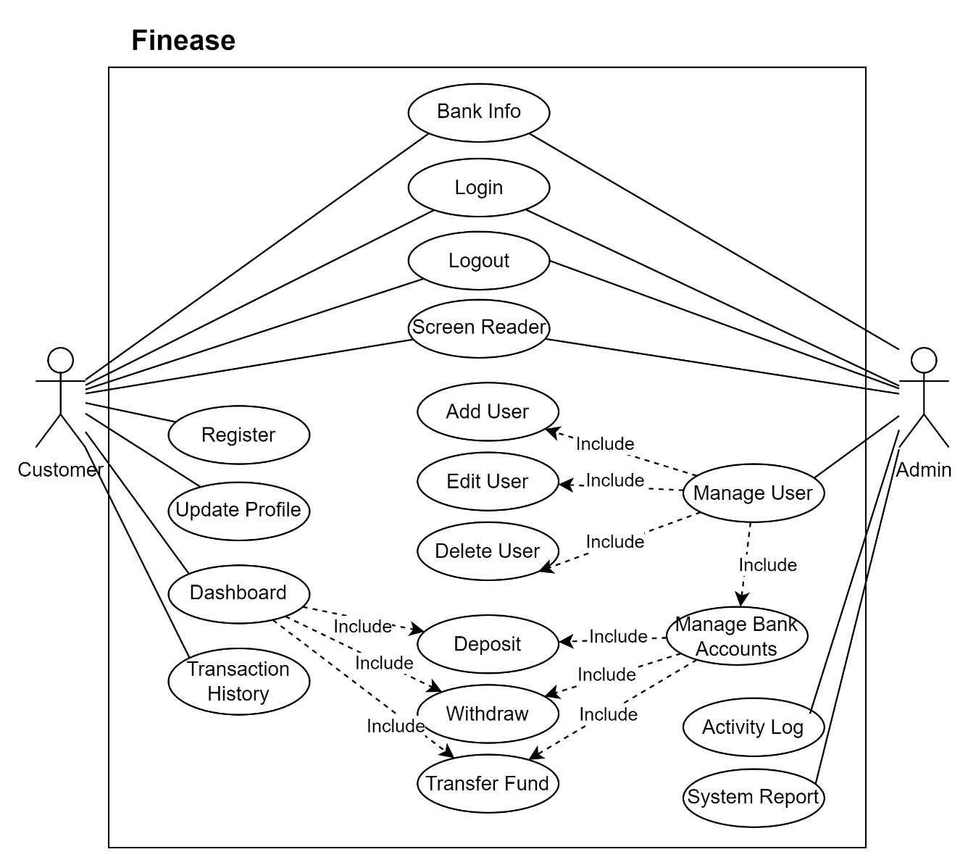

Figure 30: Finease's Use Case Diagram

The use case diagram of Finease illustrates the interactions between system users and the functionalities available. Customers can participate in tasks like controlling their accounts, accessing financial data, and conducting transactions. In contrast, Admins have broader permissions, including managing user accounts, supervising financial operations, and accessing system reports. Both users and admins have common features such as using accessibility options and handling login sessions. This use case diagram offers a comprehensive understanding of the system's capabilities as well as the roles played by various actors within Finease banking ecosystem.

#### 4.2.1.1 Use Case Specification – Bank Information

Table 2: Use Case Specification for Bank Information

|  |  |
| --- | --- |
| **Use Case Name** | Bank Information |
| **Actor(s)** | Customer, Admin |
| **Description** | Allows user to access to bank information. |
| **Priority** | High |
| **Precondition(s)** | - |
| **Main Flow** | 1. User navigates to index page. 2. User access to bank information. |
| **Alternative Flow** | - |
| **Postcondition(s)** | - |

#### 4.2.1.2 Use Case Specification – Register

Table 3: Use Case Specification for Register

|  |  |
| --- | --- |
| **Use Case Name** | Register |
| **Actor(s)** | Customer |
| **Description** | Allows user to register an account for Finease. |
| **Priority** | High |
| **Precondition(s)** | - |
| **Main Flow** | 1. User navigates to login page. 2. User click sign up link. 3. User provides necessary personal information. 4. User submits the registration form. 5. Redirect to login page to log in with newly created account. |
| **Alternative Flow** | 1(a). User cancels the registration process.  4(a) User does not enter all the required information.   1. Prompt error indicating all required information need to be filled. 2. Use Case resume at step 3.   4(b). User’s input email has already been used.   1. Prompt error indicating email has already been used. 2. Use case resume at step 3.   4(c). User’s input username has already been used.   1. Prompt error indicating username has already been used. 2. Use case resume at step 3. |
| **Postcondition(s)** | User account is successfully registered and redirect to login page. |

#### 4.2.1.3 Use Case Specification – Login

Table 4: Use Case Specification for Login

|  |  |
| --- | --- |
| **Use Case Name** | Login |
| **Actor(s)** | Customer, Admin |
| **Description** | Allows users to log into their Finease account. |
| **Priority** | High |
| **Precondition(s)** | User must have a registered Finease account. |
| **Main Flow** | 1. User navigates to login page. 2. User provides username and password. 3. User submits the login form. |
| **Alternative Flow** | 1(a). User cancels the login process.  3(a). User provided the incorrect login credentials.   1. Prompt error indicating invalid input. 2. Use case resume at step 2. |
| **Postcondition(s)** | User account is successfully login and redirect to dashboard page. |

#### 4.2.1.4 Use Case Specification – Logout

Table 5: Use Case Specification for Logout

|  |  |
| --- | --- |
| **Use Case Name** | Logout |
| **Actor(s)** | Customer, Admin |
| **Description** | Allow users to end the current session and log out of their currently active account. |
| **Priority** | Medium |
| **Precondition(s)** | User must be logged into their Finease account. |
| **Main Flow** | 1. User clicks on the logout button. 2. System terminates the current session. |
| **Alternative Flow** | - |
| **Postcondition(s)** | User is successfully logged out of Finease. |

#### 4.2.1.5 Use Case Specification – Screen Reader

Table 6: Use Case Specification for Screen Reader

|  |  |
| --- | --- |
| **Use Case Name** | Screen Reader |
| **Actor(s)** | Customer, Admin |
| **Description** | Allow users activate text to speech feature for page navigation. |
| **Priority** | High |
| **Precondition(s)** | User must toggle on screen reader. |
| **Main Flow** | 1. User navigates to any Finease’s page. 2. User click on activation button to toggle screen reader. |
| **Alternative Flow** | - |
| **Postcondition(s)** | Text to speech feature is successfully activated. |

#### 4.2.1.6 Use Case Specification – Update Profile

Table 7: Use Case Specification for Update Profile

|  |  |
| --- | --- |
| **Use Case Name** | Update Profile |
| **Actor(s)** | Customer |
| **Description** | Allow users view profile and update profile information. |
| **Priority** | High |
| **Precondition(s)** | User must be logged into their Finease account. |
| **Main Flow** | 1. User click profile page. 2. User click edit button. 3. User make changes on their information. 4. User click save button. |
| **Alternative Flow** | 2(a). User cancel edit process.  4(a). User made no changes on profile information.   1. No changes on profile information is made. |
| **Postcondition(s)** | Updated user profile information displayed on profile page. |

#### 4.2.1.7 Use Case Specification – Dashboard

Table 8: Use Case Specification for Dashboard

|  |  |
| --- | --- |
| **Use Case Name** | Dashboard |
| **Actor(s)** | Customer |
| **Description** | Allow users view bank accounts and account balance |
| **Priority** | High |
| **Precondition(s)** | User must be logged into their Finease account. |
| **Main Flow** | 1. User logged into their Finease account and redirect to dashboard page. |
| **Alternative Flow** | - |
| **Postcondition(s)** | User bank accounts and balance displayed on dashboard. |

#### 4.2.1.8 Use Case Specification - Deposit

Table 9: Use Case Specification for Deposit

|  |  |
| --- | --- |
| **Use Case Name** | Deposit |
| **Actor(s)** | Customer, Admin |
| **Description** | Allow users deposit funds into their bank account. |
| **Priority** | High |
| **Precondition(s)** | * User must be logged into their Finease account. * User must have either current or savings account. |
| **Main Flow** | 1. User click deposit button. 2. User select bank account to deposit to and input amount of fund to deposit. 3. User click deposit button. |
| **Alternative Flow** | 2(a). User cancels the deposit process. |
| **Postcondition(s)** | User successfully deposit funds into the selected bank account. |

#### 4.2.1.9 Use Case Specification - Withdraw

Table 10: Use Case Specification for Withdraw

|  |  |
| --- | --- |
| **Use Case Name** | Withdraw |
| **Actor(s)** | Customer, Admin |
| **Description** | Allow users withdraw funds from their bank account. |
| **Priority** | High |
| **Precondition(s)** | * User must be logged into their Finease account. * User must have either current or savings account. |
| **Main Flow** | 1. User click withdraw button. 2. User select bank account to deposit to and input amount of fund to withdraw. 3. User click withdraw button. |
| **Alternative Flow** | 2(a). User cancels the withdraw process.  3(a). Bank account has insufficient balance to be withdrawn.   1. Prompt error indicating insufficient balance. 2. Use Case resume at step 2. |
| **Postcondition(s)** | User successfully withdraw funds into the selected bank account. |

#### 4.2.1.10 Use Case Specification – Transfer Fund

Table 11: Use Case Specification for Transfer Fund

|  |  |
| --- | --- |
| **Use Case Name** | Transfer Fund |
| **Actor(s)** | Customer, Admin |
| **Description** | Allow users transfer funds from selected account to other account. |
| **Priority** | High |
| **Precondition(s)** | * User must be logged into their Finease account. * User must have either current or savings account. |
| **Main Flow** | 1. User click transfer button. 2. User select bank account to transfer from, bank account to transfer to and input amount of fund to transfer. 3. User click transfer button. |
| **Alternative Flow** | 2(a). User cancels the transfer process.  3(a). Bank account has insufficient balance to be transferred.   1. Prompt error indicating insufficient balance. 2. Use Case resume at step 2. |
| **Postcondition(s)** | User successfully transfer funds from selected account to other account. |

#### 4.2.1.11 Use Case Specification –Transaction History

Table 12: Use Case Specification for Transaction History

|  |  |
| --- | --- |
| **Use Case Name** | Transaction History |
| **Actor(s)** | Customer |
| **Description** | Allow user to view all transaction history that has been made in table format and PDF receipts. |
| **Priority** | High |
| **Precondition(s)** | * User must be logged into their Finease account. |
| **Main Flow** | 1. User click History page. |
| **Alternative Flow** | 1(a). User click view PDF from transaction history’s row.   1. PDF of the selected transaction is displayed. |
| **Postcondition(s)** | User successfully view all transaction history and selected transaction’s PDF receipt. |

#### 4.2.1.12 Use Case Specification – Manage User

Table 13: Use Case Specification for Manage User

|  |  |
| --- | --- |
| **Use Case Name** | Manage User |
| **Actor(s)** | Admin |
| **Description** | Allow user to view all users in Finease database. |
| **Priority** | High |
| **Precondition(s)** | User must be logged into Finease as admin. |
| **Main Flow** | 1. User click manage user page. |
| **Alternative Flow** | - |
| **Postcondition(s)** | All users information successfully displayed in page. |

#### 4.2.1.13 Use Case Specification – Add User

Table 14: Use Case Specification for Add User

|  |  |
| --- | --- |
| **Use Case Name** | Add User |
| **Actor(s)** | Admin |
| **Description** | Allow user to add user into Finease database. |
| **Priority** | High |
| **Precondition(s)** | User must be logged into Finease as admin. |
| **Main Flow** | 1. User click manage user page. 2. User click add user button. 3. User fill in all the required fields. 4. User click add user button. |
| **Alternative Flow** | 2(a). User cancels the add user process.  4(a) User does not enter all the required information.   1. Prompt error indicating all required information need to be filled. 2. Use Case resume at step 3.   4(b). User’s input email has already been used.   1. Prompt error indicating email has already been used. 2. Use case resume at step 3.   4(c). User’s input username has already been used.   1. Prompt error indicating username has already been used. 2. Use case resume at step 3. |
| **Postcondition(s)** | New user is successfully add into Finease database. |

#### 4.2.1.14 Use Case Specification – Edit User

Table 15: Use Case Specification for Edit User

|  |  |
| --- | --- |
| **Use Case Name** | Edit User |
| **Actor(s)** | Admin |
| **Description** | Allow user to edit user in Finease database. |
| **Priority** | High |
| **Precondition(s)** | User must be logged into Finease as admin. |
| **Main Flow** | 1. User click manage user page. 2. User click edit user button. 3. User make changes on the user information. 4. User click edit user button. |
| **Alternative Flow** | 2(a). User cancels the edit user process.  4(a) User does not make any changes on user information.   1. User made no changes on profile information. 2. No changes on profile information is made. |
| **Postcondition(s)** | Edited user information is successfully updated in Finease database. |

#### 4.2.1.15 Use Case Specification – Delete User

Table 16: Use Case Specification for Delete User

|  |  |
| --- | --- |
| **Use Case Name** | Delete User |
| **Actor(s)** | Admin |
| **Description** | Allow user to delete user in Finease database. |
| **Priority** | High |
| **Precondition(s)** | User must be logged into Finease as admin. |
| **Main Flow** | 1. User click manage user page. 2. User click delete user button. 3. User select user to delete. 4. User click delete user button. |
| **Alternative Flow** | 2(a). User cancels the delete user process.  4(a) User does not select user to delete.   1. No user is deleted. |
| **Postcondition(s)** | Selected user is successfully deleted from Finease database. |

#### 4.2.1.16 Use Case Specification – Manage Bank Accounts

Table 17: Use Case Specification for Manage Bank Accounts

|  |  |
| --- | --- |
| **Use Case Name** | Manage Bank Accounts |
| **Actor(s)** | Admin |
| **Description** | Allow user to view all bank accounts and balance in Finease database. |
| **Priority** | High |
| **Precondition(s)** | User must be logged into Finease as admin. |
| **Main Flow** | 1. User click manage user page. 2. User click current account or savings account tab. |
| **Alternative Flow** | - |
| **Postcondition(s)** | The selected type of bank account’s ID and balance is shown. |

#### 4.2.1.17 Use Case Specification – Activity Log

Table 18: Use Case Specification for Activity Log

|  |  |
| --- | --- |
| **Use Case Name** | Activity Log |
| **Actor(s)** | Admin |
| **Description** | Allow user to view all transactions history made by all customers. |
| **Priority** | High |
| **Precondition(s)** | User must be logged into Finease as admin. |
| **Main Flow** | 1. User click activity log page. |
| **Alternative Flow** | - |
| **Postcondition(s)** | All transactions made by all customers is shown. |

#### 4.2.1.18 Use Case Specification – System Report

Table 19: Use Case Specification for System Report

|  |  |
| --- | --- |
| **Use Case Name** | System Report |
| **Actor(s)** | Admin |
| **Description** | Allow user to view system report. |
| **Priority** | Medium |
| **Precondition(s)** | User must be logged into Finease as admin. |
| **Main Flow** | 1. User click system report page. |
| **Alternative Flow** | - |
| **Postcondition(s)** | System report successfully displayed. |

### 4.2.2 Activity Diagrams

#### 4.2.2.1 Bank Information

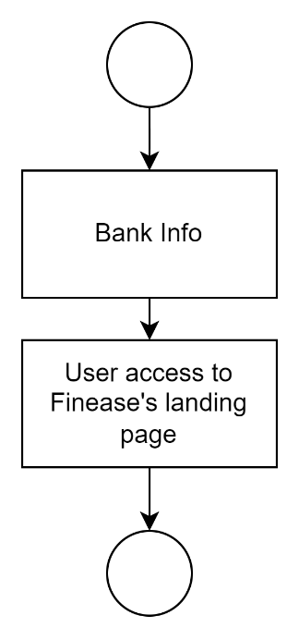

Figure 31: Activity Diagram for Bank Information

#### 4.2.2.2 Register

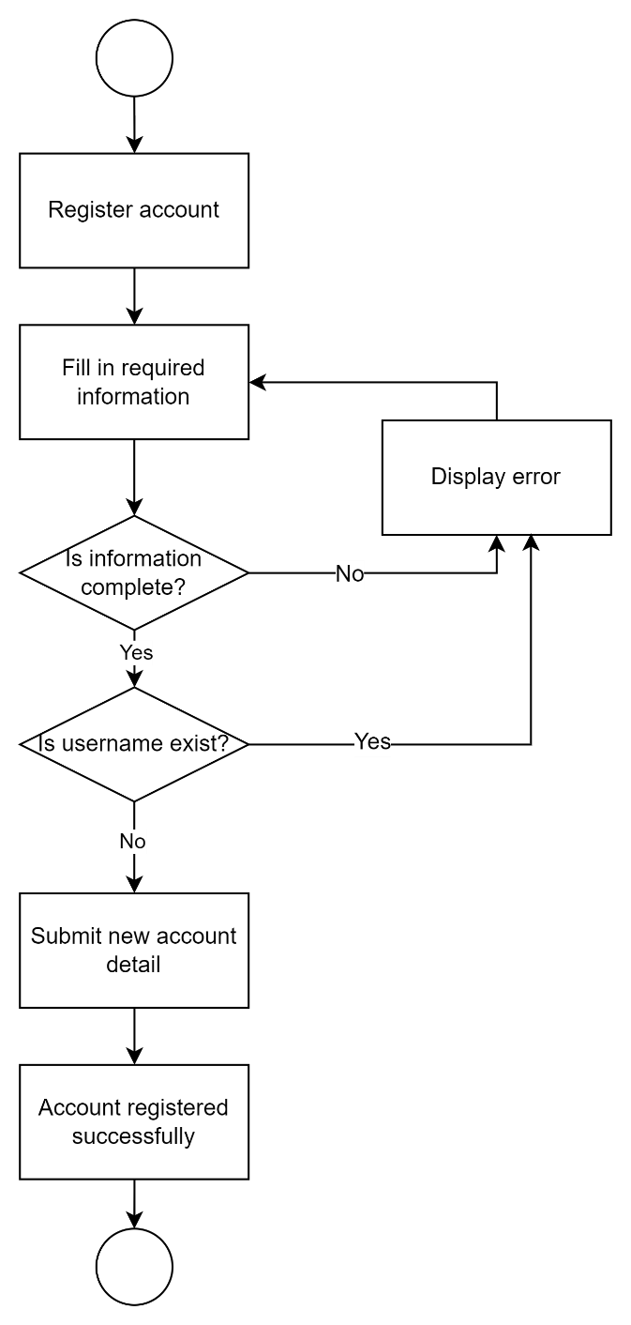

Figure 32: Activity Diagram for Register

#### 4.2.2.3 Login

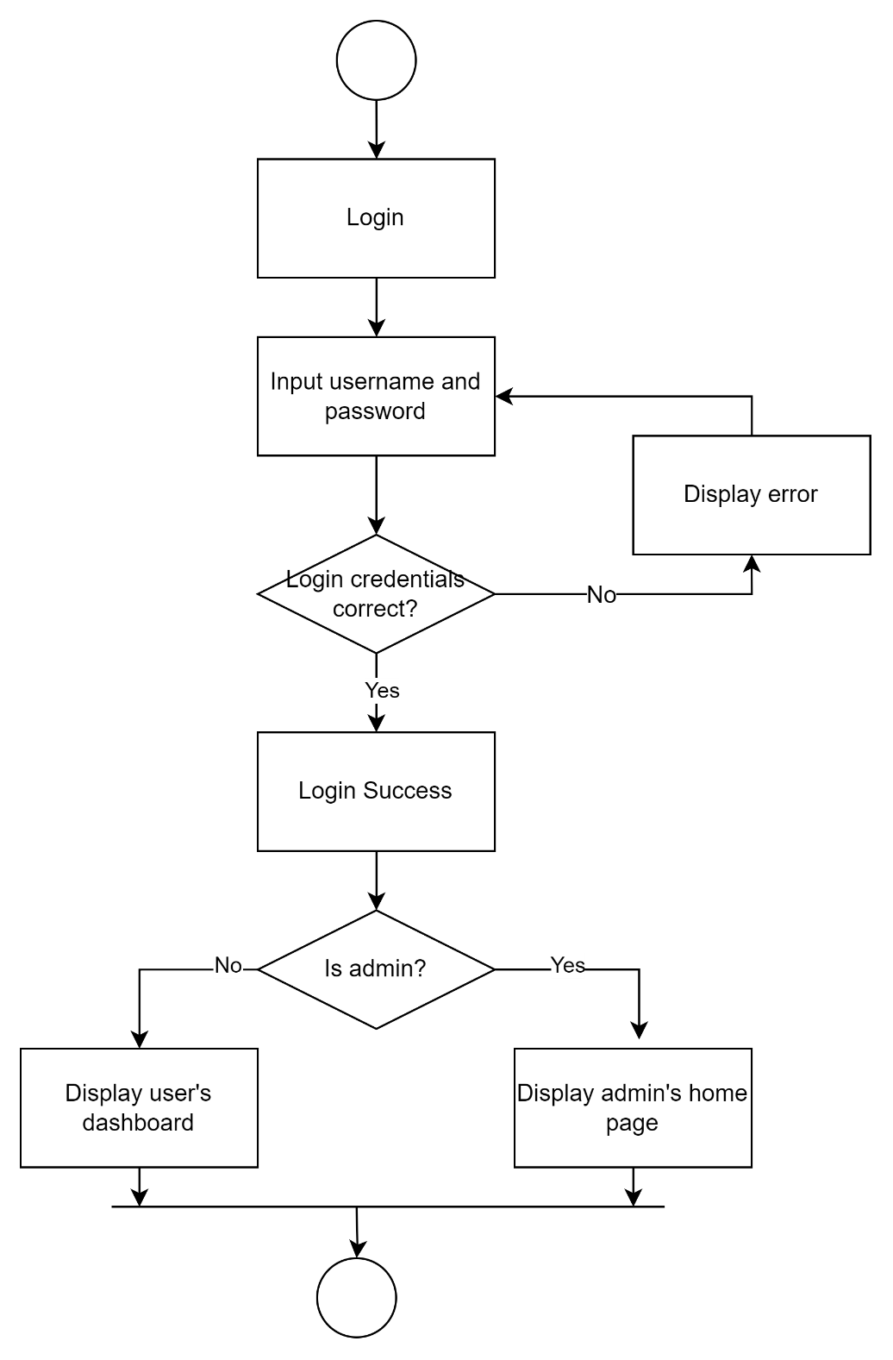

Figure 33: Activity Diagram for Login

#### 4.2.2.4 Logout

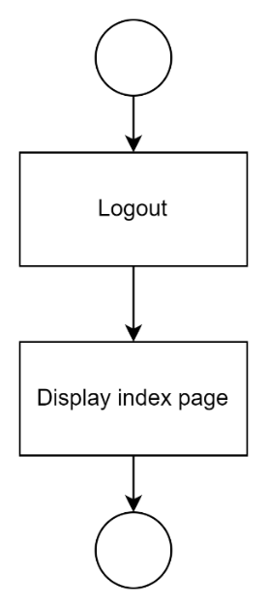

Figure 34: Activity Diagram for Logout

#### 4.2.2.5 Screen Reader

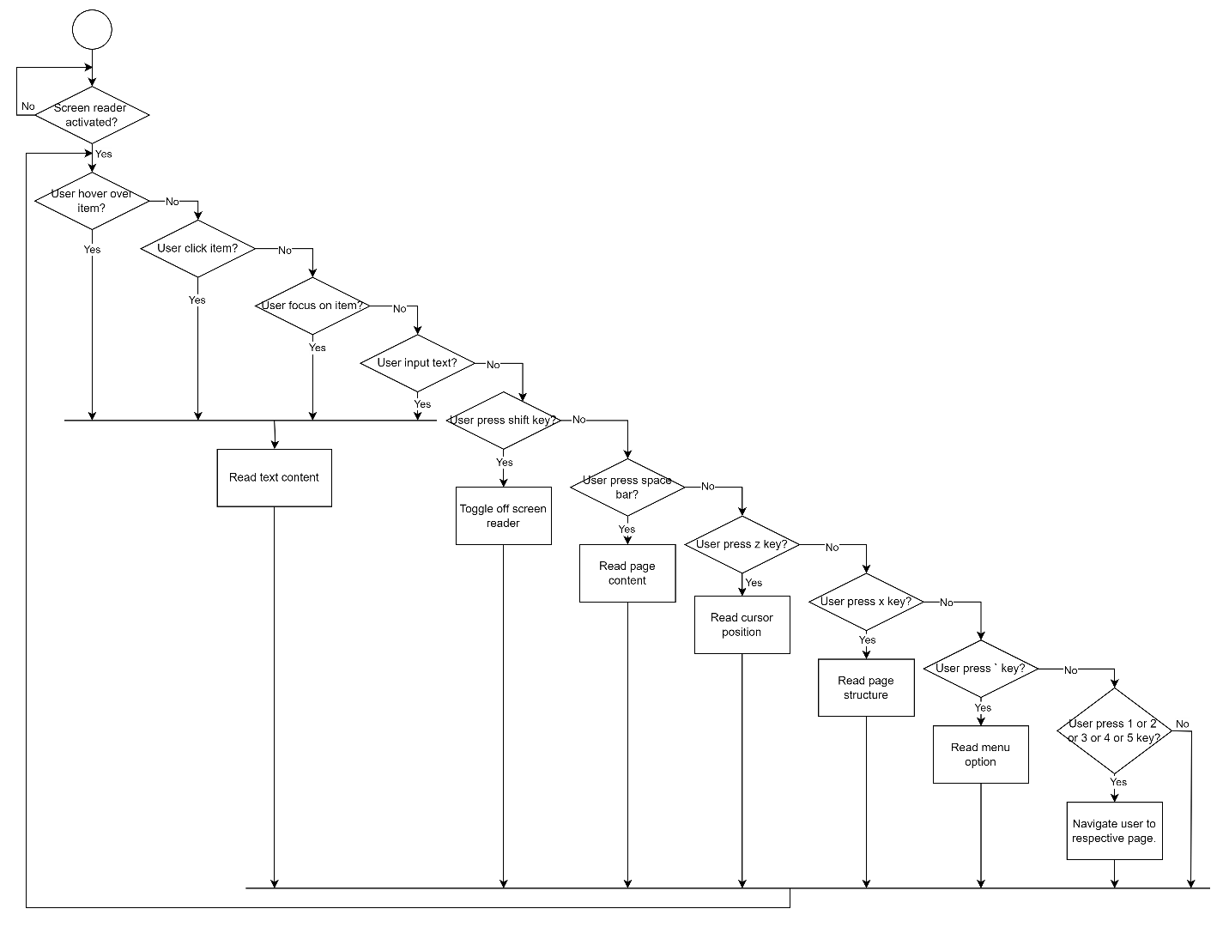

Figure 35: Activity Diagram for Screen Reader

#### 4.2.2.6 Update Profile

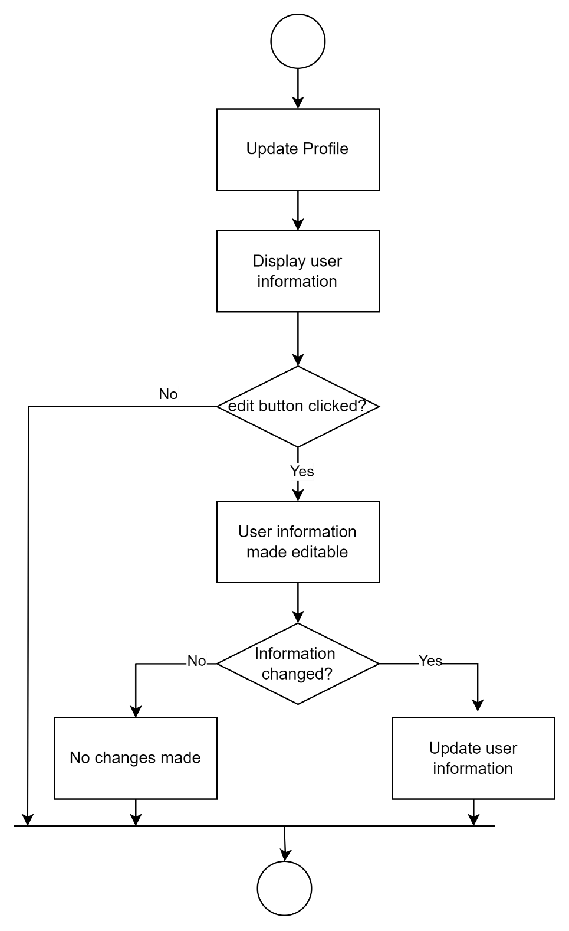

Figure 36: Activity Diagram for Update Profile

#### 4.2.2.7 Dashboard

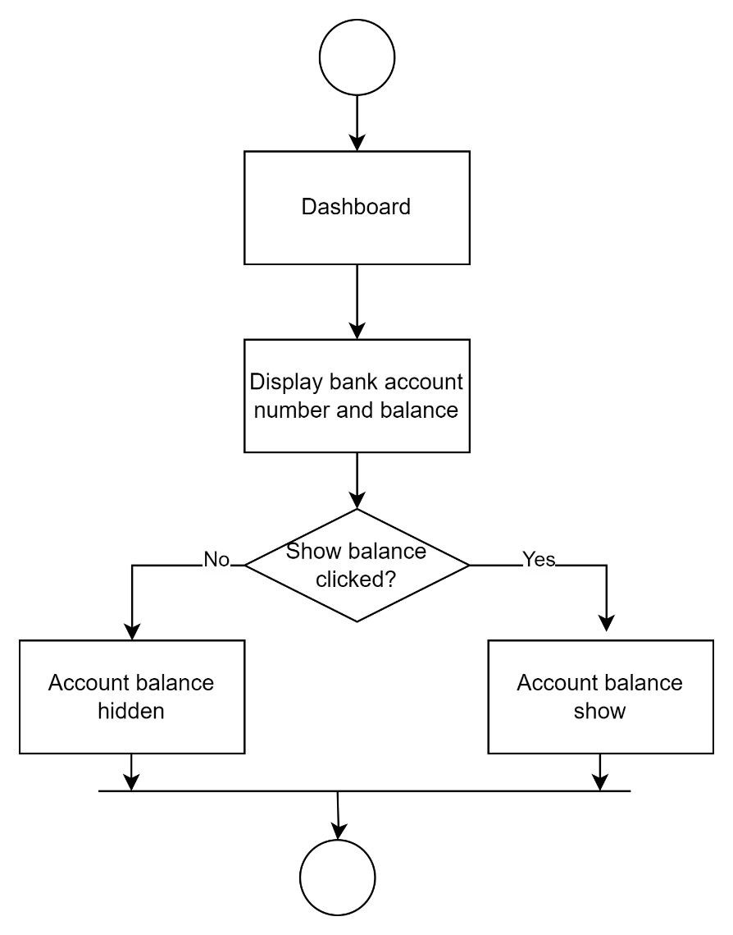

Figure 37: Activity Diagram for Dashboard

#### 4.2.2.8 Deposit

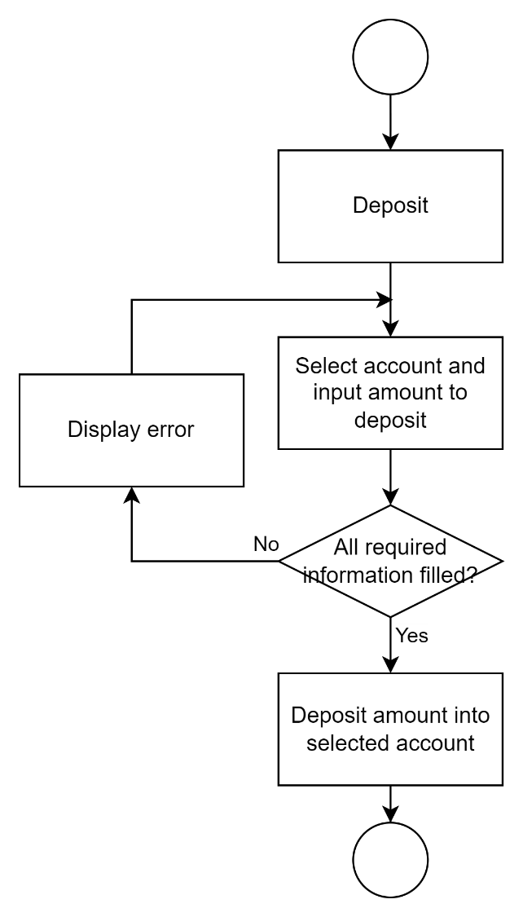

Figure 38: Activity Diagram for Deposit

#### 4.2.2.9 Withdraw

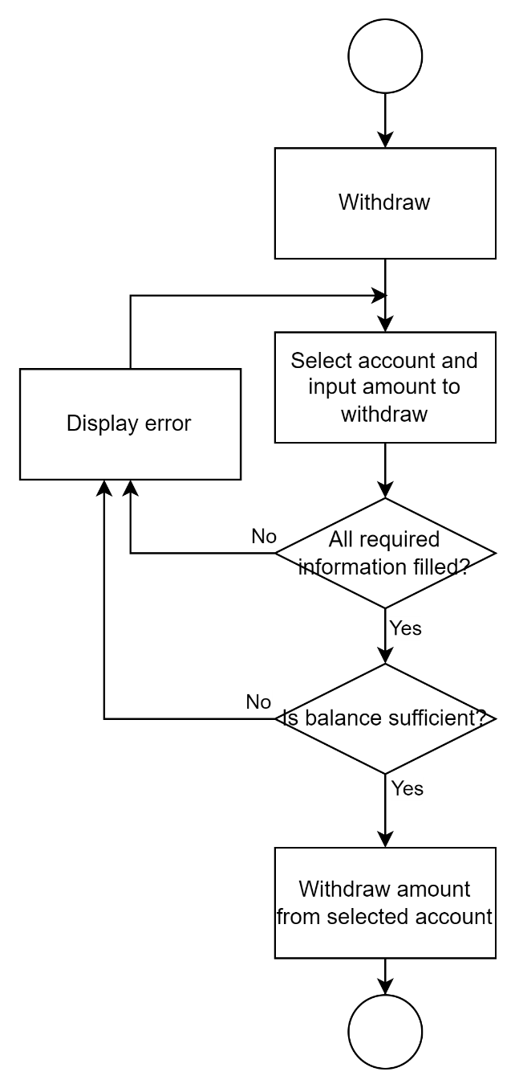

Figure 39: Activity Diagram for Withdraw

#### 4.2.2.10 Transfer Fund

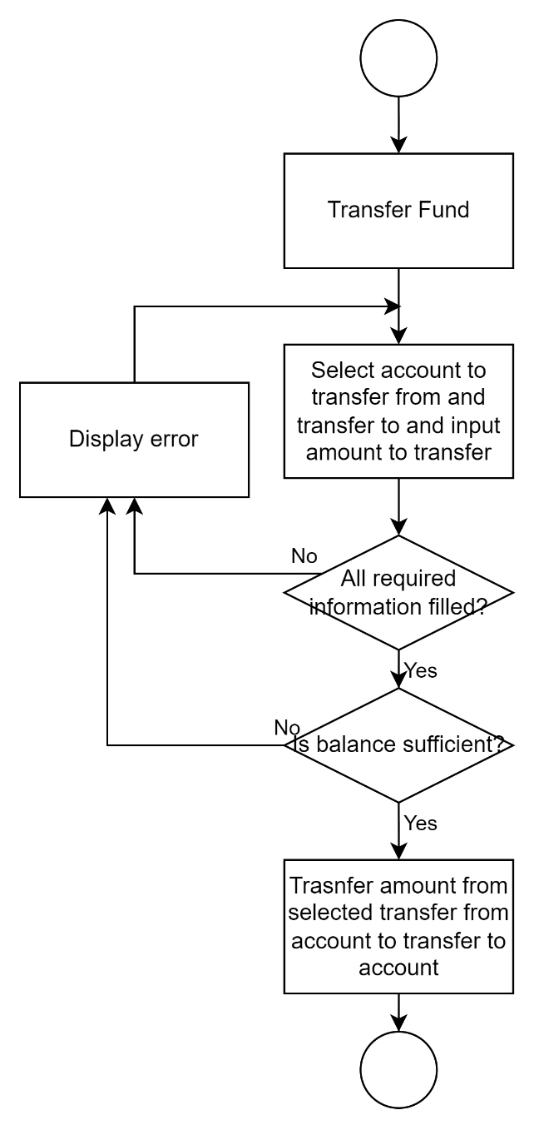

Figure 40: Activity Diagram for Transfer Fund

#### 4.2.2.11 Transaction History

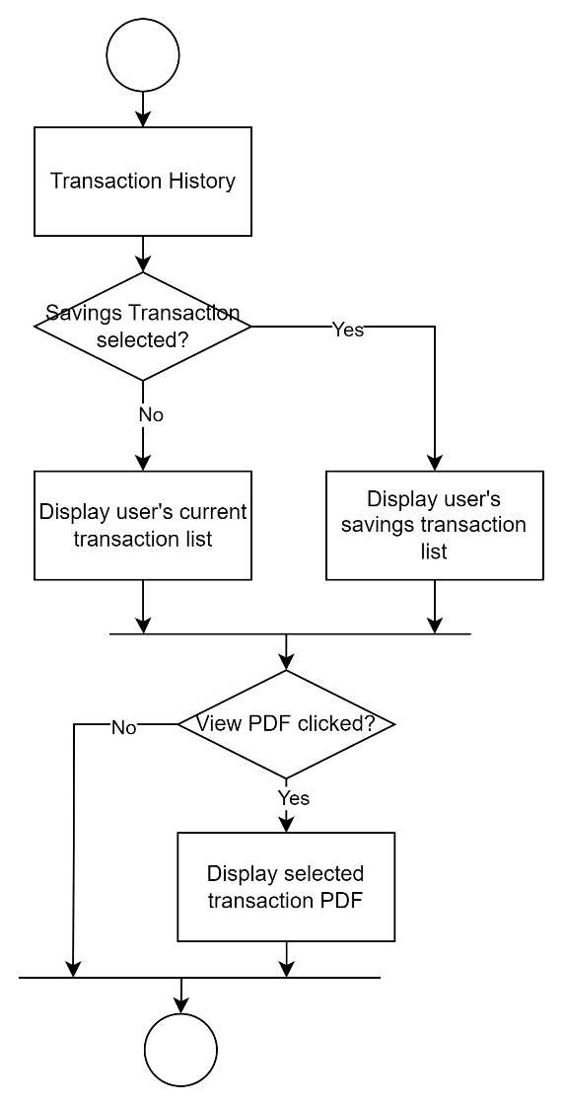

Figure 41: Activity Diagram for Transaction History

#### 4.2.2.12 Manage User

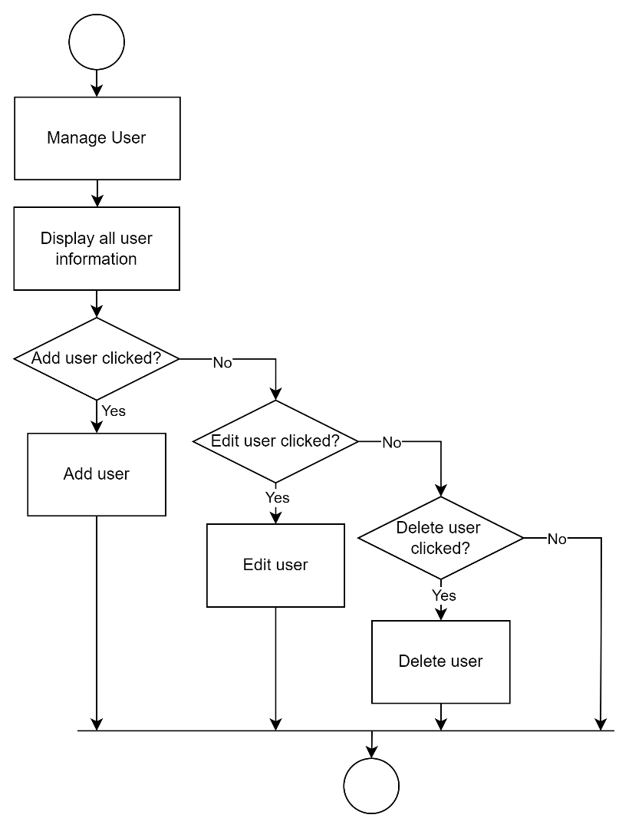

Figure 42: Activity Diagram for Manage User

#### 4.2.2.13 Add User

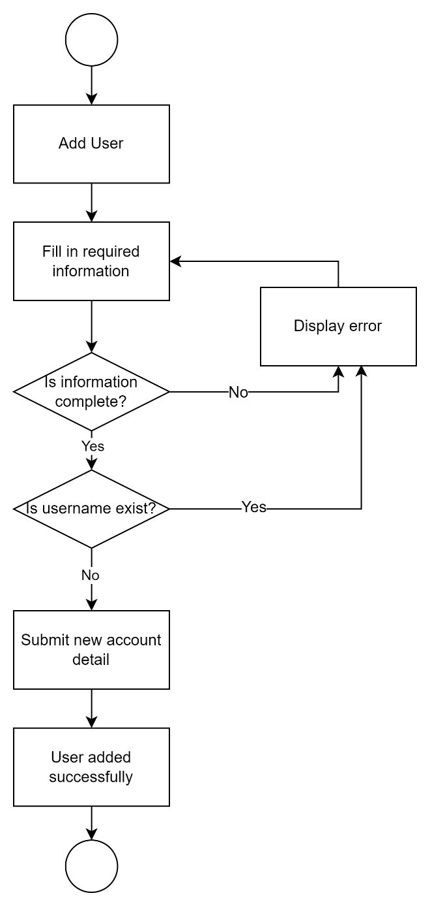

Figure 43: Activity Diagram for Add User

#### 4.2.2.14 Edit User

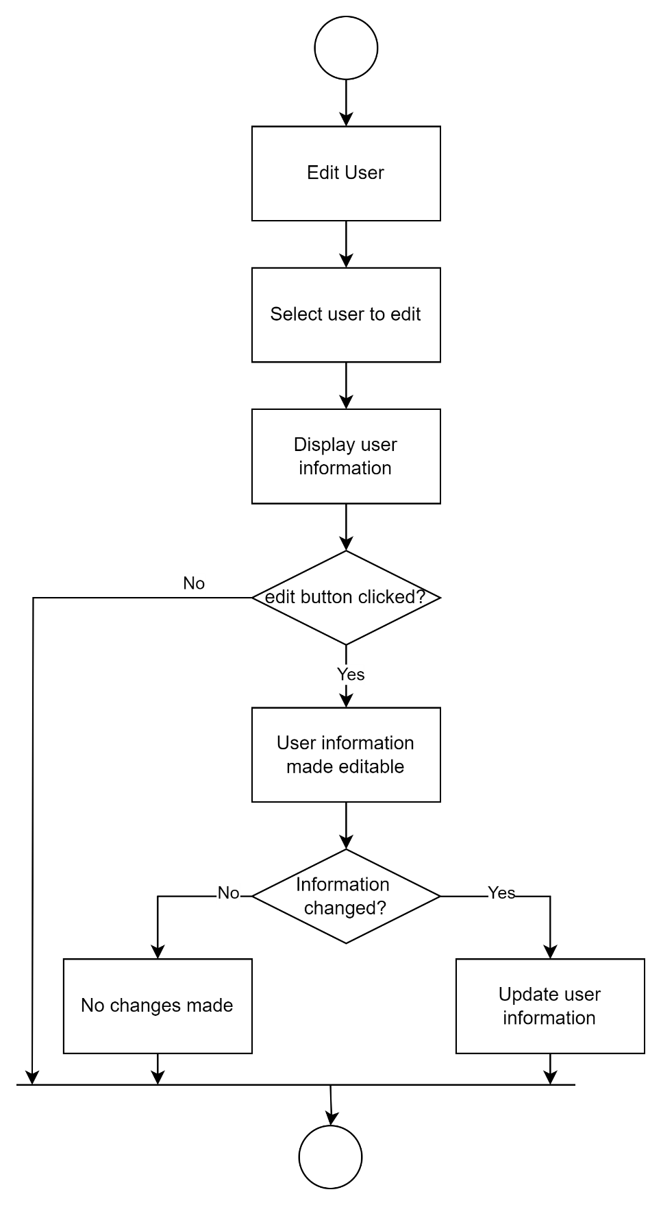

Figure 44: Activity Diagram for Edit User

#### 4.2.2.15 Delete User

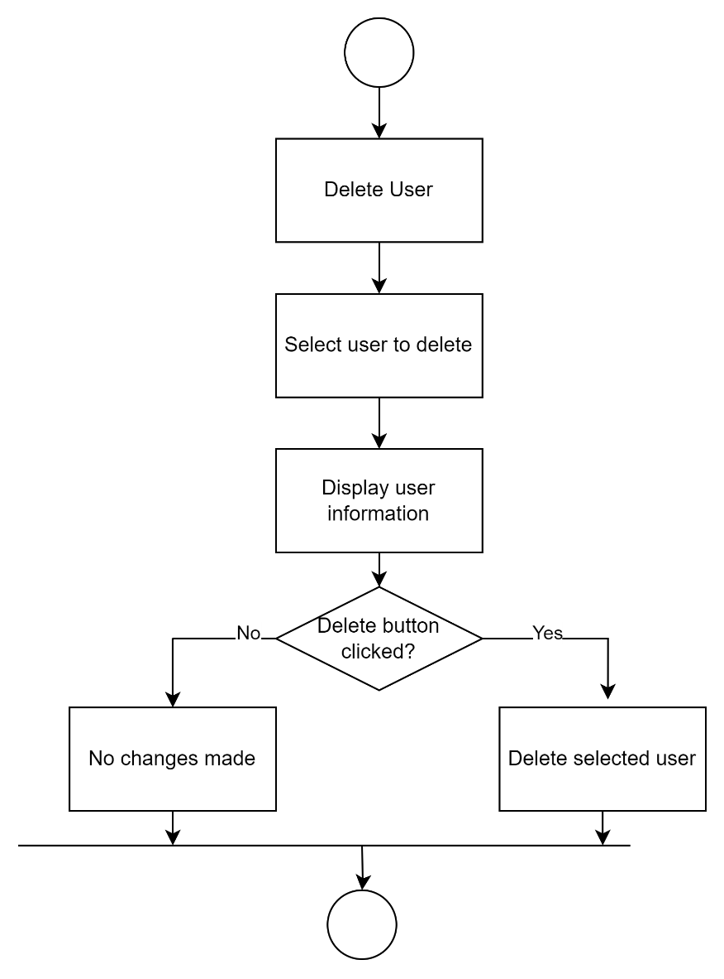

Figure 45: Activity Diagram for Delete User

#### 4.2.2.16 Manage Bank Accounts

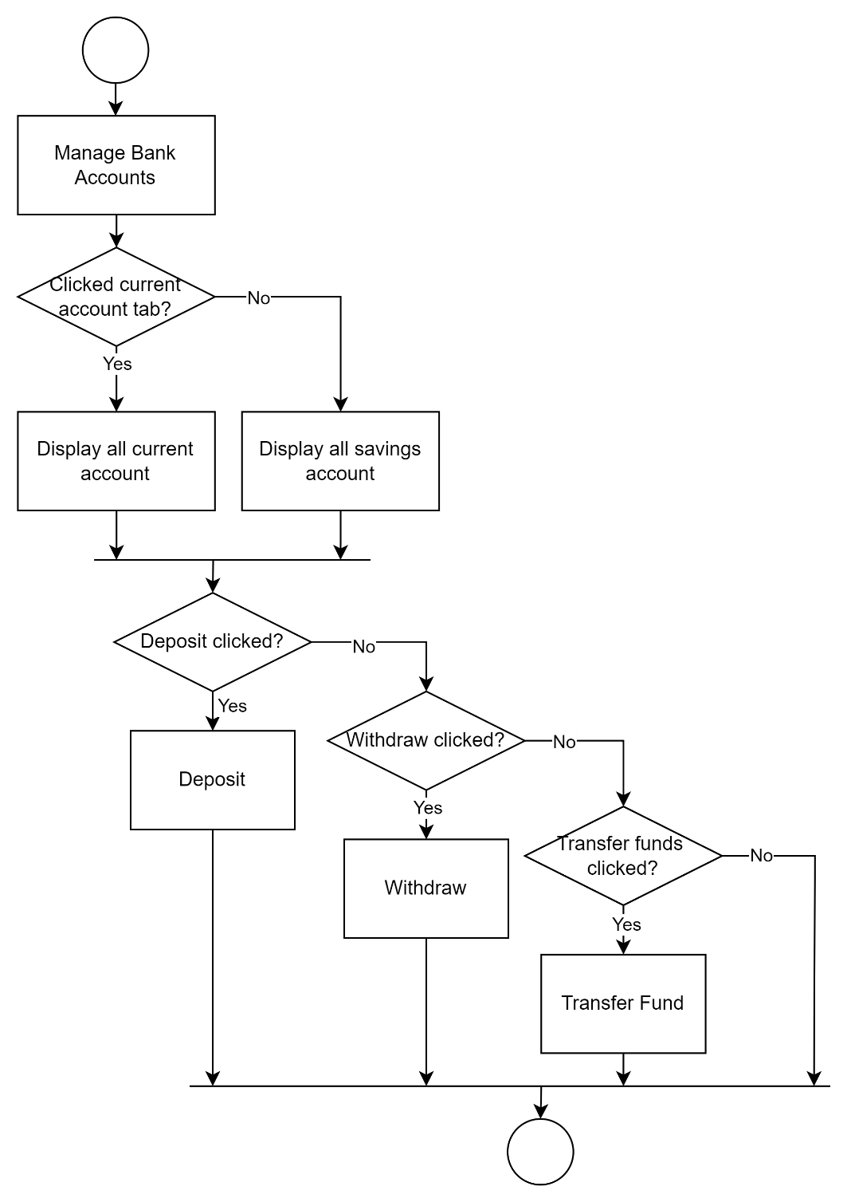

Figure 46: Activity Diagram for Manage Bank Accounts

#### 4.2.2.17 Activity Log

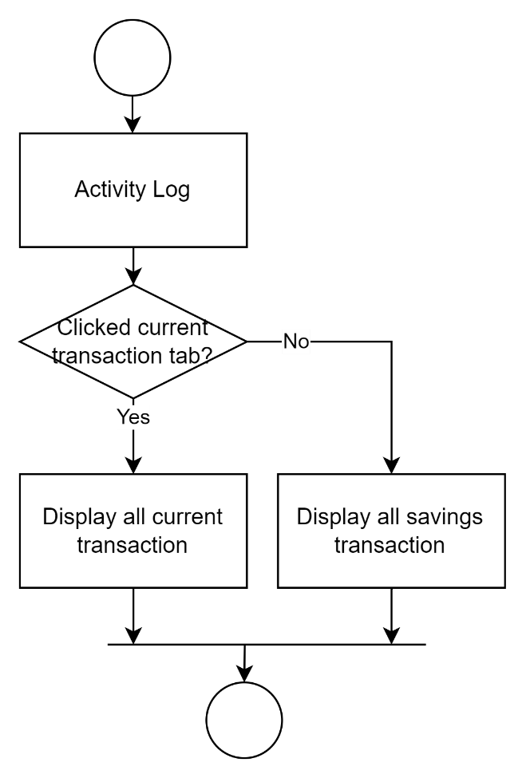

Figure 47: Activity Diagram for Activity Log

#### 4.2.2.18 System Report

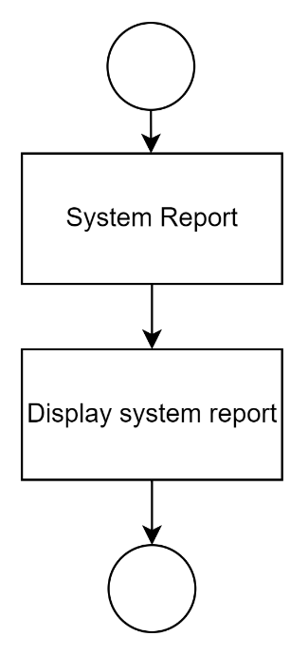

Figure 48: Activity Diagram for System Report

### 4.2.3 Class Diagram

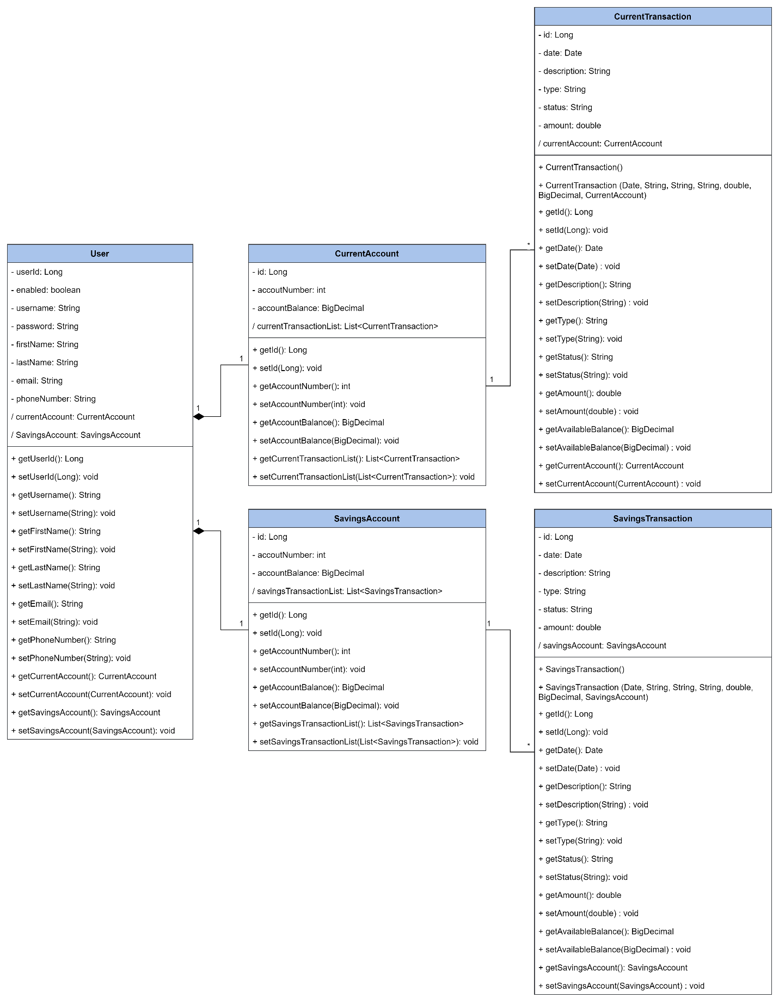

Figure 49: Finease's Class Diagram

The class diagram depicts the connections and utilization of Java classes in the context of a banking system. The User class embodies individual users' details, including their username, password, and contact information. Each user is linked to both SavingsAccount and a CurrentAccount through their respective classes—SavingsAccount and CurrentAccount—which store account numbers and balances. Additionally, each type of account is associated with corresponding transaction classes: SavingsTransaction and CurrentTransaction. These transaction classes contain specifics about financial operations related to the accounts such as transaction dates, descriptions, amounts, and status. In summary, this diagram offers a comprehensive outline of how users, accounts, and transactions are organized within the backend model of the banking system, enabling effective administration and monitoring of financial activities.

### 4.2.4 System Architecture Diagram

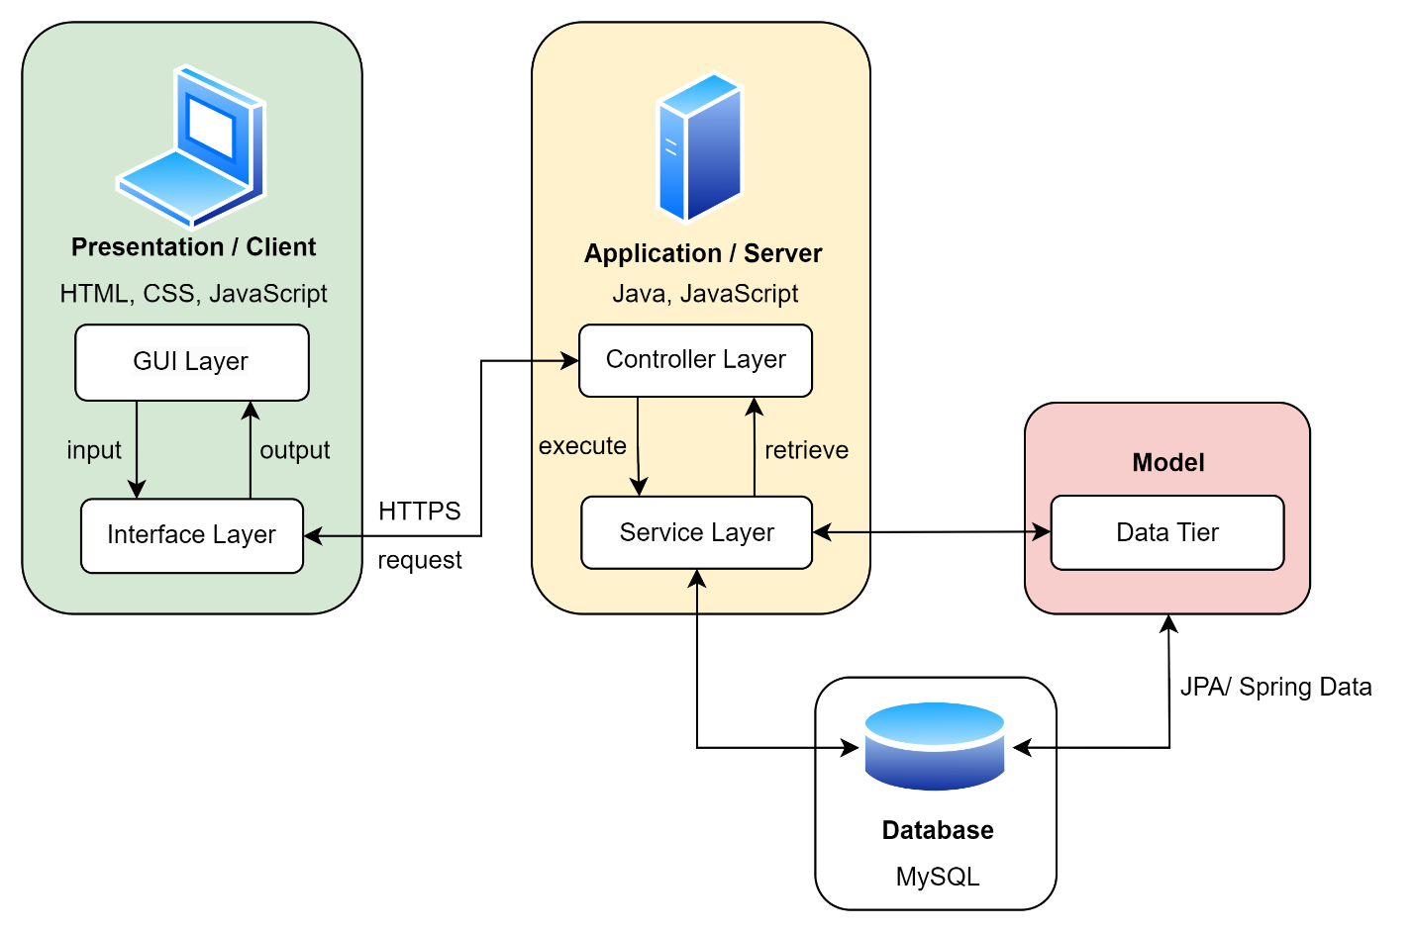

Figure 50: Finease's System Architecture Diagram

The system architecture of Finease is structured into three layers: Client, Server, and Model. The Client layer employs HTML, CSS, and JavaScript to handle user interface management as well as input and output interactions. These elements interact with the Server layer through HTTPS requests, which in turn utilizes Java and JavaScript components for application logic execution. Controllers manage user requests at this level while interfacing with the Service layer responsible for orchestrating operations across all layers including MySQL database interactions via the Model layer. Data storage and retrieval within the Model layer are efficiently managed using technologies like JPA or Spring Data. This architectural design ensures clear separation of concerns, scalability across banking functions secure communication via HTTPS protocol inclusion alongside streamlined data handling facilitated by MySQL integration.

## 4.3 Database Design

### 4.3.1 Entity-Relationship Diagram

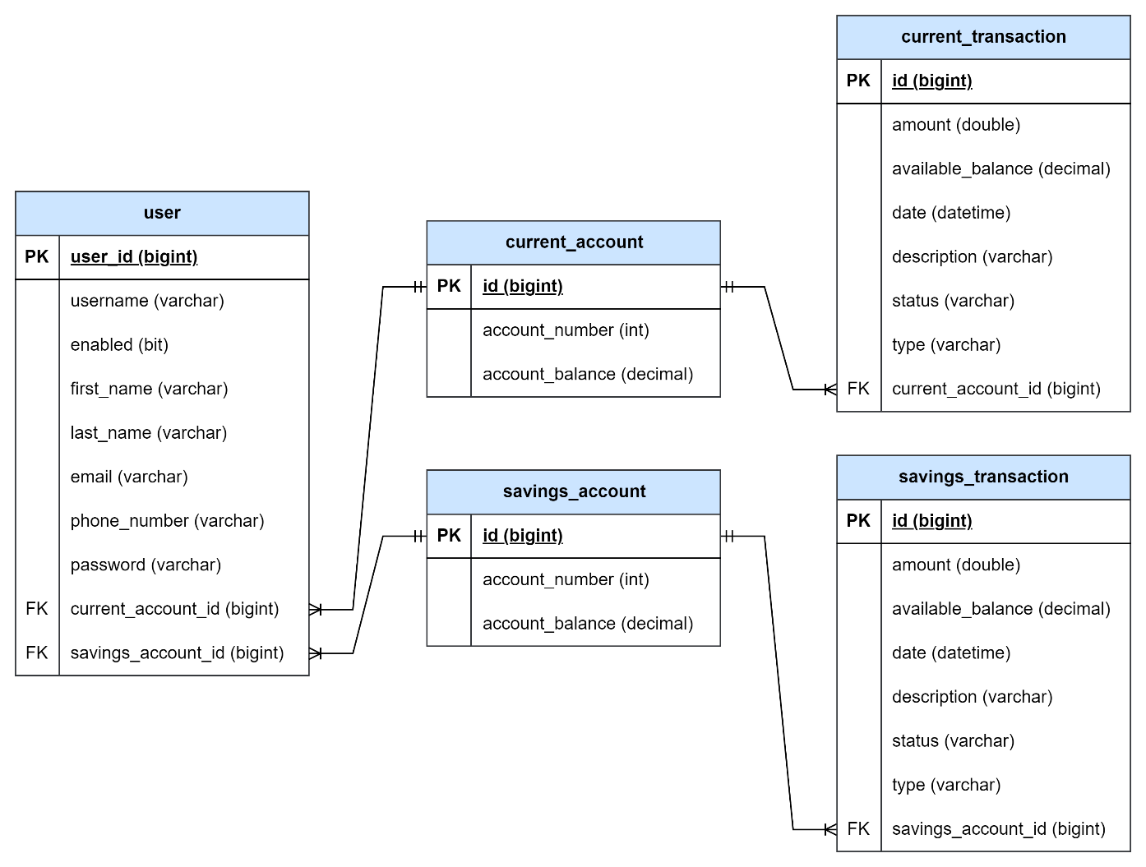

Figure 51: Finease's Entity-Relationship Diagram

The Entity-Relationship Diagram displays the connections between entities and their characteristics. At the center of the system is the "User" entity, identified uniquely by its primary key (userId), which is used to identify each user. Each user can be linked to a maximum of one "CurrentAccount" and one "SavingsAccount," both with their own primary key (id) for distinct identification of accounts. Moreover, in the "SavingsTransaction" entity, there exists a foreign key (savingsAccount_id) that points to the primary key of the related savings account, establishing a one-to-many relationship between savings accounts and transactions. Similarly, within the "CurrentTransaction" entity, there is a foreign key (currentAccount_id) referencing the main identifier of connected current accounts, thus creating an analogous one-to-many relationship between current accounts and transactions. These paramount as well as subsidiary keys form associations among entities that facilitate effective data retrieval and management within the database structure of Finease.

### 4.3.2 Data Dictionary

Table 20: Data dictionary for Users Collection

|  |  |  |
| --- | --- | --- |
| **User Collection** | | |
| **Field Name** | **Field Type** | **Description** |
| user_id | BigInt | ID of the user |
| Email | String | Email of the user |
| Enabled | Boolean | Account status of the user |
| first_name | Varchar | First name of the user |
| last_name | Varchar | Last name of the user |
| Password | Varchar | Password of the user |
| phone_number | Varchar | Phone number of the user |
| username | Varchar | Username of the user |
| current_account_id | BigInt | Current account ID of the user |
| savings_account_id | BigInt | Savings account ID of the user |

Table 21: Data dictionary for Savings Account Collection

|  |  |  |
| --- | --- | --- |
| **Savings Account Collection** | | |
| **Field Name** | **Field Type** | **Description** |
| id | BigInt | ID of the savings account |
| account_balance | Decimal | Account balance of the savings account |
| account_number | Int | Account number of the savings account |

Table 22: Data dictionary for Savings Transaction Collection

|  |  |  |
| --- | --- | --- |
| **Savings Transaction Collection** | | |
| **Field Name** | **Field Type** | **Description** |
| id | BigInt | ID of the savings transaction |
| amount | Double | Amount of the savings transaction |
| available_balance | Decimal | Available balance of the savings account |
| date | Datetime | Date of the savings transaction |
| description | Varchar | Description of the savings transaction |
| status | Varchar | Status of the savings transaction |
| type | Varchar | Type of the savings transaction |
| savings_account_id | BigInt | Savings account ID of the user |

Table 23: Data dictionary for Current Account Collection

|  |  |  |
| --- | --- | --- |
| **Current Account Collection** | | |
| **Field Name** | **Field Type** | **Description** |
| id | BigInt | ID of the current account |
| account_balance | Decimal | Account balance of the current account |
| account_number | Int | Account number of the current account |

Table 24: Data dictionary for Current Transaction Collection

|  |  |  |
| --- | --- | --- |
| **Current Transaction Collection** | | |
| **Field Name** | **Field Type** | **Description** |
| id | BigInt | ID of the current transaction |
| amount | Double | Amount of the current transaction |
| available_balance | Decimal | Available balance of the current account |
| date | Datetime | Date of the current transaction |
| description | Varchar | Description of the current transaction |
| status | Varchar | Status of the current transaction |
| type | Varchar | Type of the current transaction |
| current_account_id | BigInt | Current account ID of the user |

## 4.4 Interface Design

Finease leverages the capabilities of Figma to simplify the process of interface design and development. Designers create a unified design system using reusable elements such as buttons and input fields. Developers can utilize these elements in Figma, simplifying the conversion of design into HTML and CSS. Figma's user-friendly interface enables developers to swiftly design UI components and produce well-structured code. This method simplifies the development process, empowering users to craft functioning and visually pleasing interfaces with minimal exertion.

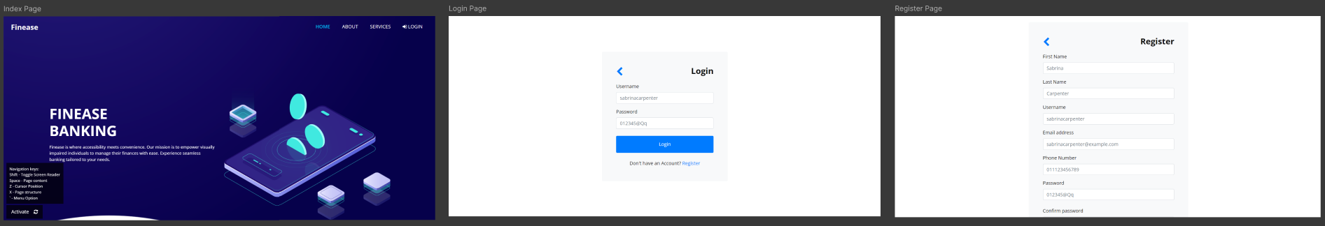

Figure 52: Finease's Home, Login and Register Page

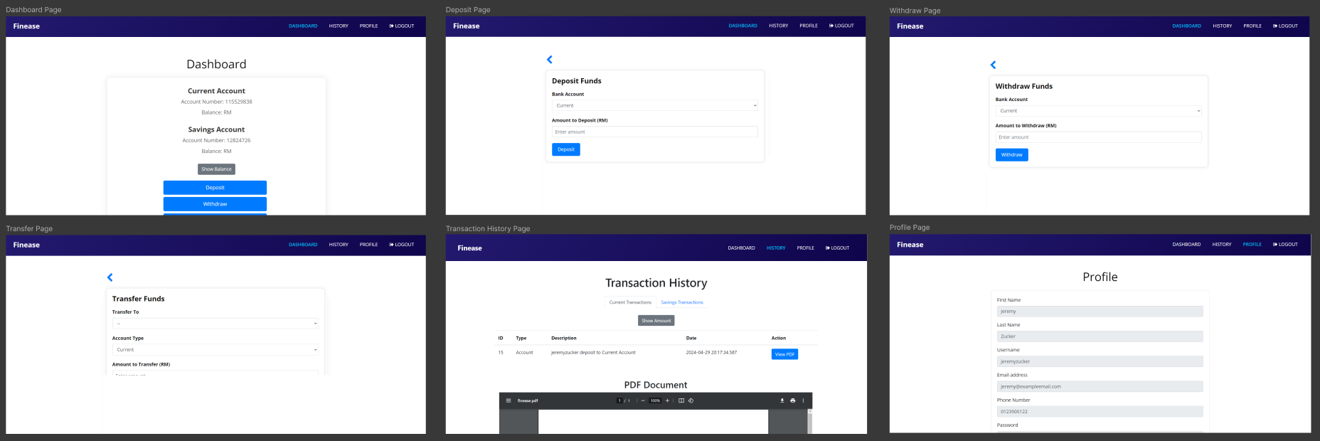

Figure 53: Finease's Customer Pages

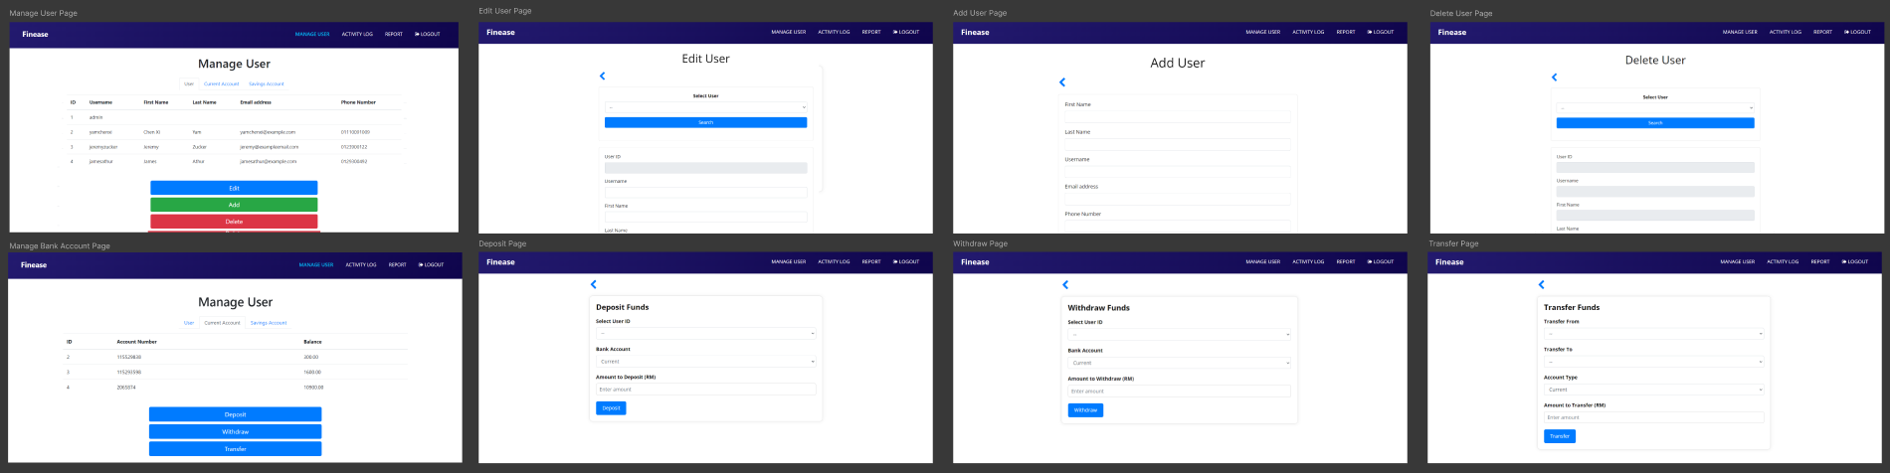

Figure 54: Finease's Admin Pages

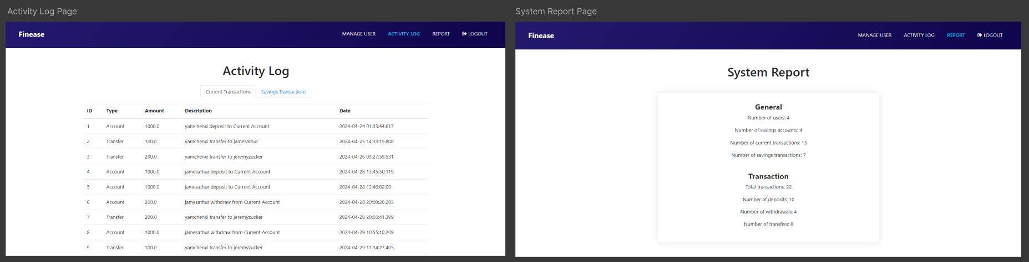

Figure 55: Finease's Admin Activity Log and System Report Page

## 4.5 Execution

The Finease project was initiated by setting up a Maven Spring Boot coding environment in Visual Studio Code. Once the project was initialized, a repository was created on GitHub and connected to the local project using Git commands for version control. Subsequently, the project's structure was established with its essential folders and files.

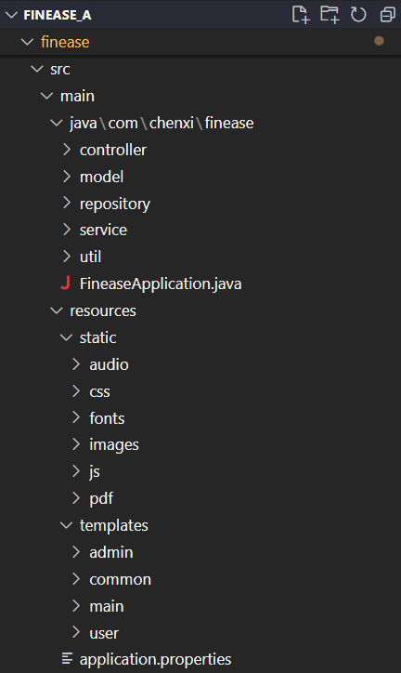

Figure 56: Screenshot of Finease’s project directory

The developer begins by creating the front-end portion through HTML and CSS, as well as leveraging Thymeleaf, a Java template engine for transmitting values. User accessibility is prioritized during the coding of the user interfaces, with interactive elements designed to be large and easily accessible. Once the HTML templates are completed, JavaScript is employed to enhance page interactivity.

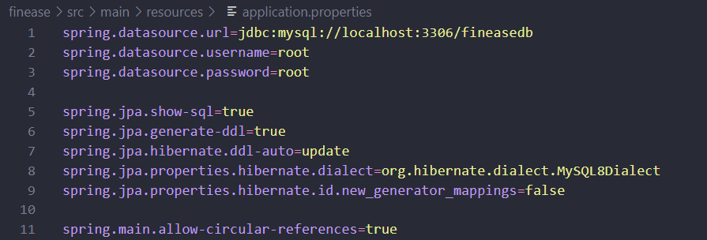

Figure 57: Screenshot of application properties code

Upon startup, Spring Boot automatically sets up the database connection using configuration settings in the application.properties file to connect with MySQL. It uses JPA for managing entities and their mappings to database tables, while Hibernate takes care of schema generation and updates. During runtime, the application interacts with MySQL by executing CRUD operations according to business requirements. Logging SQL statements helps in debugging, and transactions are employed to maintain data consistency.

Following the database in Spring Boot, the developer creates entity models that correspond to database tables and repositories for handling database tasks. Entity models use JPA annotations to map Java classes to database tables, specifying fields, connections, and restrictions. Repositories are interfaces that extend JpaRepository and offer methods for Create, Read, Update, and Delete operations on entities while hiding SQL queries. These elements optimize interactions with the database by guaranteeing data consistency and making it easier to access information within the application.

After setting up the entity models and repositories, the developer moves on to implementing the controller and services. Controllers are responsible for defining endpoint mappings that specify URL paths and HTTP methods to handle incoming requests. Inside controllers, developers use annotations like @GetMapping and @PostMapping to associate HTTP requests with specific methods. These methods then call corresponding service methods to execute business logic and interact with the database. Services encapsulate the application's core logic by coordinating interactions between controllers and repositories. This separation of concerns promotes modularity and facilitates maintainability. The endpoint mappings in controllers’ direct requests to appropriate service methods, ensuring smooth execution of operations.

Finally, the developer incorporates JavaScript code with Web Speech API to facilitate the text-to-speech function, enhancing user engagement through auditory responses. This JavaScript code captures user interactions with the interface, like clicking buttons or submitting forms, and creates corresponding text-to-speech output. Moreover, keyboard navigation capability is included to enhance accessibility by enabling users to navigate using keyboard shortcuts or tab keys. By integrating these functionalities, the application delivers a more comprehensive and user-centric experience that accommodates the needs of visually impaired users.

## 4.6 Screenshot of the completed system – Finease

### 4.6.1 User

#### 4.6.1.1 Home Page

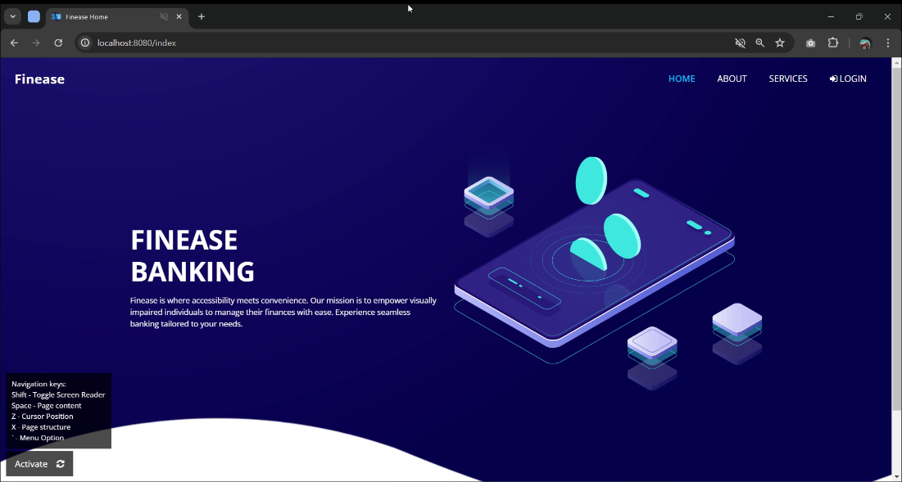

Figure 58: Screenshot of Finease’s Home Page

Upon accessing Finease’s website, the user is greeted with a home page where the user can access other pages without logging into the system. The bottom left corner of the website will constantly have an accessibility widget on, allowing convenient access to the screen reader. Whenever the user hover over the “Activate” button, it will reads “Press shift or click to activate screen reader”.

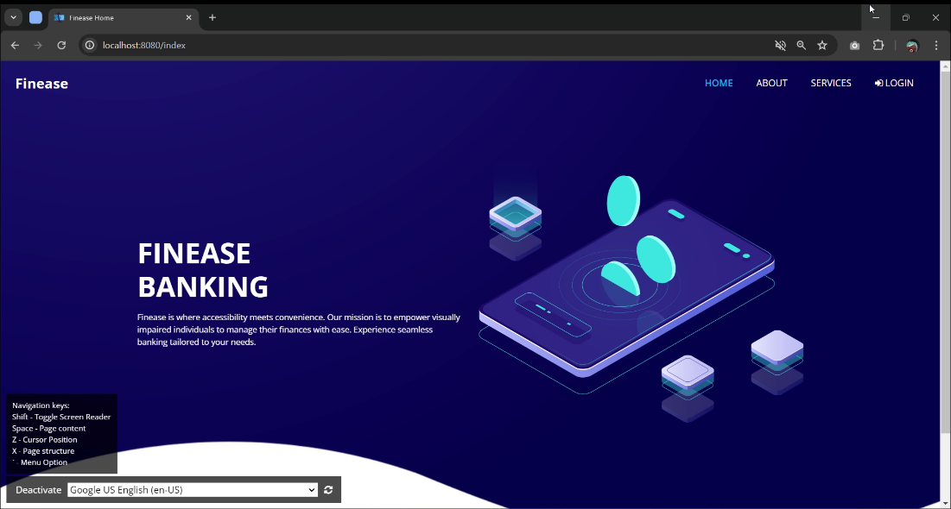

Figure 59: Screenshot of Finease’s Home Page, Activated Screen Reader

Once the user toggles the screen reader via the accessibility widget, it will read out “Screen reader activated”. Then, the user can begin using the navigation guide provided. Pressing the shift key will toggle the screen reader, the spacebar will read the page content, the Z key will indicate cursor position, the X key will read the page structure, and the backtick key (`) will access menu options. The menu options are designed to listen for user input from 1 to 5. On all pages, pressing the number 1 key will act as the back button, while numbers 2 through 5 correspond to navigation bar options. When the user navigates to other pages, the system will emit a “pop” noise as feedback to indicate the page change. With the screen reader activated, any interaction with text elements, interactive elements or images with alternative text will read out the content.

#### 4.6.1.2 About Page

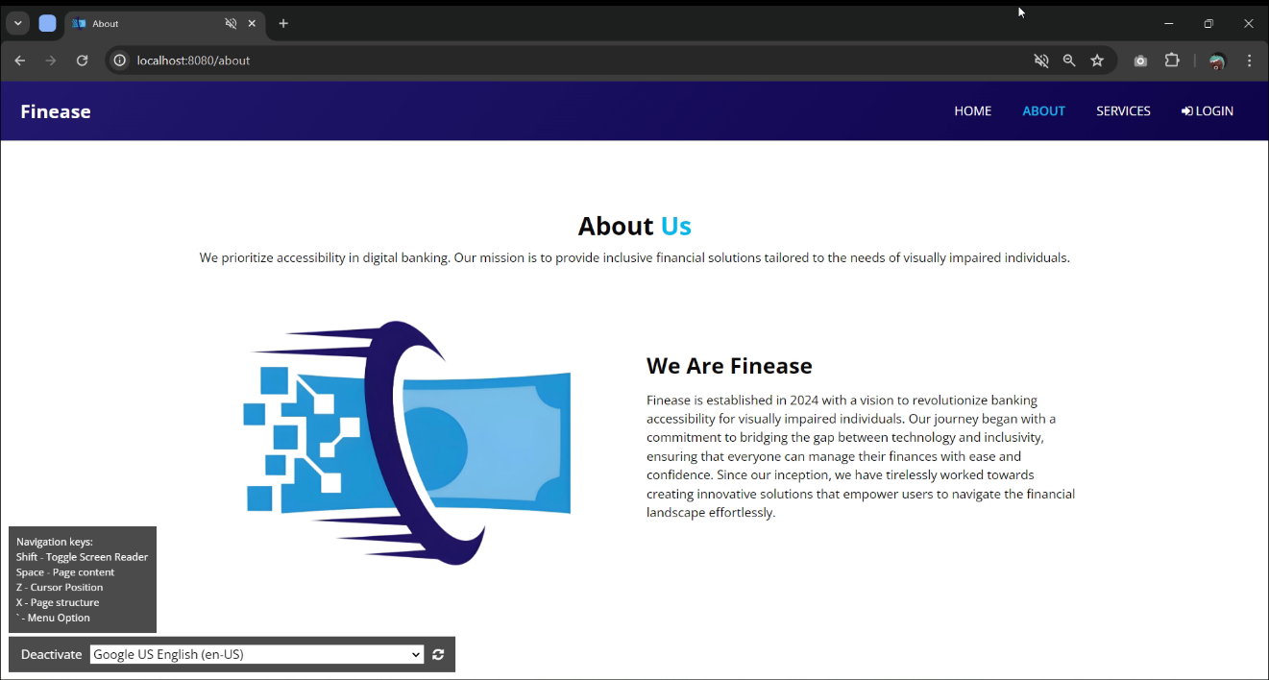

Figure 60: Screenshot of Finease’s About Page

On the about us page, it consists of comprehensive details about Finease's establishment, as well as its vision and mission.

#### 4.6.1.3 Services Page

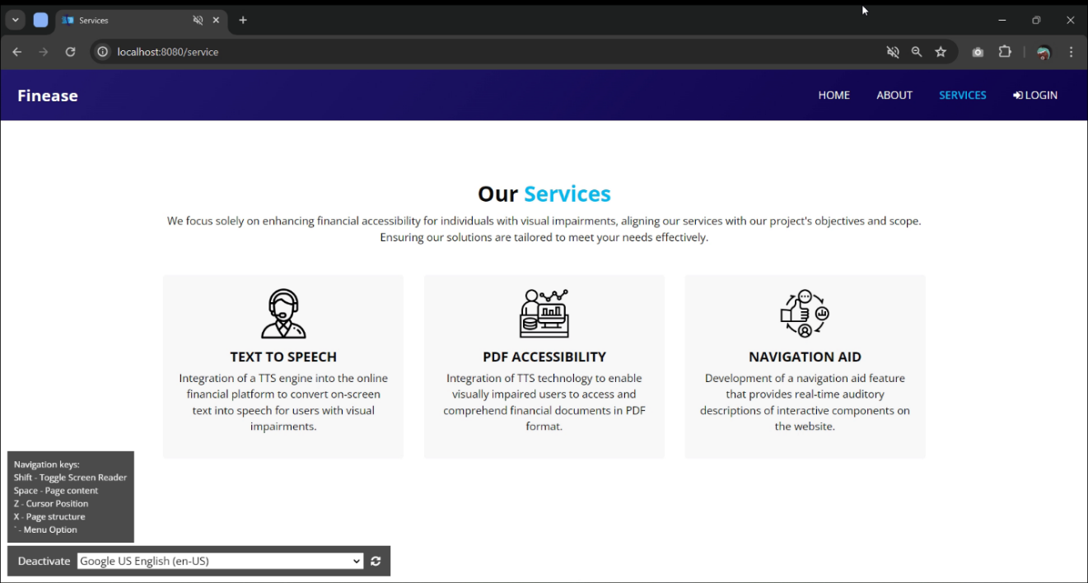

Figure 61: Screenshot of Finease’s Services Page

On the services page, it offers a detailed overview of the various services provided by Finease.

#### 4.6.1.4 Login Page

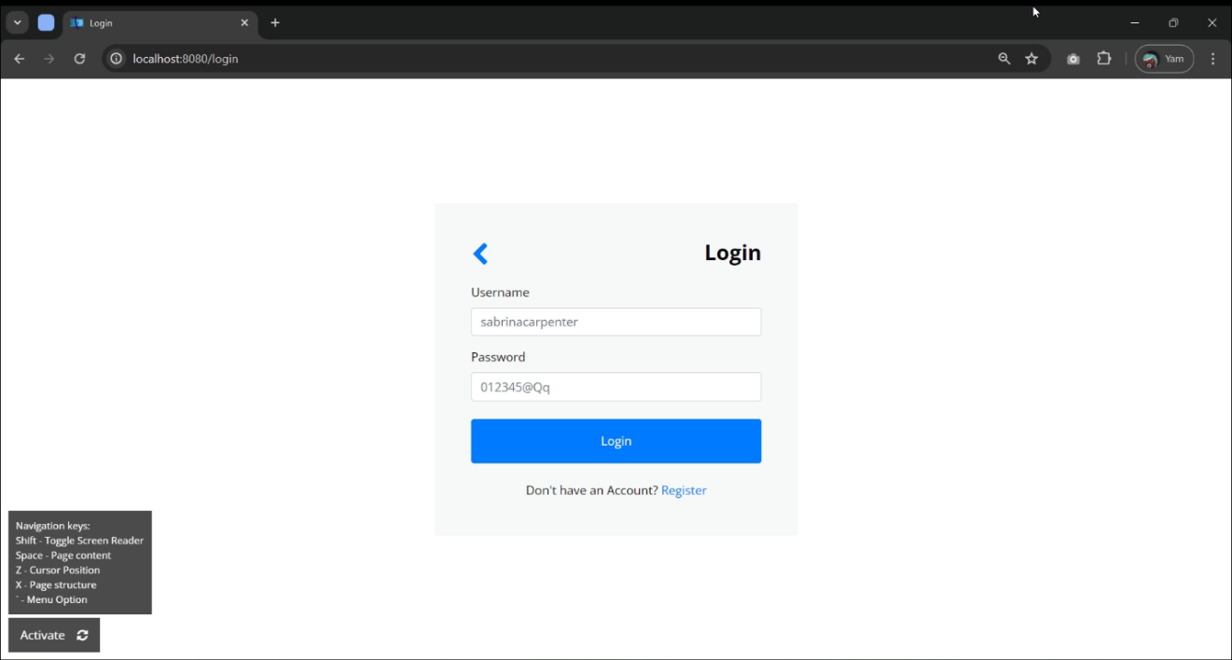

Figure 62: Screenshot of Finease’s Login Page

On the login page, the user is required to register an account before they login to the system. The user with an existing account can input username and password to login to Finease.

#### 4.6.1.5 Register Page

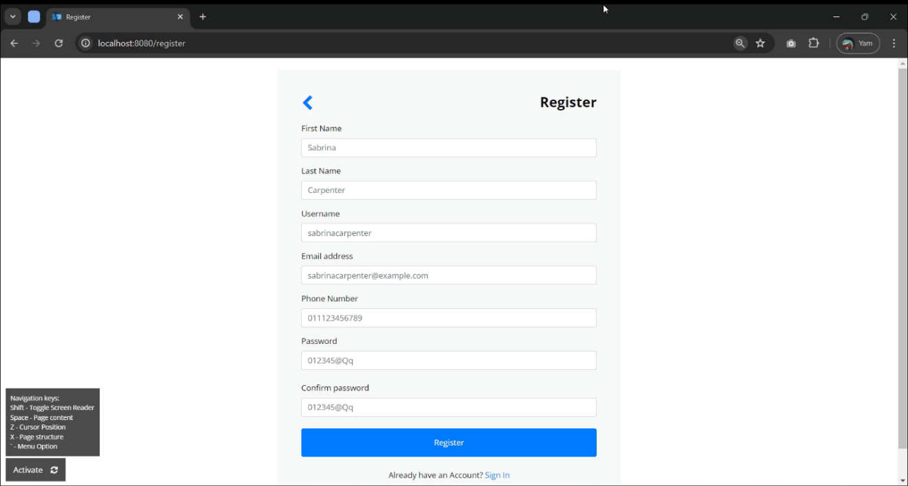

Figure 63: Screenshot of Finease’s Register Page

On the registration page, the user is required to fill in all the personal information including first name, last name, username, email address, phone number, password and confirm password. If the user input username or email address that is already exist in the database, it will prompt error and speak “Input invalid, please try again”. The password and confirm password field input must be the same, else it will also prompt error. Upon filling up the field with correct information, the user can click the register button to register account.

### 4.6.2 Customer

#### 4.6.2.1 Dashboard Page

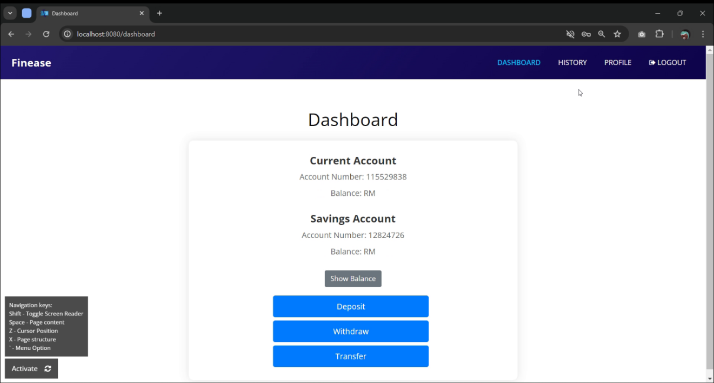

Figure 64: Screenshot of Finease’s Dashboard Page

Upon logging into Finease customer account, the user landed on dashboard page, where it displays the user bank account information such as account number and balance. The balance is hidden on default where the user has to click show balance button to allow balance to be unhide it. This ensures privacy of the user’s information. On dashboard page, the user is provided with deposit, withdraw and transfer button. By clicking any of the buttons, it will redirect the user to the respective page.

#### 4.6.2.2 Deposit

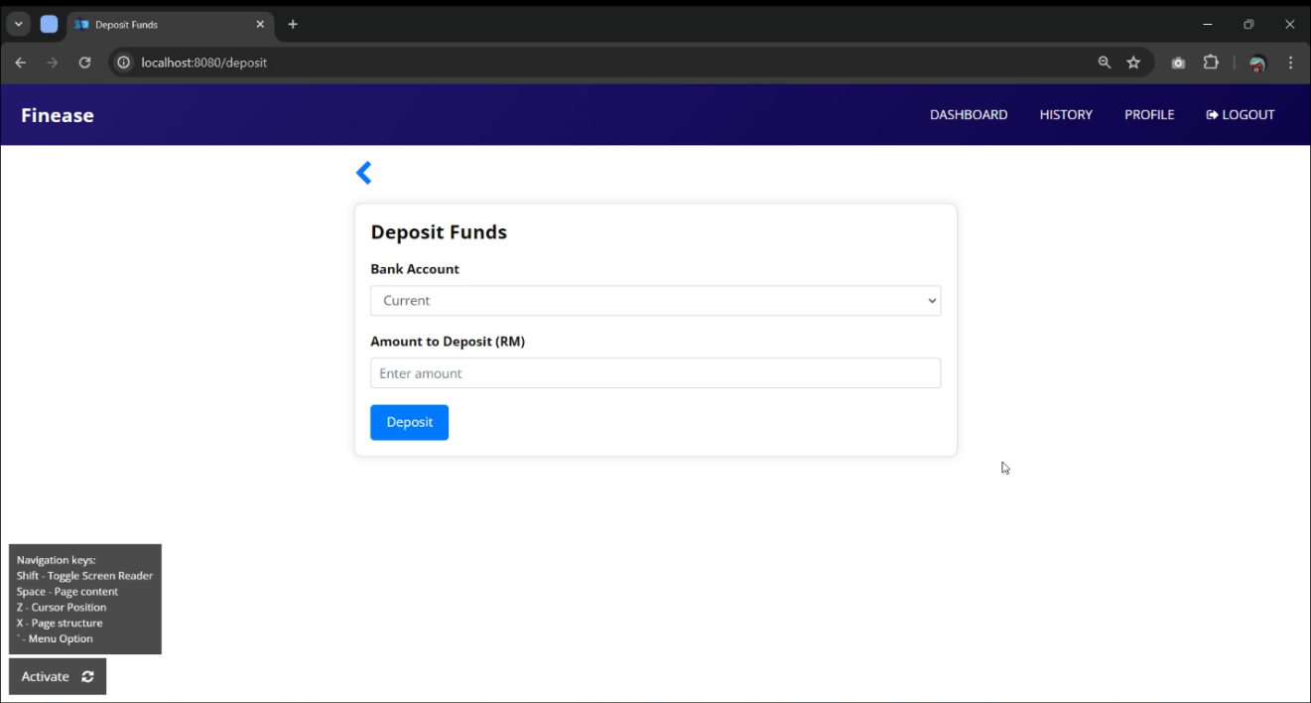

Figure 65: Screenshot of Finease’s Deposit Page

The deposit page allows the user to deposit funds to either their current account or savings account. The user is required to fill in a certain amount of deposit to complete the transaction. Once the transaction is completed, the system will prompt success “Transaction successful”.

#### 4.6.2.3 Withdraw

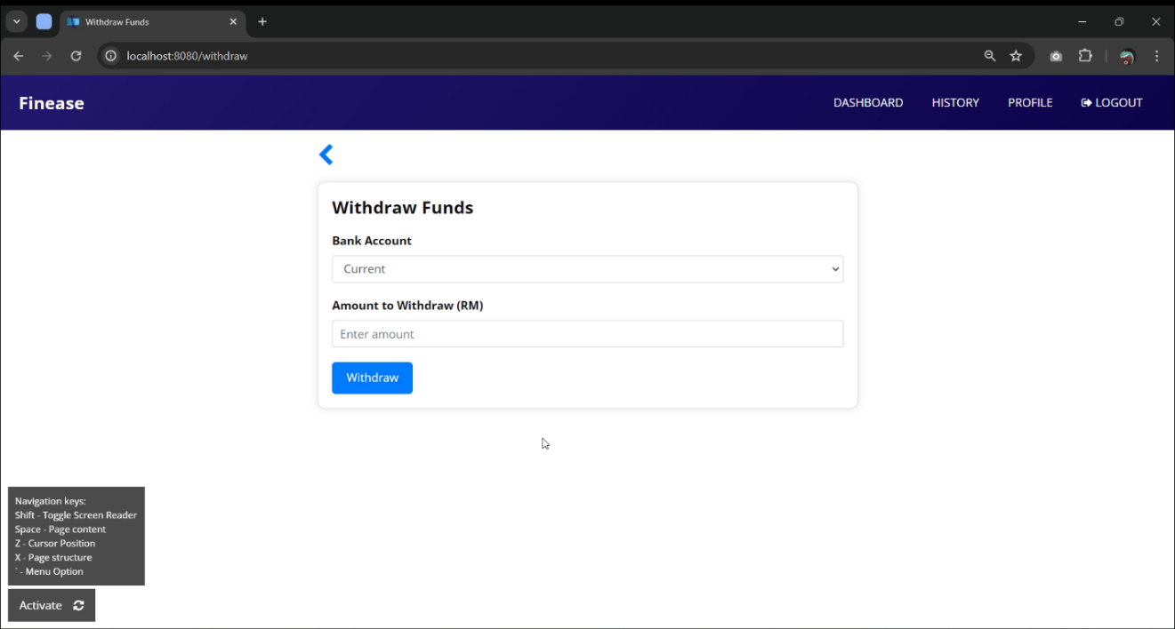

Figure 66: Screenshot of Finease’s Withdraw Page

The deposit page allows the user to withdraw funds from either their current account or savings account. The user is required to fill in a certain amount of withdrawal to complete the transaction. If the withdraw amount exceeds the balance that is in the selected account, the transaction will fail and prompting error “Insufficient balance, please try again”. Once the transaction is completed, the system will prompt success “Transaction successful”.

#### 4.6.2.4 Transfer

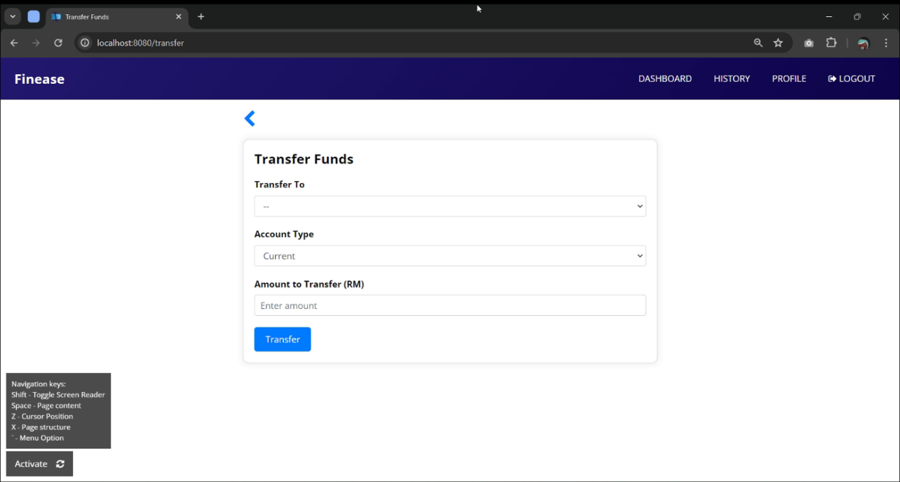

Figure 67: Screenshot of Finease’s Transfer Page

The deposit page allows the user to transfer funds from either their current account or savings account to another user. The user is required to select transfer to user, account to transfer from and fill in the amount to transfer. If the transfer amount exceeds the balance that is in the selected account, the transaction will fail and prompting error “Insufficient balance, please try again”. Once the transaction is completed, the system will prompt success “Transaction successful”.

#### 4.6.2.5 Transaction History

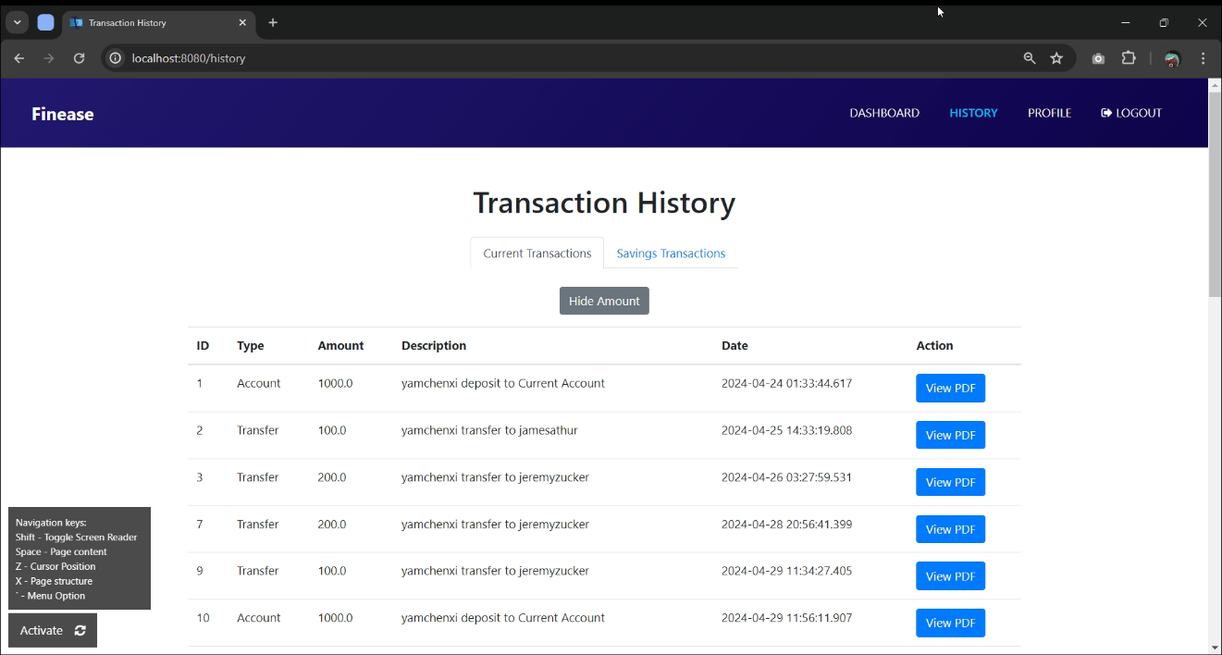

Figure 68: Screenshot of Finease’s Transaction History Page

In the transaction history page, it shows all the transactions made by the user. Upon landing, the transaction amount is hidden and can be toggled to show amount or hide amount. Each transaction will have a generated PDF linked with “View PDF” button.

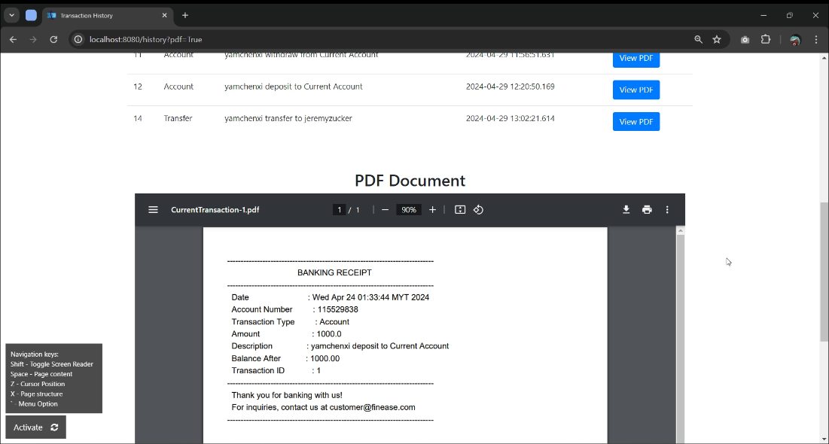

Figure 69: Screenshot of Finease’s Transaction History Page’s embed PDF view

Once the user clicked “View PDF” button of the selected transaction, the system will show the PDF below the page. If the screen reader is activated, the user can hover over the embed PDF viewer and it will read out the PDF content.

#### 4.6.2.6 Profile Page

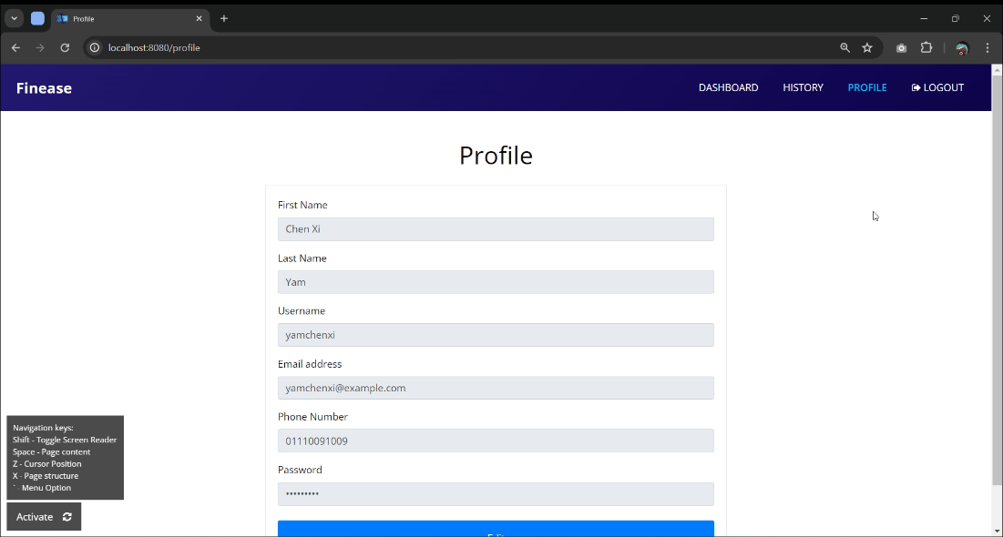

Figure 70: Screenshot of Finease’s Profile Page

On the profile page, the user can view their personal information that has been saved in the database. The user is not allowed to edit their information until “edit” button is clicked.

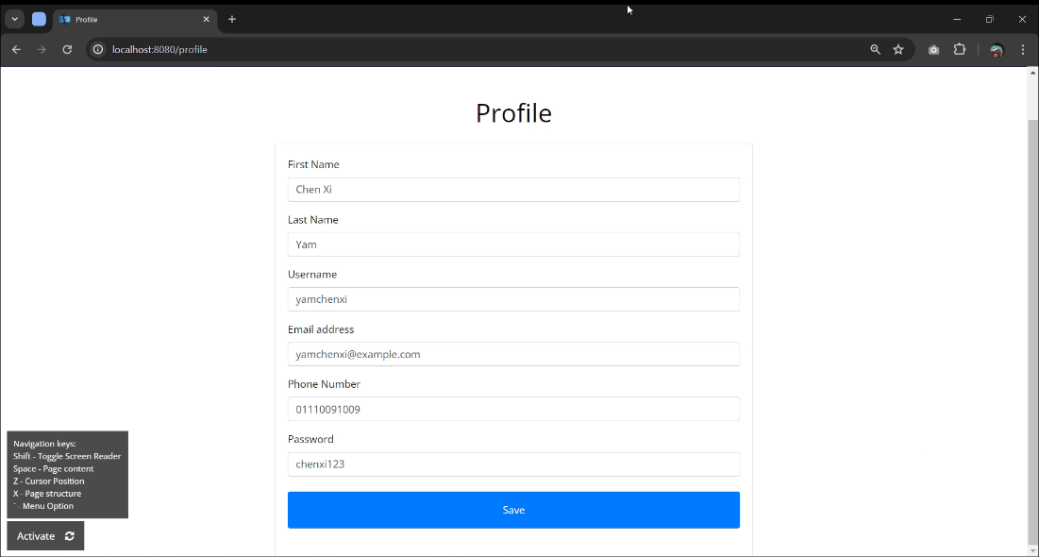

Figure 71: Screenshot of Finease’s Edit Profile Page

Once “edit” button is clicked, it will allow user to make changes on the input fields. If any changes are made to the user information and clicked save, it will update the user information in the database and prompt “Action successful”. If no changes are made, the user information will remain the same.

### 4.6.3 Admin

#### 4.6.3.1 Manage User Page

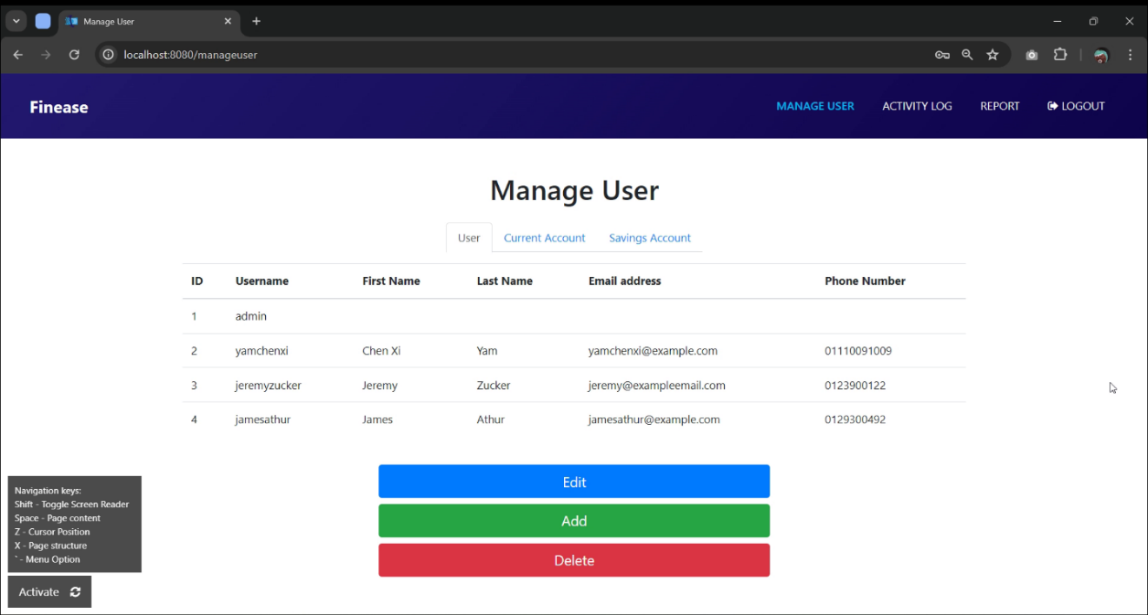

Figure 72: Screenshot of Finease’s Manage User Page

Once the user logged in as admin, the user will be directed to manage user page, the user is granted permission to edit, add and delete users. By clicking on the buttons, it will navigate the user to the respective pages.

#### 4.6.3.2 Edit User

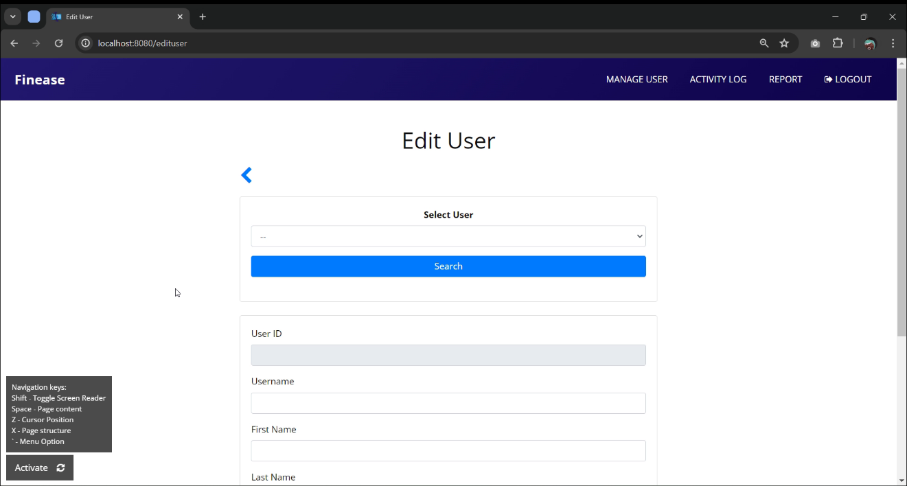

Figure 73: Screenshot of Finease’s Edit User Page

On the edit user page, the admin is required to search for the user to edit. The list of existing users will be displayed for the admin to select. Once the user clicks “search” button after selecting user to edit, the fields below will display the selected user information, allowing admin to make changes to the user information. If any changes are made to the user information and clicked save, it will update the user information in the database and prompt “Action successful”. If no changes are made, the user information will remain the same.

#### 4.6.3.3 Add User

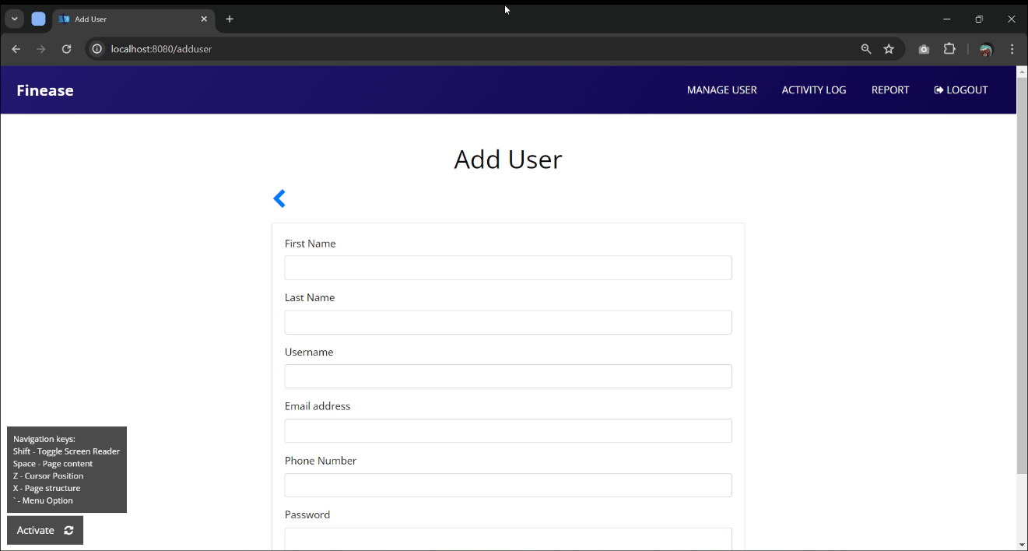

Figure 74: Screenshot of Finease’s Add User Page

On the add user page, the admin is required to fill in all the personal information including first name, last name, username, email address, phone number, password and confirm password. If the user input username or email address that is already exist in the database, it will prompt error and speak “Input invalid, please try again”. The password and confirm password field input must be the same, else it will also prompt error. Upon filling up the field with correct information and submitted the form, the system will prompt “Action successful”.

#### 4.6.3.4 Delete User

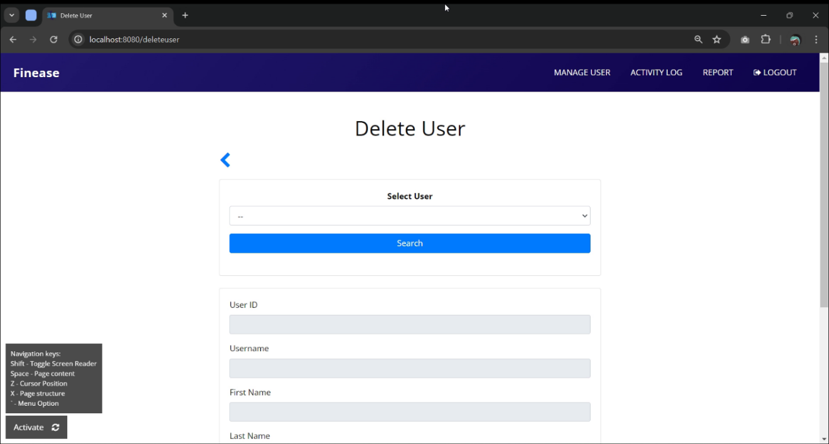

Figure 75: Screenshot of Finease’s Delete User Page

On the edit user page, the admin is required to search for the user to delete. The list of existing users will be displayed for the admin to select. Once the user clicks “search” button after selecting user to delete, the fields below will display the selected user information, allowing admin to view the user information. If the user clicked delete button, it will remove the user from the database and prompt “Action successful”.

#### 4.6.3.5 Manage Bank Accounts

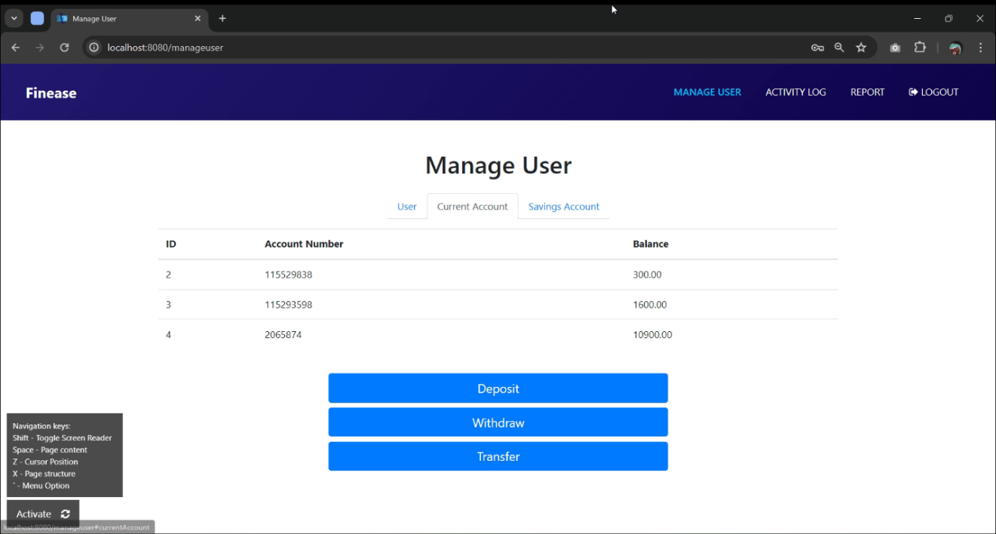

Figure 76: Screenshot of Finease’s Manage User Page

On manage user page, the admin can also manage bank accounts such as current account and savings account. Where admin can view the bank details and take action such as deposit, withdraw and transfer for customers. By clicking on the buttons, it will navigate the admin to the respective pages.

#### 4.6.3.6 Deposit

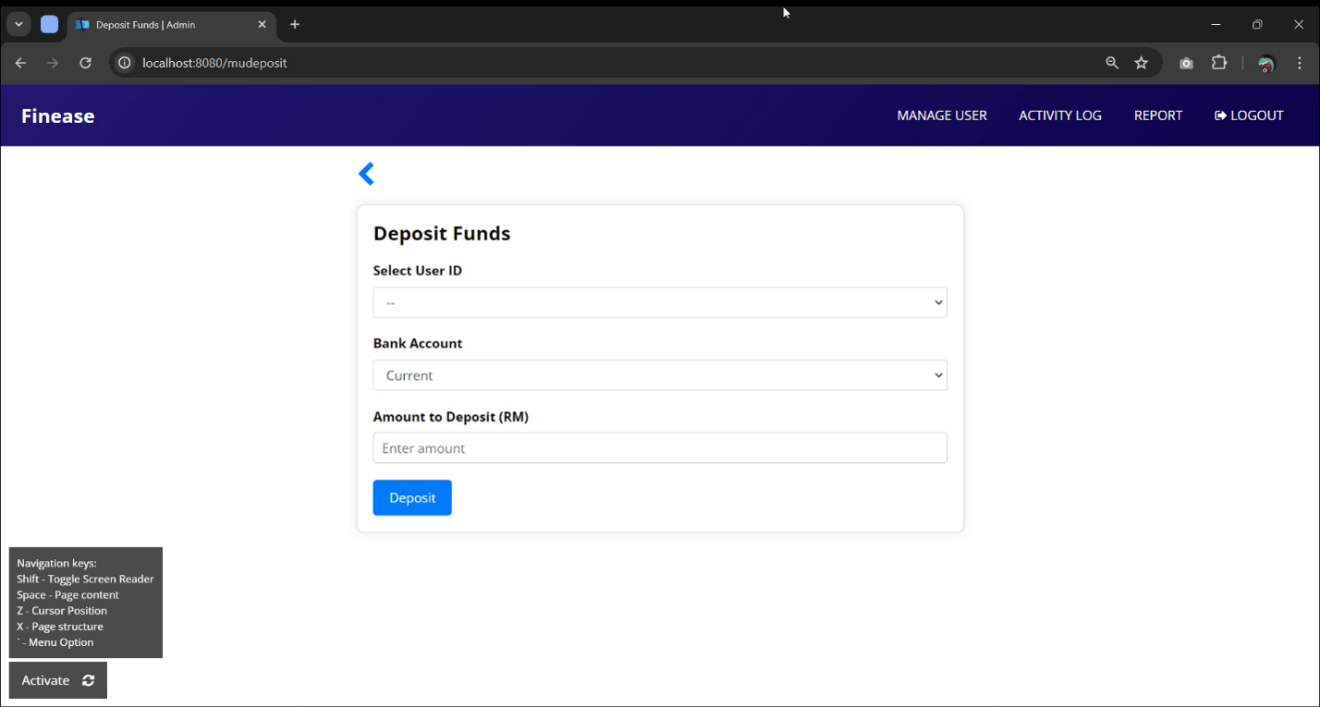

Figure 77: Screenshot of Finease’s Admin Deposit Page

On the deposit page, the admin is required to search for the user to deposit fund. It allows the admin to deposit funds to the selected user’s either current account or savings account. The admin is required to fill in a certain amount of deposit to complete the transaction. Once the transaction is completed, the system will prompt success “Transaction successful”.

#### 4.6.3.7 Withdraw

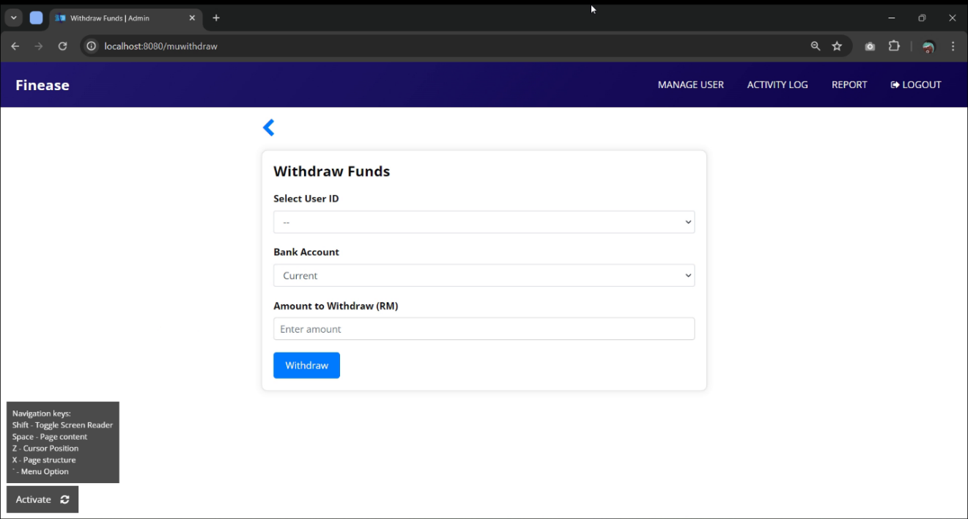

Figure 78: Screenshot of Finease’s Admin Withdraw Page

On the withdraw page, the admin is required to search for the user to withdraw funds. It allows the admin to withdraw funds from the selected user’s either current account or savings account. The admin is required to fill in a certain amount of withdraw to complete the transaction. If the withdraw amount exceeds the balance that is in the selected account, the transaction will fail and prompting error “Insufficient balance, please try again”. Once the transaction is completed, the system will prompt success “Transaction successful”.

#### 4.6.3.8 Transfer

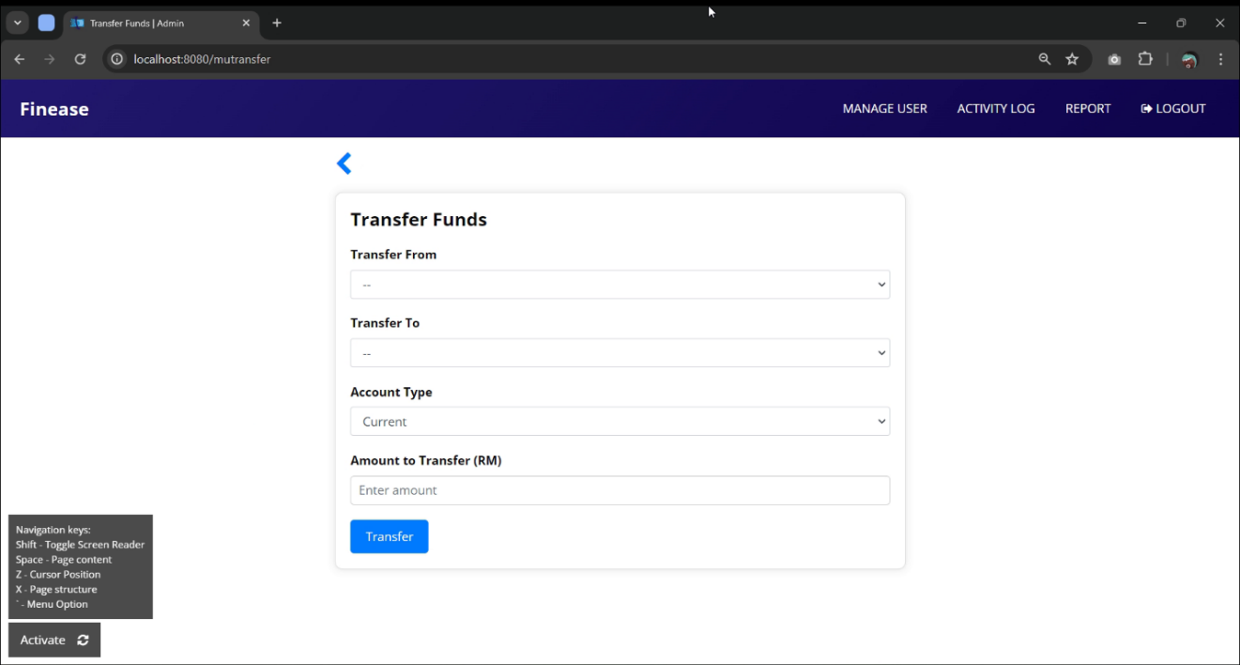

Figure 79: Screenshot of Finease’s Admin Transfer Page

On the transfer page, the admin is required to select the user to transfer from and transfer to. It allows the admin to transfer funds from the selected transfer from user’s either current account or savings account to the selected transfer to account. The admin is required to fill in a certain amount of transfer to complete the transaction. If the transfer amount exceeds the balance that is in the selected transfer from account, the transaction will fail and prompting error “Insufficient balance, please try again”. Once the transaction is completed, the system will prompt success “Transaction successful”.

#### 4.6.3.9 Activity Log Page

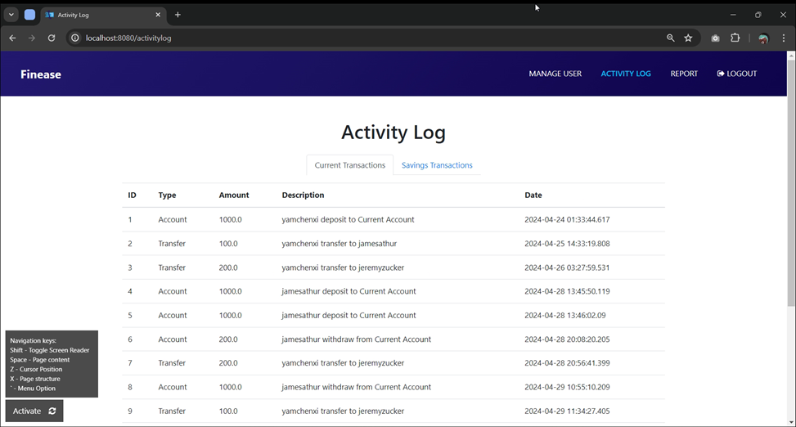

Figure 80: Screenshot of Finease’s Activity Log Page

On the transfer page, the admin is required to select the user to transfer from and transfer to. It allows the admin to transfer funds from the selected transfer from user’s either current account or savings account to the selected transfer to account. The admin is required to fill in a certain amount of transfer to complete the transaction. If the transfer amount exceeds the balance that is in the selected transfer from account, the transaction will fail and prompting error “Insufficient balance, please try again”. Once the transaction is completed, the system will prompt success “Transaction successful”.

#### 4.6.3.10 System Report Page

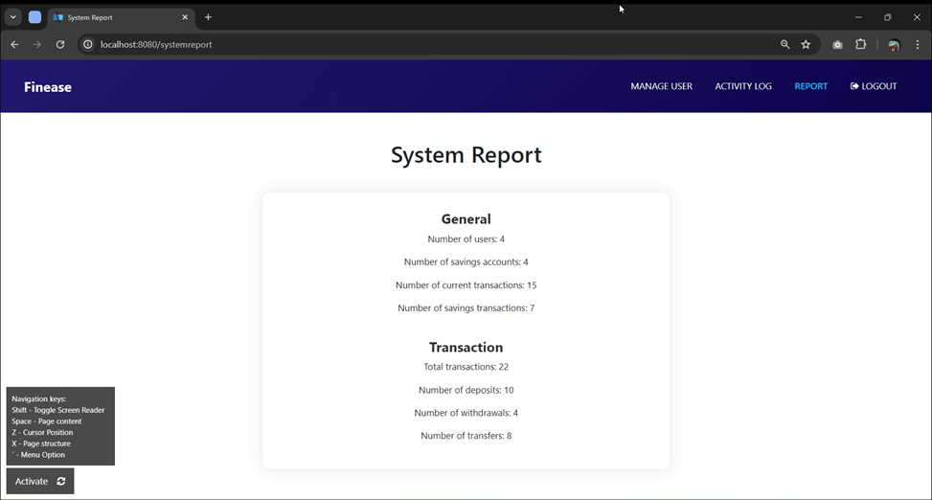

Figure 81: Screenshot of Finease’s System Report Page

On the transfer page, the admin is required to select the user to transfer from and transfer to. It allows the admin to transfer funds from the selected transfer from user’s either current account or savings account to the selected transfer to account. The admin is required to fill in a certain amount of transfer to complete the transaction. If the transfer amount exceeds the balance that is in the selected transfer from account, the transaction will fail and prompting error “Insufficient balance, please try again”. Once the transaction is completed, the system will prompt success “Transaction successful”.

## 4.7 Summary

Chapter 4 presents a thorough discussion of the development and execution of Finease, an advanced banking system created to address the requirements of customers and administrators. The chapter starts with an overview of the technology stack employed in the project and then proceeds to delve into detailed conversations about system design, activity diagrams, class diagrams, system architecture, database design, interface design, and implementation.

Activity diagrams provide visual depictions of the system's flow, while class diagrams illustrate the structure of Java classes and their connections within the system. The database design provides an entity-relationship diagram and a data dictionary, explaining the organization of the database and how entities are related. The interface design presents images of the user interface, demonstrating different pages and features available to both users and administrators. The execution section details the construction process, covering setup, front-end and back-end development, incorporating databases, and implementing extra features to improve accessibility like text-to-speech and keyboard navigation.

# Chapter 5: Result and Discussion

## 5.1 Introduction

Testing plays a critical role in ensuring the dependability, efficiency, and satisfaction of Finease, especially for visually impaired users who depend on text-to-speech features. With Finease being important for financial management, any flaw or mistake could have a significant impact. Thorough testing validates the integrity of the system's functionality and user interface. Testing not only identifies and resolves potential issues but also builds trust among users who rely on text-to-speech capabilities. This section explores the results of testing and discusses the effects on Finease's effectiveness and accessibility.

## 5.2 Testing Plan

The two methods that will be used to test Finease are unit testing and user acceptance testing. The focus of unit testing is on examining individual components or units of the application in isolation, serving as a fundamental strategy within software development. This approach allows developers to methodically evaluate each unit independently, ensuring that it meets predefined specifications. Through early detection and correction of defects during the development process, unit testing greatly improves the accuracy and dependability of each component before its integration into the larger system.

User Acceptance Testing is a crucial phase in the testing process, focusing on evaluating the system from the perspective of end-users. It ensures that the system meets specific requirements and expectations before deployment, primarily through active involvement of end-users in testing. User acceptance testing allows users to determine if the system meets their preferences and operational needs for a smooth user experience. Additionally, it identifies potential usability issues and accessibility challenges to accommodate diverse user groups. This helps enhance overall user satisfaction and maintain high standards of quality and usability in the software.

### 5.2.1 Unit Testing Design

Finease conducts unit testing to verify the accuracy, functionality, and dependability of its individual components, functions, and modules. Developers select particular units for isolated testing and analyze them using predetermined test cases. This proactive approach to identifying and fixing issues helps prevent major system failures, guaranteeing overall stability and a smooth user experience. Below is a unit testing template designed for Finease.

Table 25: Sample unit test template

|  |  |  |  |  |  |
| --- | --- | --- | --- | --- | --- |
| **1.0 Sample Test Scenario** | | | | | |
| **ID** | **Test Procedures** | **Test Data** | **Expected Result** | **Actual Result** | **Status (Pass/Fail)** |
| 1.1 |  |  |  |  |  |
| 1.2 |  |  |  |  |  |
| 1.3 |  |  |  |  |  |
| 1.4 |  |  |  |  |  |

The testing template captures test scenarios, procedures, data, anticipated and real outcomes, as well as the Pass/Fail status for each test. It encompasses a distinct ID for each scenario, test procedures, test data, expected results, and actual results. The assessment of actual versus expected results is used to ascertain the Pass/Fail status which enables methodical testing documentation and assessment.

### 5.2.2 User Acceptance Testing Design

Finease's process for user acceptance testing starts with establishing criteria that are in line with the expectations of the users. Following this, test scenarios and cases are created to address different types of user interactions. Users, including those with visual impairments, play an active role in carrying out tests and offering input. This feedback is used to make incremental enhancements aimed at delivering a superior user experience. Below is a user acceptance testing template designed for Finease.

**User Acceptance Testing**

|  |  |
| --- | --- |
| **Tester Demographic Profile** | |
| Name |  |
| Age |  |
| Occupation |  |
| Role in the system |  |
| Vision Condition |  |
| Date of Testing |  |

Instructions: Please use the following rating scale to evaluate your experience with Finease. Rate each criterion on a scale of 1 to 5, where:

1: Strongly Disagree

2: Disagree

3: Neutral

4: Agree

5: Strongly Agree

|  |  |  |  |  |  |  |
| --- | --- | --- | --- | --- | --- | --- |
|  | **User Interface Criteria** | **1** | **2** | **3** | **4** | **5** |
| **I** | **Clarity**: The interface is clear and easy to understand |  |  |  |  |  |
| **II** | **Ease of Use**: The platform is easy to use and navigate. |  |  |  |  |  |
| **III** | **Visual Appeal**: The design is visually appealing and engaging. |  |  |  |  |  |
| **IV** | **Responsiveness**: The interface responds quickly to user interactions. |  |  |  |  |  |
| **V** | **Accessibility**: The platform provides accessibility options for all users. |  |  |  |  |  |

|  |  |  |  |  |  |  |
| --- | --- | --- | --- | --- | --- | --- |
|  | **Functionality Criteria (For Customer)** | **1** | **2** | **3** | **4** | **5** |
| **I** | **Account Management**: Customer can easily manage their accounts. |  |  |  |  |  |
| **II** | **Transaction Processing**: Customer can conduct transactions smoothly. |  |  |  |  |  |
| **III** | **Security**: Customer's sensitive information is securely handled. |  |  |  |  |  |
| **IV** | **Notification System**: Customer receive timely and relevant notifications. |  |  |  |  |  |

|  |  |  |  |  |  |  |
| --- | --- | --- | --- | --- | --- | --- |
|  | **Functionality Criteria (For Admin)** | **1** | **2** | **3** | **4** | **5** |
| **I** | **User Management**: Admin can efficiently manage user accounts. |  |  |  |  |  |
| **II** | **Transaction Monitoring**: Admin can monitor financial transactions effectively. |  |  |  |  |  |
| **III** | **Reporting**: The system generates comprehensive report. |  |  |  |  |  |
| **IV** | **Data Management**: Admin can manage and manipulate data securely. |  |  |  |  |  |

|  |
| --- |
| **Tester feedbacks and suggestions:** |
|  |

**Tester’s Signature**

## 5.3 System Testing and Discussion

### 5.3.1 Unit Testing

#### 5.3.1.1 Accessibility widget

Accessibility widget is included in all pages throughout the system with the same functionality.

Table 26: Unit Testing for Accessibility widget

|  |  |  |  |  |  |
| --- | --- | --- | --- | --- | --- |
| **1.0 Accessibility widget (Customer & Admin)** | | | | | |
| **ID** | **Test Procedures** | **Test Data** | **Expected Result** | **Actual Result** | **Status (Pass/Fail)** |
| 1.1 | Activate screen reader using activate button | Click ‘Activate’ Button | Screen reader feature activated | As expected | Pass |
| 1.2 | Activate screen reader using shift key | Press Shift key | Screen reader feature activated | As expected | Pass |
| 1.3 | Deactivate screen reader using activate button | Click ‘Deactivate’ Button | Screen reader feature deactivated | As expected | Pass |
| 1.4 | Deactivate screen reader using shift key | Press Shift key | Screen reader feature deactivated | As expected | Pass |
| 1.5 | Reset screen reader activation | Press reset button | Screen reader set to deactivate and voice set to “Google US English (en-US)” | As expected | Pass |
| 1.6 | Select text to speech voice | Select voice from voice list | Text to speech voice change to selected voice | As expected | Pass |
| 1.7 | Activated screen reader, hover on text | Cursor hover on text | Read text | As expected | Pass |
| 1.8 | Activated screen reader, hover on image | Cursor hover on image | Read image alternative text | As expected | Pass |
| 1.9 | Activated screen reader, hover on embed PDF | Cursor hover on embed PDF | Read embed PDF’s content | As expected | Pass |
| 1.10 | Activated screen reader, hover on link | Cursor hover on link | Read link name | As expected | Pass |
| 1.11 | Activated screen reader, hover on button | Cursor hover on button | Read button name | As expected | Pass |
| 1.12 | Activated screen reader, hover on editable input field | Cursor hover on input field | Read input field name | As expected | Pass |
| 1.13 | Activated screen reader, hover on read only input field | Cursor hover on read only input field | Read input field name and input field content | As expected | Pass |
| 1.14 | Activated screen reader, hover on select field | Cursor hover on select field | Read selected option and available option | As expected | Pass |
| 1.15 | Activated screen reader, click on link | Cursor click on link | Read click link name | As expected | Pass |
| 1.16 | Activated screen reader, click on button | Cursor click on button | Read click button name | As expected | Pass |
| 1.17 | Activated screen reader, click on input field | Cursor click on input field | Read click input field name | As expected | Pass |
| 1.18 | Activated screen reader, click on select field | Cursor click on select field | Read click select field name | As expected | Pass |
| 1.19 | Text to speech read focused element using tab key | Press tab key | Read focused element text | As expected | Pass |
| 1.20 | Text to speech read page content using spacebar key | Press Spacebar key | Read page content | As expected | Pass |
| 1.21 | Text to speech read cursor position using Z key | Press Z key | Read cursor position | As expected | Pass |
| 1.22 | Text to speech read page structure using X key | Press X key | Read page structure | As expected | Pass |
| 1.23 | Text to speech read menu option using ` key | Press ` key | Read menu option | As expected | Pass |
| 1.24 | Go back to previous page using 1 key | Press 1 key | Navigate user to previous page | As expected | Pass |
| **Main pages** | | | | | |
| 1.25 | Navigate to Home page using 2 key | Press 2 key | Navigate user to Home page | As expected | Pass |
| 1.26 | Navigate to About page using 3 key | Press 3 key | Navigate user to About page | As expected | Pass |
| 1.27 | Navigate to Services page using 4 key | Press 4 key | Navigate user to Services page | As expected | Pass |
| 1.28 | Navigate to Login page using 5 key | Press 5 key | Navigate user to Login page | As expected | Pass |
| **Customer pages** | | | | | |
| 1.29 | Navigate to Dashboard page using 2 key | Press 2 key | Navigate user to Dashboard page | As expected | Pass |
| 1.30 | Navigate to History page using 3 key | Press 3 key | Navigate user to History page | As expected | Pass |
| 1.31 | Navigate to Profile page using 4 key | Press 4 key | Navigate user to Profile page | As expected | Pass |
| 1.32 | Logout from system using 5 key | Press 5 key | Logout user from system and return to home page | As expected | Pass |
| **Admin pages** | | | | | |
| 1.33 | Navigate to Manage User page using 2 key | Press 2 key | Navigate user to Manage User page | As expected | Pass |
| 1.34 | Navigate to Activity Log page using 3 key | Press 3 key | Navigate user to Activity Log page | As expected | Pass |
| 1.35 | Navigate to Report page using 4 key | Press 4 key | Navigate user to Report page | As expected | Pass |
| 1.36 | Logout from system using 5 key | Press 5 key | Logout user from system and return to home page | As expected | Pass |

#### 5.3.1.2 Home Page

Table 27: Unit Testing for Home Page

|  |  |  |  |  |  |
| --- | --- | --- | --- | --- | --- |
| **2.0 Home Page (Customer & Admin)** | | | | | |
| **ID** | **Test Procedures** | **Test Data** | **Expected Result** | **Actual Result** | **Status (Pass/Fail)** |
| 2.1 | Navigate to Home page using Finease link | Click Finease link | Navigate user to Home page | As expected | Pass |
| 2.2 | Navigate to Home page using navigation bar | Click Home link | Navigate user to Home page | As expected | Pass |
| 2.3 | Navigate to About page using navigation bar | Click About link | Navigate user to About page | As expected | Pass |
| 2.4 | Navigate to Services page using navigation bar | Click Services link | Navigate user to Services page | As expected | Pass |
| 2.5 | Navigate to Login page using navigation bar | Click Login link | Navigate user to Login page | As expected | Pass |

#### 5.3.1.3 About Page

Table 28: Unit Testing for About Page

|  |  |  |  |  |  |
| --- | --- | --- | --- | --- | --- |
| **3.0 About Page (Customer & Admin)** | | | | | |
| **ID** | **Test Procedures** | **Test Data** | **Expected Result** | **Actual Result** | **Status (Pass/Fail)** |
| 3.1 | Navigate to Home page using Finease link | Click Finease link | Navigate user to Home page | As expected | Pass |
| 3.2 | Navigate to Home page using navigation bar | Click Home link | Navigate user to Home page | As expected | Pass |
| 3.3 | Navigate to About page using navigation bar | Click About link | Navigate user to About page | As expected | Pass |
| 3.4 | Navigate to Services page using navigation bar | Click Services link | Navigate user to Services page | As expected | Pass |
| 3.5 | Navigate to Login page using navigation bar | Click Login link | Navigate user to Login page | As expected | Pass |

#### 5.3.1.4 Services Page

Table 29: Unit Testing for Services Page

|  |  |  |  |  |  |
| --- | --- | --- | --- | --- | --- |
| **4.0 Services Page (Customer & Admin)** | | | | | |
| **ID** | **Test Procedures** | **Test Data** | **Expected Result** | **Actual Result** | **Status (Pass/Fail)** |
| 4.1 | Navigate to Home page using Finease link | Click Finease link | Navigate user to Home page | As expected | Pass |
| 4.2 | Navigate to Home page using navigation bar | Click Home link | Navigate user to Home page | As expected | Pass |
| 4.3 | Navigate to About page using navigation bar | Click About link | Navigate user to About page | As expected | Pass |
| 4.4 | Navigate to Services page using navigation bar | Click Services link | Navigate user to Services page | As expected | Pass |
| 4.5 | Navigate to Login page using navigation bar | Click Login link | Navigate user to Login page | As expected | Pass |

#### 5.3.1.5 Login Page

Table 30: Unit Testing for Login Page

|  |  |  |  |  |  |
| --- | --- | --- | --- | --- | --- |
| **5.0 Login (Customer & Admin)** | | | | | |
| **ID** | **Test Procedures** | **Test Data** | **Expected Result** | **Actual Result** | **Status (Pass/Fail)** |
| 5.1 | Navigate to previous page using back button | Click back button | Navigate user to previous page | As expected | Pass |
| 5.2 | Fill in username field | Username: yamchenxi | No error | As expected | Pass |
| 5.3 | Leave username field blank | Username: {empty} | Display error “Input invalid” | As expected | Pass |
| 5.4 | Fill in password field | Password: chenxi123 | No error | As expected | Pass |
| 5.5 | Leave password field blank | Password: {empty}s | Display error “Input invalid” | As expected | Pass |
| 5.6 | Click login button with correct credentials | Username: yamchenxi  Password: chenxi123 | Display success message “Action successful” | As expected | Pass |
| 5.7 | Click login button with incorrect credentials | Username: yamchenxi223  Password: chenxii0192 | Display error “Input invalid, please try again” | As expected | Pass |
| 5.8 | Click login button with some field left blank | Username: {empty}  Password: chenxi123 | Display error “Input invalid, please try again” | As expected | Pass |
| 5.9 | Navigate to register page using register link | Click register link | Navigate user to register page | As expected | Pass |

#### 5.3.1.6 Register Page

Table 31: Unit Testing for Register Page

|  |  |  |  |  |  |
| --- | --- | --- | --- | --- | --- |
| **6.0 Register (Customer & Admin)** | | | | | |
| **ID** | **Test Procedures** | **Test Data** | **Expected Result** | **Actual Result** | **Status (Pass/Fail)** |
| 6.1 | Navigate to previous page using back button | Click back button | Navigate user to previous page | As expected | Pass |
| 6.2 | Fill in first name field | First name: Chen Xi | No error | As expected | Pass |
| 6.3 | Leave first name field blank | First name: {empty} | Display error “Input invalid” | As expected | Pass |
| 6.4 | Fill in last name field | Last name: Yam | No error | As expected | Pass |
| 6.5 | Leave last name field blank | Last name: {empty} | Display error “Input invalid” | As expected | Pass |
| 6.6 | Fill in username field | Username: yamchenxi | No error | As expected | Pass |
| 6.7 | Leave username field blank | Username: {empty} | Display error “Input invalid” | As expected | Pass |
| 6.8 | Fill in email address field | Email address: yamchenxi@  example.com | No error | As expected | Pass |
| 6.9 | Leave email address field blank | Email address: {empty} | Display error “Input invalid” | As expected | Pass |
| 6.10 | Fill in phone number field | Phone number: 012939202 | No error | As expected | Pass |
| 6.11 | Leave phone number field blank | Phone number: {empty} | Display error “Input invalid” | As expected | Pass |
| 6.12 | Fill in password field | Password: chenxi123 | No error | As expected | Pass |
| 6.13 | Leave password field blank | Password: {empty}s | Display error “Input invalid” | As expected | Pass |
| 6.14 | Fill in confirm password field | Confirm Password: chenxi5433 | No error | As expected | Pass |
| 6.15 | Leave confirm password field blank | Password: {empty} | Display error “Input invalid” | As expected | Pass |
| 6.16 | Click register button with all required fields filled in | Username and email address use for registration has not been used before | Display success message “Action successful”, redirect to login page. | As expected | Pass |
| 6.17 | Click register button with all required fields filled in | Username or email address use for registration has been used before | Display error “Input invalid, please try again” | As expected | Pass |
| 6.18 | Click register button with all required fields filled in | Confirm password is not a match with password | Display error “Input invalid, please try again” | As expected | Pass |
| 6.19 | Click register button with some required fields not filled in | Leave blank for some inputs | Display error “Input invalid, please try again” | As expected | Pass |
| 6.20 | Navigate to login page using login link | Click login link | Navigate user to login page | As expected | Pass |

#### 5.3.1.7 Customer: Dashboard Page

Table 32: Unit Testing for Customer Dashboard Page

|  |  |  |  |  |  |
| --- | --- | --- | --- | --- | --- |
| **7.0 Dashboard (Customer)** | | | | | |
| **ID** | **Test Procedures** | **Test Data** | **Expected Result** | **Actual Result** | **Status (Pass/Fail)** |
| 7.1 | Navigate to Dashboard page using Finease link | Click Finease link | Navigate user to Dashboard page | As expected | Pass |
| 7.2 | Navigate to Dashboard page using navigation bar | Click Dashboard link | Navigate user to Dashboard page | As expected | Pass |
| 7.3 | Navigate to History page using navigation bar | Click History link | Navigate user to History page | As expected | Pass |
| 7.4 | Navigate to Profile page using navigation bar | Click Profile link | Navigate user to Profile page | As expected | Pass |
| 7.5 | Logout user using navigation bar | Click Logout link | Logout user and redirect user to home page | As expected | Pass |
| 7.6 | Toggle hide balance button | Click hide balance button | Account balance is hidden. | As expected | Pass |
| 7.7 | Toggle show balance button | Click show balance button | Account balance is shown | As expected | Pass |
| 7.8 | Navigate to Deposit page using button | Click Deposit button | Navigate user to Deposit page | As expected | Pass |
| 7.9 | Navigate to Withdraw page using button | Click Withdraw button | Navigate user to Withdraw page | As expected | Pass |
| 7.10 | Navigate to Transfer page using button | Click Transfer button | Navigate user to Transfer page | As expected | Pass |

#### 5.3.1.8 Customer: Deposit

Table 33: Unit Testing for Customer Deposit Page

|  |  |  |  |  |  |
| --- | --- | --- | --- | --- | --- |
| **8.0 Deposit (Customer)** | | | | | |
| **ID** | **Test Procedures** | **Test Data** | **Expected Result** | **Actual Result** | **Status (Pass/Fail)** |
| 8.1 | Navigate to Dashboard page using Finease link | Click Finease link | Navigate user to Dashboard page | As expected | Pass |
| 8.2 | Navigate to Dashboard page using navigation bar | Click Dashboard link | Navigate user to Dashboard page | As expected | Pass |
| 8.3 | Navigate to History page using navigation bar | Click History link | Navigate user to History page | As expected | Pass |
| 8.4 | Navigate to Profile page using navigation bar | Click Profile link | Navigate user to Profile page | As expected | Pass |
| 8.5 | Logout user using navigation bar | Click Logout link | Logout user and redirect user to home page | As expected | Pass |
| 8.6 | Navigate to previous page using back button | Click back button | Navigate user to previous page | As expected | Pass |
| 8.7 | Select bank account option | Bank Account: Current | No error | As expected | Pass |
| 8.8 | Fill in amount to deposit field | Amount: 1000 | No error | As expected | Pass |
| 8.9 | Leave amount to deposit field blank | Amount: {empty} | No error | As expected | Pass |
| 8.10 | Click deposit button with all required fields filled in | Bank Account: Current  Amount: 1000 | Display success message “Transaction successful” | As expected | Pass |
| 8.11 | Click deposit button with some required fields not filled in | Bank Account: Current  Amount: {empty} | Display error “Input invalid, please try again” | As expected | Pass |

#### 5.3.1.9 Customer: Withdraw

Table 34: Unit Testing for Customer Withdraw Page

|  |  |  |  |  |  |
| --- | --- | --- | --- | --- | --- |
| **9.0 Withdraw (Customer)** | | | | | |
| **ID** | **Test Procedures** | **Test Data** | **Expected Result** | **Actual Result** | **Status (Pass/Fail)** |
| 9.1 | Navigate to Dashboard page using Finease link | Click Finease link | Navigate user to Dashboard page | As expected | Pass |
| 9.2 | Navigate to Dashboard page using navigation bar | Click Dashboard link | Navigate user to Dashboard page | As expected | Pass |
| 9.3 | Navigate to History page using navigation bar | Click History link | Navigate user to History page | As expected | Pass |
| 9.4 | Navigate to Profile page using navigation bar | Click Profile link | Navigate user to Profile page | As expected | Pass |
| 9.5 | Logout user using navigation bar | Click Logout link | Logout user and redirect user to home page | As expected | Pass |
| 9.6 | Navigate to previous page using back button | Click back button | Navigate user to previous page | As expected | Pass |
| 9.7 | Select bank account option | Bank Account: Current | No error | As expected | Pass |
| 9.8 | Fill in amount to withdraw field | Amount: 1000 | No error | As expected | Pass |
| 9.9 | Leave amount to withdraw field blank | Amount: {empty} | No error | As expected | Pass |
| 9.10 | Click withdraw button with all required fields filled in | Amount to withdraw is within the balance amount of the account | Display success message “Transaction successful” | As expected | Pass |
| 9.11 | Click withdraw button with all required fields filled in | Amount to withdraw exceeds the balance amount of the account | Display error message “Insufficient balance, please try again” | As expected | Pass |
| 9.12 | Click withdraw button with some required fields not filled in | Bank Account: Current  Amount: {empty} | Display error “Input invalid, please try again” | As expected | Pass |

#### 5.3.1.10 Customer: Transfer

Table 35: Unit Testing for Customer Transfer Page

|  |  |  |  |  |  |
| --- | --- | --- | --- | --- | --- |
| **10.0 Withdraw (Customer)** | | | | | |
| **ID** | **Test Procedures** | **Test Data** | **Expected Result** | **Actual Result** | **Status (Pass/Fail)** |
| 10.1 | Navigate to Dashboard page using Finease link | Click Finease link | Navigate user to Dashboard page | As expected | Pass |
| 10.2 | Navigate to Dashboard page using navigation bar | Click Dashboard link | Navigate user to Dashboard page | As expected | Pass |
| 10.3 | Navigate to History page using navigation bar | Click History link | Navigate user to History page | As expected | Pass |
| 10.4 | Navigate to Profile page using navigation bar | Click Profile link | Navigate user to Profile page | As expected | Pass |
| 10.5 | Logout user using navigation bar | Click Logout link | Logout user and redirect user to home page | As expected | Pass |
| 10.6 | Navigate to previous page using back button | Click back button | Navigate user to previous page | As expected | Pass |
| 10.7 | Select transfer to option | Transfer To: jamesathur | No error | As expected | Pass |
| 10.8 | Leave transfer to option blank | Transfer To: {empty} | No error | As expected | Pass |
| 10.9 | Select bank account option | Bank Account: Current | No error | As expected | Pass |
| 10.10 | Fill in amount to withdraw field | Amount: 1000 | No error | As expected | Pass |
| 10.11 | Leave amount to withdraw field blank | Amount: {empty} | No error | As expected | Pass |
| 10.12 | Click transfer button with all required fields filled in | Amount to transfer is within the balance amount of the account | Display success message “Transaction successful” | As expected | Pass |
| 10.13 | Click transfer button with all required fields filled in | Amount to transfer exceeds the balance amount of the account | Display error message “Insufficient balance, please try again” | As expected | Pass |
| 10.14 | Click transfer button with some required fields not filled in | Bank Account: Current  Amount: {empty} | Display error “Input invalid, please try again” | As expected | Pass |

#### 5.3.1.11 Customer: Transaction History Page

Table 36: Unit Testing for Customer Transaction History Page

|  |  |  |  |  |  |
| --- | --- | --- | --- | --- | --- |
| **11.0 Transaction History (Customer)** | | | | | |
| **ID** | **Test Procedures** | **Test Data** | **Expected Result** | **Actual Result** | **Status (Pass/Fail)** |
| 11.1 | Navigate to Dashboard page using Finease link | Click Finease link | Navigate user to Dashboard page | As expected | Pass |
| 11.2 | Navigate to Dashboard page using navigation bar | Click Dashboard link | Navigate user to Dashboard page | As expected | Pass |
| 11.3 | Navigate to History page using navigation bar | Click History link | Navigate user to History page | As expected | Pass |
| 11.4 | Navigate to Profile page using navigation bar | Click Profile link | Navigate user to Profile page | As expected | Pass |
| 11.5 | Logout user using navigation bar | Click Logout link | Logout user and redirect user to home page | As expected | Pass |
| 11.6 | Show Current Transactions information | Click Current Transactions tab | Display all Current Transactions information | As expected | Pass |
| 11.7 | Show Savings Transactions information | Click Savings Transactions tab | Display all Savings Transactions information | As expected | Pass |
| 11.8 | Toggle hide amount button | Click hide amount button | Transaction amount is hidden. | As expected | Pass |
| 11.9 | Toggle show amount button | Click show amount button | Transaction amount is shown | As expected | Pass |
| 11.10 | Click View PDF button of selected row | Click View PDF | Display selected transaction receipt PDF in embed PDF view | As expected | Pass |

#### 5.3.1.12 Customer: Profile Page

Table 37: Unit Testing for Customer Profile Page

|  |  |  |  |  |  |
| --- | --- | --- | --- | --- | --- |
| **12.0 Transaction History (Customer)** | | | | | |
| **ID** | **Test Procedures** | **Test Data** | **Expected Result** | **Actual Result** | **Status (Pass/Fail)** |
| 12.1 | Navigate to Dashboard page using Finease link | Click Finease link | Navigate user to Dashboard page | As expected | Pass |
| 12.2 | Navigate to Dashboard page using navigation bar | Click Dashboard link | Navigate user to Dashboard page | As expected | Pass |
| 12.3 | Navigate to History page using navigation bar | Click History link | Navigate user to History page | As expected | Pass |
| 12.4 | Navigate to Profile page using navigation bar | Click Profile link | Navigate user to Profile page | As expected | Pass |
| 12.5 | Logout user using navigation bar | Click Logout link | Logout user and redirect user to home page | As expected | Pass |
| 12.6 | Click edit button to enable input fields | Click edit button | All input fields enabled | As expected | Pass |
| 12.7 | Click save button with changes on user information fields | User information fields have changes | Update on user information. All input fields change to read only. | As expected | Pass |
| 12.8 | Click save button with no changes on user information fields | User information fields no changes | No changes made on user information. All input fields change to read only. | As expected | Pass |

#### 5.3.1.13 Admin: Manage User Page

Table 38: Unit Testing for Admin Manage User Page

|  |  |  |  |  |  |
| --- | --- | --- | --- | --- | --- |
| **13.0 Manage User (Admin)** | | | | | |
| **ID** | **Test Procedures** | **Test Data** | **Expected Result** | **Actual Result** | **Status (Pass/Fail)** |
| 13.1 | Navigate to Manage User page using Finease link | Click Finease link | Navigate user to Manage User page | As expected | Pass |
| 13.2 | Navigate to Manage User page using navigation bar | Click Manage User link | Navigate user to Manage User page | As expected | Pass |
| 13.3 | Navigate to Activity Log page using navigation bar | Click Activity Log link | Navigate user to Activity Log page | As expected | Pass |
| 13.4 | Navigate to Report page using navigation bar | Click Report link | Navigate user to Report page | As expected | Pass |
| 13.5 | Logout user using navigation bar | Click Logout link | Logout user and redirect user to home page | As expected | Pass |
| 13.6 | Show User information | Click User tab | Display all User information | As expected | Pass |
| 13.7 | Show Current Account information | Click Current Account tab | Display all Current Account information | As expected | Pass |
| 13.8 | Show Savings Account information | Click Savings Account tab | Display all Savings Account information | As expected | Pass |
| 13.9 | Navigate to Edit User page using button | Click Edit button | Navigate to Edit User page | As expected | Pass |
| 13.10 | Navigate to Add User page using button | Click Add button | Navigate to Add User page | As expected | Pass |
| 13.11 | Navigate to Delete User page using button | Click Delete button | Navigate to Delete User page | As expected | Pass |

#### 5.3.1.14 Admin: Edit User

Table 39: Unit Testing for Admin Edit User Page

|  |  |  |  |  |  |
| --- | --- | --- | --- | --- | --- |
| **14.0 Edit User (Admin)** | | | | | |
| **ID** | **Test Procedures** | **Test Data** | **Expected Result** | **Actual Result** | **Status (Pass/Fail)** |
| 14.1 | Navigate to Manage User page using Finease link | Click Finease link | Navigate user to Manage User page | As expected | Pass |
| 14.2 | Navigate to Manage User page using navigation bar | Click Manage User link | Navigate user to Manage User page | As expected | Pass |
| 14.3 | Navigate to Activity Log page using navigation bar | Click Activity Log link | Navigate user to Activity Log page | As expected | Pass |
| 14.4 | Navigate to Report page using navigation bar | Click Report link | Navigate user to Report page | As expected | Pass |
| 14.5 | Logout user using navigation bar | Click Logout link | Logout user and redirect user to home page | As expected | Pass |
| 14.6 | Navigate to previous page using back button | Click back button | Navigate user to previous page | As expected | Pass |
| 14.7 | Select user option | Select user: jamesathur | No error | As expected | Pass |
| 14.8 | Leave user option blank | Select user: {empty} | No error | As expected | Pass |
| 14.9 | Search user to edit with select user field filled in | Click search button | Display selected user’s information | As expected | Pass |
| 14.10 | Search user to edit with select user field blank | Click search button | Display no user selected | As expected | Pass |
| 14.11 | Click save button with changes on user information fields | User information fields have changes | Update on user information. All input fields change to read only. | As expected | Pass |
| 14.12 | Click save button with no changes on user information fields | User information fields no changes | No changes made on user information. All input fields change to read only. | As expected | Pass |

#### 5.3.1.15 Admin: Add User

Table 40: Unit Testing for Admin Add User Page

|  |  |  |  |  |  |
| --- | --- | --- | --- | --- | --- |
| **15.0 Edit User (Admin)** | | | | | |
| **ID** | **Test Procedures** | **Test Data** | **Expected Result** | **Actual Result** | **Status (Pass/Fail)** |
| 15.1 | Navigate to Manage User page using Finease link | Click Finease link | Navigate user to Manage User page | As expected | Pass |
| 15.2 | Navigate to Manage User page using navigation bar | Click Manage User link | Navigate user to Manage User page | As expected | Pass |
| 15.3 | Navigate to Activity Log page using navigation bar | Click Activity Log link | Navigate user to Activity Log page | As expected | Pass |
| 15.4 | Navigate to Report page using navigation bar | Click Report link | Navigate user to Report page | As expected | Pass |
| 15.5 | Logout user using navigation bar | Click Logout link | Logout user and redirect user to home page | As expected | Pass |
| 15.6 | Navigate to previous page using back button | Click back button | Navigate user to previous page | As expected | Pass |
| 15.7 | Fill in first name field | First name: Chen Xi | No error | As expected | Pass |
| 15.8 | Leave first name field blank | First name: {empty} | Display error “Input invalid” | As expected | Pass |
| 15.9 | Fill in last name field | Last name: Yam | No error | As expected | Pass |
| 15.10 | Leave last name field blank | Last name: {empty} | Display error “Input invalid” | As expected | Pass |
| 15.11 | Fill in username field | Username: yamchenxi | No error | As expected | Pass |
| 15.12 | Leave username field blank | Username: {empty} | Display error “Input invalid” | As expected | Pass |
| 15.13 | Fill in email address field | Email address: yamchenxi@  example.com | No error | As expected | Pass |
| 15.14 | Leave email address field blank | Email address: {empty} | Display error “Input invalid” | As expected | Pass |
| 15.15 | Fill in phone number field | Phone number: 012939202 | No error | As expected | Pass |
| 15.16 | Leave phone number field blank | Phone number: {empty} | Display error “Input invalid” | As expected | Pass |
| 15.17 | Fill in password field | Password: chenxi123 | No error | As expected | Pass |
| 15.18 | Leave password field blank | Password: {empty}s | Display error “Input invalid” | As expected | Pass |
| 15.19 | Fill in confirm password field | Confirm Password: chenxi5433 | No error | As expected | Pass |
| 15.20 | Leave confirm password field blank | Password: {empty} | Display error “Input invalid” | As expected | Pass |
| 15.21 | Click add button with all required fields filled in | Username and email address use for registration has not been used before | Display success message “Action successful”, redirect to login page. | As expected | Pass |
| 15.22 | Click add button with all required fields filled in | Username or email address use for registration has been used before | Display error “Input invalid, please try again” | As expected | Pass |
| 15.23 | Click add button with all required fields filled in | Confirm password is not a match with password | Display error “Input invalid, please try again” | As expected | Pass |

#### 5.3.1.16 Admin: Delete User

Table 41: Unit Testing for Admin Delete User Page

|  |  |  |  |  |  |
| --- | --- | --- | --- | --- | --- |
| **16.0 Delete User (Admin)** | | | | | |
| **ID** | **Test Procedures** | **Test Data** | **Expected Result** | **Actual Result** | **Status (Pass/Fail)** |
| 16.1 | Navigate to Manage User page using Finease link | Click Finease link | Navigate user to Manage User page | As expected | Pass |
| 16.2 | Navigate to Manage User page using navigation bar | Click Manage User link | Navigate user to Manage User page | As expected | Pass |
| 16.3 | Navigate to Activity Log page using navigation bar | Click Activity Log link | Navigate user to Activity Log page | As expected | Pass |
| 16.4 | Navigate to Report page using navigation bar | Click Report link | Navigate user to Report page | As expected | Pass |
| 16.5 | Logout user using navigation bar | Click Logout link | Logout user and redirect user to home page | As expected | Pass |
| 16.6 | Navigate to previous page using back button | Click back button | Navigate user to previous page | As expected | Pass |
| 16.7 | Select user option | Select user: jamesathur | No error | As expected | Pass |
| 16.8 | Leave user option blank | Select user: {empty} | No error | As expected | Pass |
| 16.9 | Search user to delete with select user field filled in | Click search button | Display selected user’s information | As expected | Pass |
| 16.10 | Search user to delete with select user field blank | Click search button | Display no user selected | As expected | Pass |
| 16.11 | Click delete button with selected delete user | Click delete button | Selected user deleted from database. Display success message “Action successful” | As expected | Pass |

#### 5.3.1.17 Admin: Manage Bank Accounts

Table 42: Unit Testing for Admin Manage Bank Accounts Page

|  |  |  |  |  |  |
| --- | --- | --- | --- | --- | --- |
| **17.0 Delete User (Admin)** | | | | | |
| **ID** | **Test Procedures** | **Test Data** | **Expected Result** | **Actual Result** | **Status (Pass/Fail)** |
| 17.1 | Navigate to Manage User page using Finease link | Click Finease link | Navigate user to Manage User page | As expected | Pass |
| 17.2 | Navigate to Manage User page using navigation bar | Click Manage User link | Navigate user to Manage User page | As expected | Pass |
| 17.3 | Navigate to Activity Log page using navigation bar | Click Activity Log link | Navigate user to Activity Log page | As expected | Pass |
| 17.4 | Navigate to Report page using navigation bar | Click Report link | Navigate user to Report page | As expected | Pass |
| 17.5 | Logout user using navigation bar | Click Logout link | Logout user and redirect user to home page | As expected | Pass |
| 17.6 | Show User information | Click User tab | Display all User information | As expected | Pass |
| 17.7 | Show Current Account information | Click Current Account tab | Display all Current Account information | As expected | Pass |
| 17.8 | Show Savings Account information | Click Savings Account tab | Display all Savings Account information | As expected | Pass |
| 17.9 | Navigate to Deposit page using button | Click Deposit button | Navigate to Deposit page | As expected | Pass |
| 17.10 | Navigate to Withdraw page using button | Click Withdraw button | Navigate to Withdraw page | As expected | Pass |
| 17.11 | Navigate to Transfer page using button | Click Transfer button | Navigate to Transfer page | As expected | Pass |

#### 5.3.1.18 Admin: Deposit

Table 43: Unit Testing for Admin Deposit Page

|  |  |  |  |  |  |
| --- | --- | --- | --- | --- | --- |
| **18.0 Deposit (Admin)** | | | | | |
| **ID** | **Test Procedures** | **Test Data** | **Expected Result** | **Actual Result** | **Status (Pass/Fail)** |
| 18.1 | Navigate to Manage User page using Finease link | Click Finease link | Navigate user to Manage User page | As expected | Pass |
| 18.2 | Navigate to Manage User page using navigation bar | Click Manage User link | Navigate user to Manage User page | As expected | Pass |
| 18.3 | Navigate to Activity Log page using navigation bar | Click Activity Log link | Navigate user to Activity Log page | As expected | Pass |
| 18.4 | Navigate to Report page using navigation bar | Click Report link | Navigate user to Report page | As expected | Pass |
| 18.5 | Logout user using navigation bar | Click Logout link | Logout user and redirect user to home page | As expected | Pass |
| 18.6 | Navigate to previous page using back button | Click back button | Navigate user to previous page | As expected | Pass |
| 18.7 | Select User ID option | User ID: 3 | No error | As expected | Pass |
| 18.8 | Leave User ID option blank | User ID: {empty} | No error | As expected | Pass |
| 18.9 | Select bank account option | Bank Account: Current | No error | As expected | Pass |
| 18.10 | Fill in amount to deposit field | Amount: 1000 | No error | As expected | Pass |
| 18.11 | Leave amount to deposit field blank | Amount: {empty} | No error | As expected | Pass |
| 18.12 | Click deposit button with all required fields filled in | User ID: 3  Bank Account: Current  Amount: 1000 | Display success message “Transaction successful” | As expected | Pass |
| 18.13 | Click deposit button with some required fields not filled in | User ID: 3  Bank Account: Current  Amount: {empty} | Display error “Input invalid, please try again” | As expected | Pass |

#### 5.3.1.19 Admin: Withdraw

Table 44: Unit Testing for Admin Withdraw Page

|  |  |  |  |  |  |
| --- | --- | --- | --- | --- | --- |
| **19.0 Withdraw (Admin)** | | | | | |
| **ID** | **Test Procedures** | **Test Data** | **Expected Result** | **Actual Result** | **Status (Pass/Fail)** |
| 19.1 | Navigate to Manage User page using Finease link | Click Finease link | Navigate user to Manage User page | As expected | Pass |
| 19.2 | Navigate to Manage User page using navigation bar | Click Manage User link | Navigate user to Manage User page | As expected | Pass |
| 19.3 | Navigate to Activity Log page using navigation bar | Click Activity Log link | Navigate user to Activity Log page | As expected | Pass |
| 19.4 | Navigate to Report page using navigation bar | Click Report link | Navigate user to Report page | As expected | Pass |
| 19.5 | Logout user using navigation bar | Click Logout link | Logout user and redirect user to home page | As expected | Pass |
| 19.6 | Navigate to previous page using back button | Click back button | Navigate user to previous page | As expected | Pass |
| 19.7 | Select User ID option | User ID: 3 | No error | As expected | Pass |
| 19.8 | Leave User ID option blank | User ID: {empty} | No error | As expected | Pass |
| 19.9 | Select bank account option | Bank Account: Current | No error | As expected | Pass |
| 19.10 | Fill in amount to withdraw field | Amount: 1000 | No error | As expected | Pass |
| 19.11 | Leave amount to withdraw field blank | Amount: {empty} | No error | As expected | Pass |
| 19.12 | Click withdraw button with all required fields filled in | Amount to withdraw is within the balance amount of the account | Display success message “Transaction successful” | As expected | Pass |
| 19.13 | Click withdraw button with all required fields filled in | Amount to withdraw exceeds the balance amount of the account | Display error message “Insufficient balance, please try again” | As expected | Pass |
| 19.14 | Click withdraw button with some required fields not filled in | User ID: 3  Bank Account: Current  Amount: {empty} | Display error “Input invalid, please try again” | As expected | Pass |

#### 5.3.1.20 Admin: Transfer

Table 45: Unit Testing for Admin Transfer Page

|  |  |  |  |  |  |
| --- | --- | --- | --- | --- | --- |
| **20.0 Transfer (Admin)** | | | | | |
| **ID** | **Test Procedures** | **Test Data** | **Expected Result** | **Actual Result** | **Status (Pass/Fail)** |
| 20.1 | Navigate to Manage User page using Finease link | Click Finease link | Navigate user to Manage User page | As expected | Pass |
| 20.2 | Navigate to Manage User page using navigation bar | Click Manage User link | Navigate user to Manage User page | As expected | Pass |
| 20.3 | Navigate to Activity Log page using navigation bar | Click Activity Log link | Navigate user to Activity Log page | As expected | Pass |
| 20.4 | Navigate to Report page using navigation bar | Click Report link | Navigate user to Report page | As expected | Pass |
| 20.5 | Logout user using navigation bar | Click Logout link | Logout user and redirect user to home page | As expected | Pass |
| 20.6 | Navigate to previous page using back button | Click back button | Navigate user to previous page | As expected | Pass |
| 20.7 | Select Transfer From option | Transfer From: yamchenxi | No error | As expected | Pass |
| 20.8 | Leave Transfer From option blank | Transfer From: {empty} | No error | As expected | Pass |
| 20.9 | Select Transfer To option | Transfer To: jeremyzucker | No error | As expected | Pass |
| 20.10 | Leave Transfer To option blank | Transfer To: {empty} | No error | As expected | Pass |
| 20.11 | Select bank account option | Bank Account: Current | No error | As expected | Pass |
| 20.12 | Fill in amount to transfer field | Amount: 1000 | No error | As expected | Pass |
| 20.13 | Leave amount to transfer field blank | Amount: {empty} | No error | As expected | Pass |
| 20.14 | Click transfer button with all required fields filled in | Amount to withdraw is within the balance amount of the account | Display success message “Transaction successful” | As expected | Pass |
| 20.15 | Click transfer button with all required fields filled in | Amount to withdraw exceeds the balance amount of the account | Display error message “Insufficient balance, please try again” | As expected | Pass |
| 20.16 | Click transfer button with same transfer from and transfer to | Transfer From: yamchenxi  Transfer To: yamchenxi | Display error “Unable to transfer to same account, please try again” | As expected | Pass |
| 20.17 | Click transfer button with some required fields not filled in | Transfer From: yamchenxi  Transfer To: jeremyzucker Bank Account: Current  Amount: {empty} | Display error “Input invalid, please try again” | As expected | Pass |

#### 5.3.1.21 Admin: Activity Log

Table 46: Unit Testing for Admin Activity Log Page

|  |  |  |  |  |  |
| --- | --- | --- | --- | --- | --- |
| **21.0 Activity Log (Admin)** | | | | | |
| **ID** | **Test Procedures** | **Test Data** | **Expected Result** | **Actual Result** | **Status (Pass/Fail)** |
| 21.1 | Navigate to Manage User page using Finease link | Click Finease link | Navigate user to Manage User page | As expected | Pass |
| 21.2 | Navigate to Manage User page using navigation bar | Click Manage User link | Navigate user to Manage User page | As expected | Pass |
| 21.3 | Navigate to Activity Log page using navigation bar | Click Activity Log link | Navigate user to Activity Log page | As expected | Pass |
| 21.4 | Navigate to Report page using navigation bar | Click Report link | Navigate user to Report page | As expected | Pass |
| 21.5 | Logout user using navigation bar | Click Logout link | Logout user and redirect user to home page | As expected | Pass |
| 21.6 | Show all user Current Transactions information | Click Current Transactions tab | Display all Current Transactions information | As expected | Pass |
| 21.7 | Show all user Savings Transactions information | Click Savings Transactions tab | Display all Savings Transactions information | As expected | Pass |

#### 5.3.1.22 Admin: System Report

Table 47: Unit Testing for Admin System Report Page

|  |  |  |  |  |  |
| --- | --- | --- | --- | --- | --- |
| **22.0 Activity Log (Admin)** | | | | | |
| **ID** | **Test Procedures** | **Test Data** | **Expected Result** | **Actual Result** | **Status (Pass/Fail)** |
| 22.1 | Navigate to Manage User page using Finease link | Click Finease link | Navigate user to Manage User page | As expected | Pass |
| 22.2 | Navigate to Manage User page using navigation bar | Click Manage User link | Navigate user to Manage User page | As expected | Pass |
| 22.3 | Navigate to Activity Log page using navigation bar | Click Activity Log link | Navigate user to Activity Log page | As expected | Pass |
| 22.4 | Navigate to Report page using navigation bar | Click Report link | Navigate user to Report page | As expected | Pass |
| 22.5 | Logout user using navigation bar | Click Logout link | Logout user and redirect user to home page | As expected | Pass |

### 5.3.2 User Acceptance Testing (3 at least)

#### 5.3.2.1 Tester 1 (Admin)

**User Acceptance Testing**

|  |  |
| --- | --- |
| **Tester Demographic Profile** | |
| Name | Soh Myles |
| Age | 22 |
| Occupation | Student |
| Role in the system | Admin |
| Vision Condition | Myopia, Astigmatism |
| Date of Testing | 26th April 2024 |

Instructions: Please use the following rating scale to evaluate your experience with Finease. Rate each criterion on a scale of 1 to 5, where:

1: Strongly Disagree

2: Disagree

3: Neutral

4: Agree

5: Strongly Agree

|  |  |  |  |  |  |  |
| --- | --- | --- | --- | --- | --- | --- |
|  | **User Interface Criteria** | **1** | **2** | **3** | **4** | **5** |
| **I** | **Clarity**: The interface is clear and easy to understand |  |  |  |  | / |
| **II** | **Ease of Use**: The platform is easy to use and navigate. |  |  |  |  | / |
| **III** | **Visual Appeal**: The design is visually appealing and engaging. |  |  |  | / |  |
| **IV** | **Responsiveness**: The interface responds quickly to user interactions. |  |  |  | / |  |
| **V** | **Accessibility**: The platform provides accessibility options for all users. |  |  |  |  | / |

|  |  |  |  |  |  |  |
| --- | --- | --- | --- | --- | --- | --- |
|  | **Functionality Criteria (For Admin)** | **1** | **2** | **3** | **4** | **5** |
| **I** | **User Management**: Admin can efficiently manage user accounts. |  |  |  |  | / |
| **II** | **Transaction Monitoring**: Admin can monitor financial transactions effectively. |  |  |  |  | / |
| **III** | **Reporting**: The system generates comprehensive report. |  |  |  |  | / |
| **IV** | **Data Management**: Admin can manage and manipulate data securely. |  |  |  |  | / |

|  |
| --- |
| **Tester feedbacks and suggestions:** |
| The admin features are well-functioning and convenient to use, as there is the availability of keyboard navigation. Additionally, the design layout is user-friendly, with large buttons arranged in rows, making it easy for the cursor to hover over them for text-to-speech functionality. Webpage customization is suggested, such as adjusting text size, font, and thickness, to aid individuals who struggle with vision, making website navigation easier for them without fully relying on text-to-speech functionality. |

**Tester’s Signature**



#### 5.3.2.1 Tester 2 (Customer)

**User Acceptance Testing**

|  |  |
| --- | --- |
| **Tester Demographic Profile** | |
| Name | Chee Wey Ern |
| Age | 22 |
| Occupation | Student |
| Role in the system | Customer |
| Vision Condition | Visually Impaired |
| Date of Testing | 27th April 2024 |

Instructions: Please use the following rating scale to evaluate your experience with Finease. Rate each criterion on a scale of 1 to 5, where:

1: Strongly Disagree

2: Disagree

3: Neutral

4: Agree

5: Strongly Agree

|  |  |  |  |  |  |  |
| --- | --- | --- | --- | --- | --- | --- |
|  | **User Interface Criteria** | **1** | **2** | **3** | **4** | **5** |
| **I** | **Clarity**: The interface is clear and easy to understand |  |  |  |  | / |
| **II** | **Ease of Use**: The platform is easy to use and navigate. |  |  |  |  | / |
| **III** | **Visual Appeal**: The design is visually appealing and engaging. |  |  |  |  | / |
| **IV** | **Responsiveness**: The interface responds quickly to user interactions. |  |  |  |  | / |
| **V** | **Accessibility**: The platform provides accessibility options for all users. |  |  |  |  | / |

|  |  |  |  |  |  |  |
| --- | --- | --- | --- | --- | --- | --- |
|  | **Functionality Criteria (For Customer)** | **1** | **2** | **3** | **4** | **5** |
| **I** | **Account Management**: Customer can easily manage their accounts. |  |  |  |  | / |
| **II** | **Transaction Processing**: Customer can conduct transactions smoothly. |  |  |  |  | / |
| **III** | **Security**: Customer's sensitive information is securely handled. |  |  |  |  | / |
| **IV** | **Notification System**: Customer receive timely and relevant notifications. |  |  |  | / |  |

|  |
| --- |
| **Tester feedbacks and suggestions:** |
| The website guides users and offers numerous assistive features to help visually impaired individuals navigate the system effectively. It is suggested to enhance privacy by adding a toggle button that allows users to choose whether certain information should be displayed visually or not. |

**Tester’s Signature**



#### 5.3.2.1 Tester 3 (Customer)

**User Acceptance Testing**

|  |  |
| --- | --- |
| **Tester Demographic Profile** | |
| Name | James Lee Jun Feng |
| Age | 24 |
| Occupation | Unemployed |
| Role in the system | Customer |
| Vision Condition | Blind |
| Date of Testing | 27th April 2024 |

Instructions: Please use the following rating scale to evaluate your experience with Finease. Rate each criterion on a scale of 1 to 5, where:

1: Strongly Disagree

2: Disagree

3: Neutral

4: Agree

5: Strongly Agree

|  |  |  |  |  |  |  |
| --- | --- | --- | --- | --- | --- | --- |
|  | **User Interface Criteria** | **1** | **2** | **3** | **4** | **5** |
| **I** | **Clarity**: The interface is clear and easy to understand |  |  |  |  | / |
| **II** | **Ease of Use**: The platform is easy to use and navigate. |  |  |  |  | / |
| **III** | **Visual Appeal**: The design is visually appealing and engaging. |  |  |  |  | / |
| **IV** | **Responsiveness**: The interface responds quickly to user interactions. |  |  |  | / |  |
| **V** | **Accessibility**: The platform provides accessibility options for all users. |  |  |  |  | / |

|  |  |  |  |  |  |  |
| --- | --- | --- | --- | --- | --- | --- |
|  | **Functionality Criteria (For Customer)** | **1** | **2** | **3** | **4** | **5** |
| **I** | **Account Management**: Customer can easily manage their accounts. |  |  |  |  | / |
| **II** | **Transaction Processing**: Customer can conduct transactions smoothly. |  |  |  |  | / |
| **III** | **Security**: Customer's sensitive information is securely handled. |  |  |  | / |  |
| **IV** | **Notification System**: Customer receive timely and relevant notifications. |  |  |  |  | / |

|  |
| --- |
| **Tester feedbacks and suggestions:** |
| The website experiences a slight delay when the screen reader interacts with certain interactive elements. However, overall, the system is user-friendly with the integration of navigation keys and auditory cues that assist users in navigating effectively. The PDF reading tool is particularly useful and convenient. A similar feature like PDF reading tool can be integrated into other financial documents for enhanced accessibility. |

**Tester’s Signature**



## 6.4 Summary

This section discussing the findings of the study centered on a thorough examination plan and results for Finease, a banking system with text-to-speech feature. The testing approach included two important methods, unit testing and user acceptance testing.

Finease's unit testing phase covered a wide range of components and features, such as the accessibility widget, home page, services page, login page, register page, dashboard page, deposit functionality, withdrawal functionality, transfer functionality, transaction history page, profile pages for both customers and administrators. Each component underwent thorough testing with predefined scenarios test procedures and data meticulously documented. The results confirmed that Finease met the specified requirements as all test cases produced expected outcomes.

Besides, the user acceptance testing included three testers from a range of demographic backgrounds, including people with different vision impairments. The feedback offered valuable perspectives on the user experience, emphasizing positive aspects such as the convenience of features and the option for keyboard navigation. Furthermore, recommendations for customizing webpages to accommodate individuals with vision impairments were highlighted, including options to modify text size, font styles, and thickness. Overall, the user acceptance testing phase confirmed Finease's ability to meet user expectations while also pinpointing areas for improvement in accessibility and enhancing overall satisfaction among users.

# Chapter 6: Conclusion

## 6.1 Critical Evaluation

When critically assessing the accomplishments of Finease, it is important to recognize the platform's notable progress in advancing financial inclusivity and availability. The incorporation of Text-to-Speech technology is particularly commendable as it caters to the requirements of users with disabilities who encounter obstacles when using conventional financial services. Through this integration, Finease has shown its dedication to removing barriers and ensuring that everyone, regardless of their capabilities, can efficiently handle their finances.

Furthermore, the study on the present condition of accessibility in online financial websites demonstrates Finease's proactive effort to comprehend and tackle user requirements. This investigation not only offers valuable understanding into areas that can be improved but also raises awareness among users and developers about the significance of accessibility in financial services. By highlighting crucial accessibility issues, Finease is better equipped to introduce specific solutions that improve the user experience for everyone.

In addition, Finease's continuous efforts to update and ensure ease of use demonstrate its dedication to offering a dynamic and user-friendly platform. By adapting to meet evolving user needs, Finease guarantees that its platform stays current and efficient in enabling users to independently and effectively manage their finances.

Finease's comprehensive assessment emphasizes its success in advancing financial inclusivity, carrying out important research on accessibility, and upholding a user-focused approach to platform enhancement. Nevertheless, there are opportunities for further development, including the resolution of remaining accessibility challenges and the improvement of platform functions based on user feedback.

## 6.2 Limitation

Finease encounters specific constraints that require consideration, including the potential challenge of learning to use new technology, particularly for individuals less acquainted with online financial platforms or Text-to-Speech technology. Additionally, while the platform strives to accommodate users with disabilities, ensuring universal accessibility across all devices and interfaces may present difficulties. Moreover, Finease must prioritize dealing with privacy and security issues by putting in place strong data encryption methods to effectively protect user information. The absence of encryption could make sensitive data vulnerable to potential threats, jeopardizing user trust and confidence in the platform. Additionally, despite having audio feedback features, Finease may encounter challenges in offering visual feedback, which is crucial for sighted users to confirm their actions and interact with the interface efficiently. Striking a balance between auditory and visual feedback mechanisms can improve the overall usability and accessibility of Finease for a wider spectrum of users.

## 6.3 Recommendation

The recommendation for Finease future enhancement is to go beyond Text-to-Speech technology to improve accessibility could involve conducting comprehensive accessibility assessments and implementing recommended approaches such as using semantic HTML, Accessible Rich Internet Applications (ARIA) attributes, and keyboard navigation to ensure compatibility with screen readers and other assistive tools. Second, prioritizing the enhancement of user interface responsiveness across various devices and screen sizes can be achieved by adopting a mobile-first design approach and optimizing CSS for better performance. Additionally, maintaining high security standards is also crucial through measures such as data encryption, secure authentication processes, and regular security evaluations aimed at safeguarding user privacy from potential data breaches. Finally, gathering input from various stakeholders on bank functionality would enable Finease to prioritize feature enhancements effectively based on actual needs, resulting in continuous alignment with users' evolving requirements.

# References

Ahmed, T., Hoyle, R., Connelly, K., Crandall, D., & Kapadia, A. (2015). Privacy Concerns and Behaviors of People with Visual Impairments. *Proceedings of the 33rd Annual ACM Conference on Human Factors in Computing Systems*. https://doi.org/10.1145/2702123.2702334

AWS. (n.d.). *What is Java? - Enterprise Java Beginner’s Guide - AWS*. Amazon Web Services, Inc. https://aws.amazon.com/what-is/java/

Bank of America. (n.d.). *Web Accessibility | Accessible Banking with Bank of America*. Bank of America. https://www.bankofamerica.com/accessible-banking/web-access/

Barclays. (n.d.). *Accessibility and disability*. Www.barclays.co.uk. https://www.barclays.co.uk/accessibility/

BBC. (n.d.). *Accessibility*. Www.bbc.co.uk. https://www.bbc.co.uk/accessibility/

Computer Hope. (2019). *What is Windows?* Computerhope.com. https://www.computerhope.com/jargon/w/windows.htm

Corbo, A. (2022). *What Is Python? (Definition, Uses, Difficulty) | Built In*. Builtin.com. https://builtin.com/software-engineering-perspectives/python

Fatima, K., Bawany, N. Z., & Bukhari, M. (2020, October 1). *Usability and Accessibility Evaluation of Banking Websites*. IEEE Xplore. https://doi.org/10.1109/ICACSIS51025.2020.9263083

Gangadharan, S. P. (2015). The downside of digital inclusion: Expectations and experiences of privacy and surveillance among marginal Internet users. *New Media & Society*, *19*(4), 597–615. https://doi.org/10.1177/1461444815614053

Garfinkel, S., & Lipford, H. R. (2014). Usable Security: History, Themes, and Challenges. *Synthesis Lectures on Information Security, Privacy, and Trust*, *5*(2), 1–124. https://doi.org/10.2200/s00594ed1v01y201408spt011

Kolowich, L. (2018). *Web Design 101: How HTML, CSS, and JavaScript Work*. Hubspot.com. https://blog.hubspot.com/marketing/web-design-html-css-javascript

Loshin, P., & Bigelow, S. J. (2021). *What is the Linux operating system?* SearchDataCenter. https://www.techtarget.com/searchdatacenter/definition/Linux-operating-system

MDN Contributors. (2019). *What is JavaScript?* MDN Web Docs. https://developer.mozilla.org/en-US/docs/Learn/JavaScript/First_steps/What_is_JavaScript

Napoli, D. (2018). *Accessible and Usable Security: Exploring Visually Impaired Users’ Online Security and Privacy Strategies*. https://repository.library.carleton.ca/concern/parent/rn301227c/file_sets/1544bp872

Oracle. (2019). *MySQL :: MySQL 8.0 Reference Manual :: 1.3.1 What is MySQL?* Mysql.com. https://dev.mysql.com/doc/refman/8.0/en/what-is-mysql.html

Podsiadło, M., & Chahar, S. (2016). Text-to-Speech for Individuals with Vision Loss: A User Study. *INTERSPEECH 2016*. https://doi.org/10.21437/interspeech.2016-1376

Pomponio, A. (2022). *Tomcat vs. NGINX | OpenLogic by Perforce*. Www.openlogic.com. https://www.openlogic.com/blog/tomcat-vs-nginx

Ramakrishnan, I. V., Ashok, V., & Billah, S. M. (2017). Non-visual Web Browsing: Beyond Web Accessibility. *Lecture Notes in Computer Science*, *10278*. https://doi.org/10.1007/978-3-319-58703-5_24

Ronchi, C., Khodjanov, A., Mahkamov, M., & Zakhidov, S. (2011). Security, Privacy and Efficiency of Internet Banking Transactions. *World Congress on Internet Security (WorldCIS-2011)*. https://doi.org/10.1109/WorldCIS17046.2011.5749854

Saravanan, K. (2017). SYSTEMS DEVELOPMENT METHODOLOGIES: CONCEPTUAL STUDY. *Indian J.Sci.Res*, *14*(1), 27–37. https://www.ijsr.in/upload/105047310905.pdf

Schnell, K., & Roy, K. (2021). Website Privacy Notification for the Visually Impaired. *2021 IEEE Symposium Series on Computational Intelligence (SSCI)*. https://doi.org/10.1109/ssci50451.2021.9659986

Sergeev, A. (2020). What is Scrum Lifecycle. *Hygger: Project Management Software & Tools for Companies*. https://hygger.io/blog/what-is-scrum-lifecycle/

shubhamp338. (2022). *Spring Boot - Thymeleaf with Example*. GeeksforGeeks. https://www.geeksforgeeks.org/spring-boot-thymeleaf-with-example/

Spring. (2024). *Spring Boot Maven Plugin Documentation*. Docs.spring.io. https://docs.spring.io/spring-boot/docs/current/maven-plugin/reference/htmlsingle/

Swain , D., & Sahoo, S. S. (2021). Empowering the Visually Impaired Learners with Text-to-Speech-Based Solution. *Advances in Intelligent Systems and Computing Book Series*, *1311*, 565–573. https://link.springer.com/chapter/10.1007/978-981-33-4859-2_55

Szarkowska, A. (2011). Text-to-speech audio description: towards wider availability of AD. *The Journal of Specialised Translation* , *15*, 142–163. https://www.researchgate.net/publication/245022819_Text-to-speech_audio_description_towards_wider_availability_of_AD

Turing. (2022). *Visual Studio vs Visual Studio Code*. Www.turing.com. https://www.turing.com/kb/ultimate-guide-visual-studio-vs-visual-studio-code

Valeria, K. (2023). *Usage Share of Web Browsers*. Gloria Themes. https://gloriathemes.com/usage-share-of-web-browsers/

vpadmin. (2023). *Agile Methodology: Embracing Flexibility, Collaboration, and Continuous Improvement for Effective Project Management*. Visual Paradigm Guides. https://guides.visual-paradigm.com/agile-methodology-embracing-flexibility-collaboration-and-continuous-improvement-for-effective-project-management/

Wentz, B., Pham, J., & Tressler, K. (2017). Exploring the accessibility of banking and finance systems for blind users. *First Monday*, *22*(3). https://doi.org/10.5210/fm.v22i3.7036

# Appendices

## Appendix A – PPF

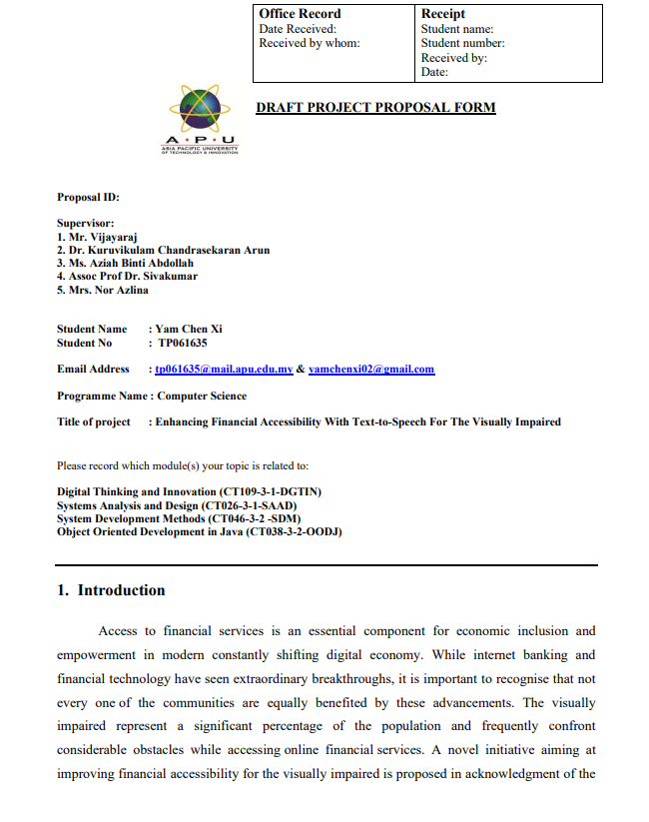

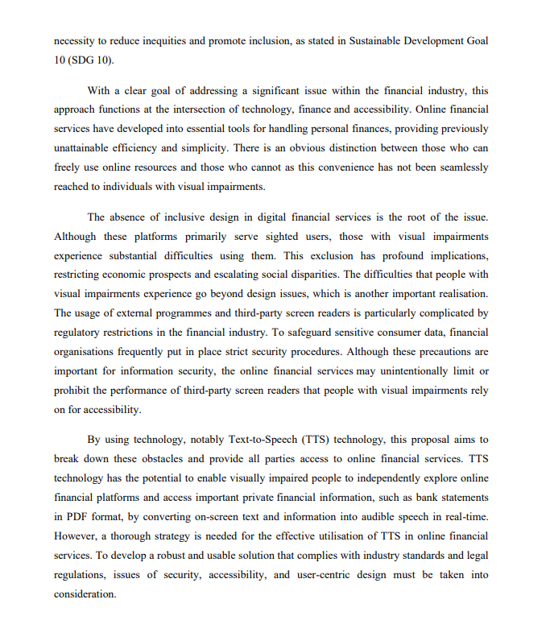

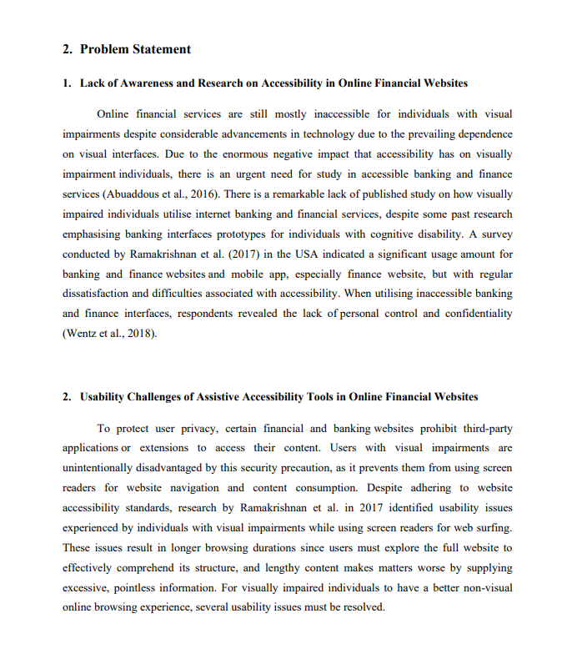

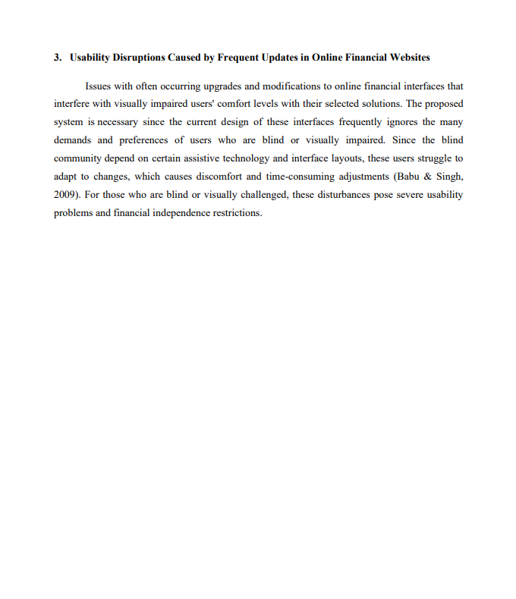

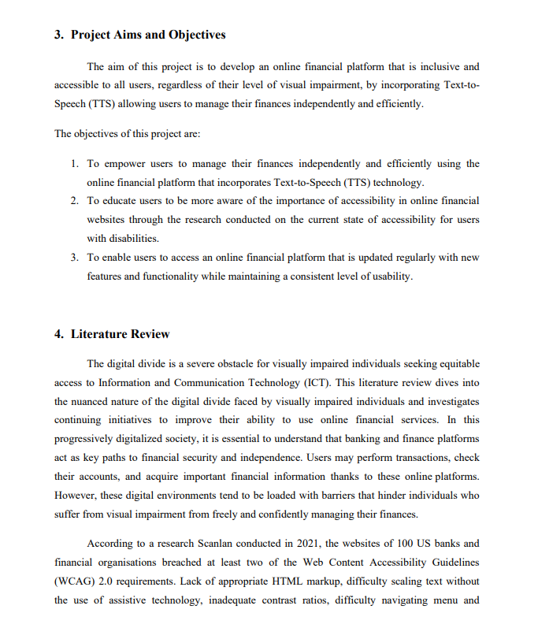

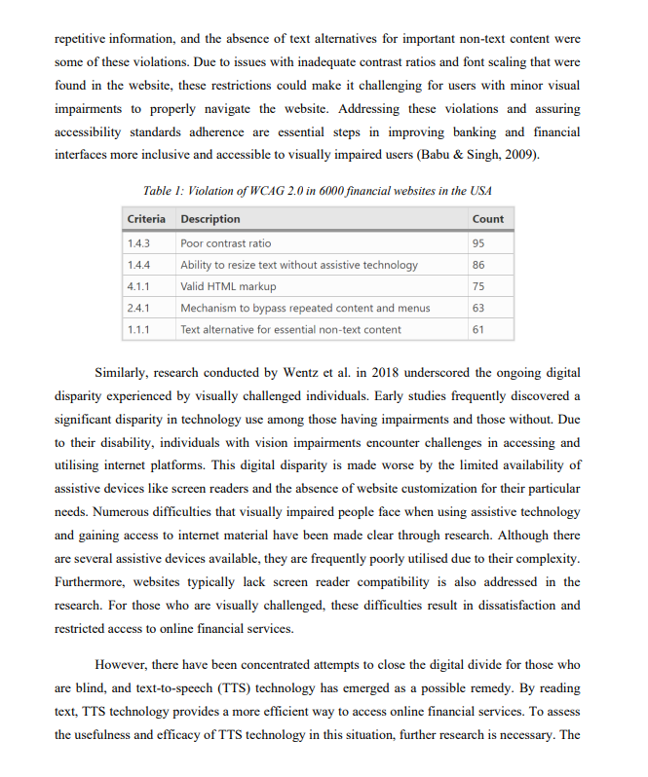

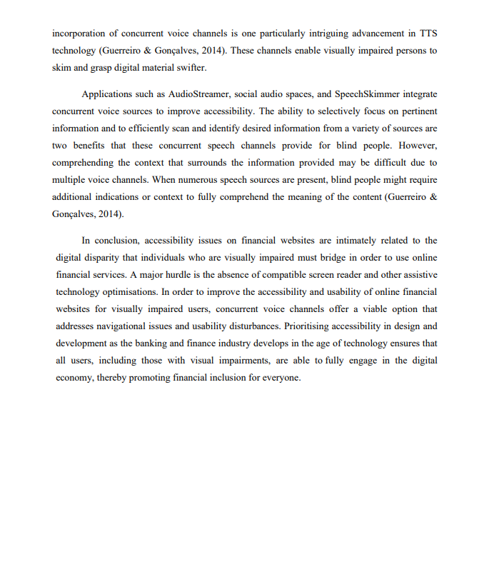

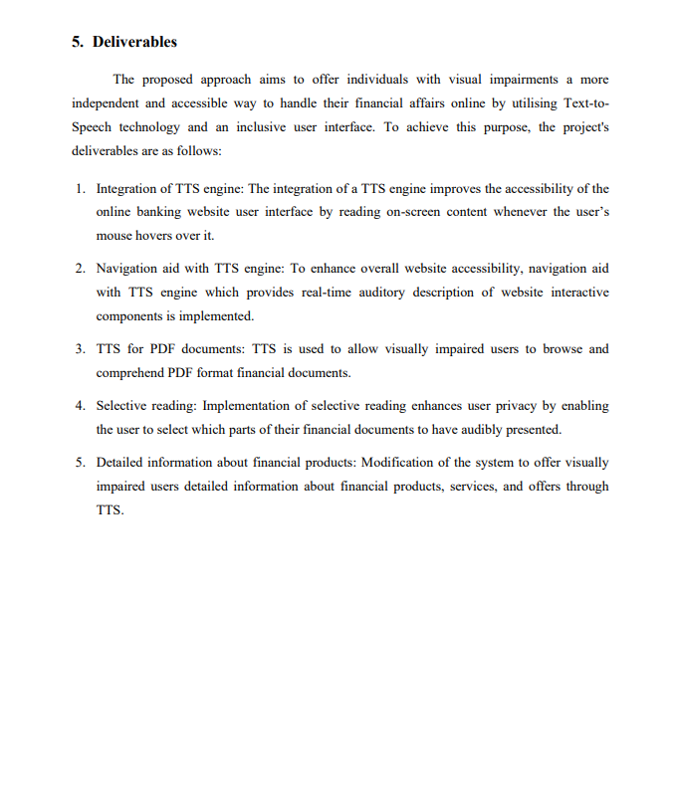

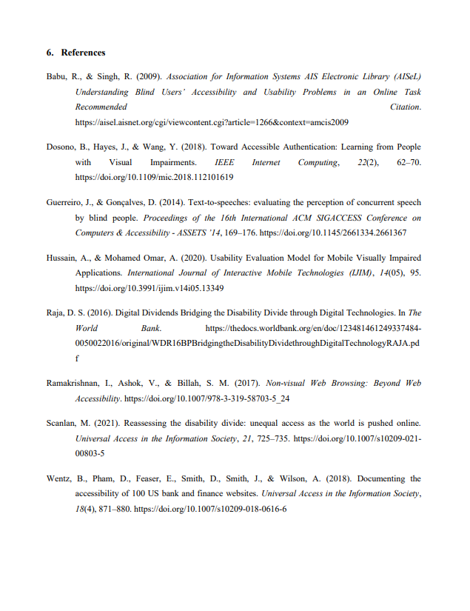

## Appendix B – Ethics Form



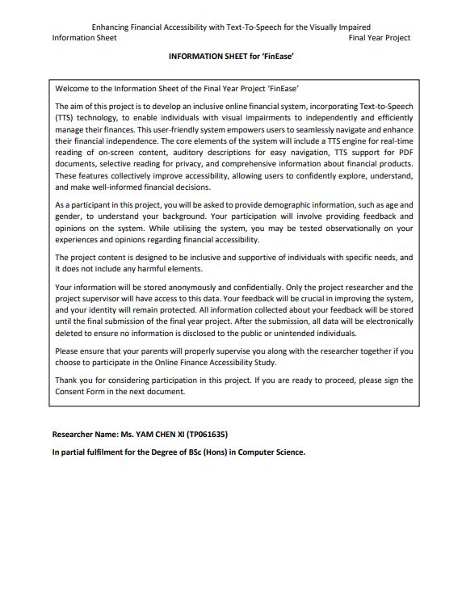

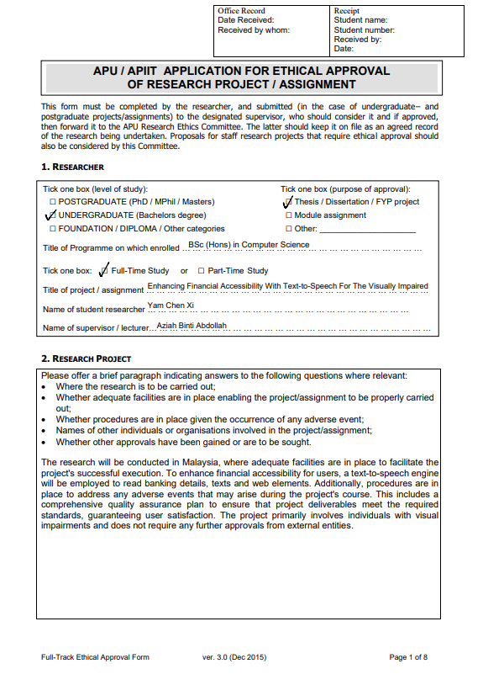

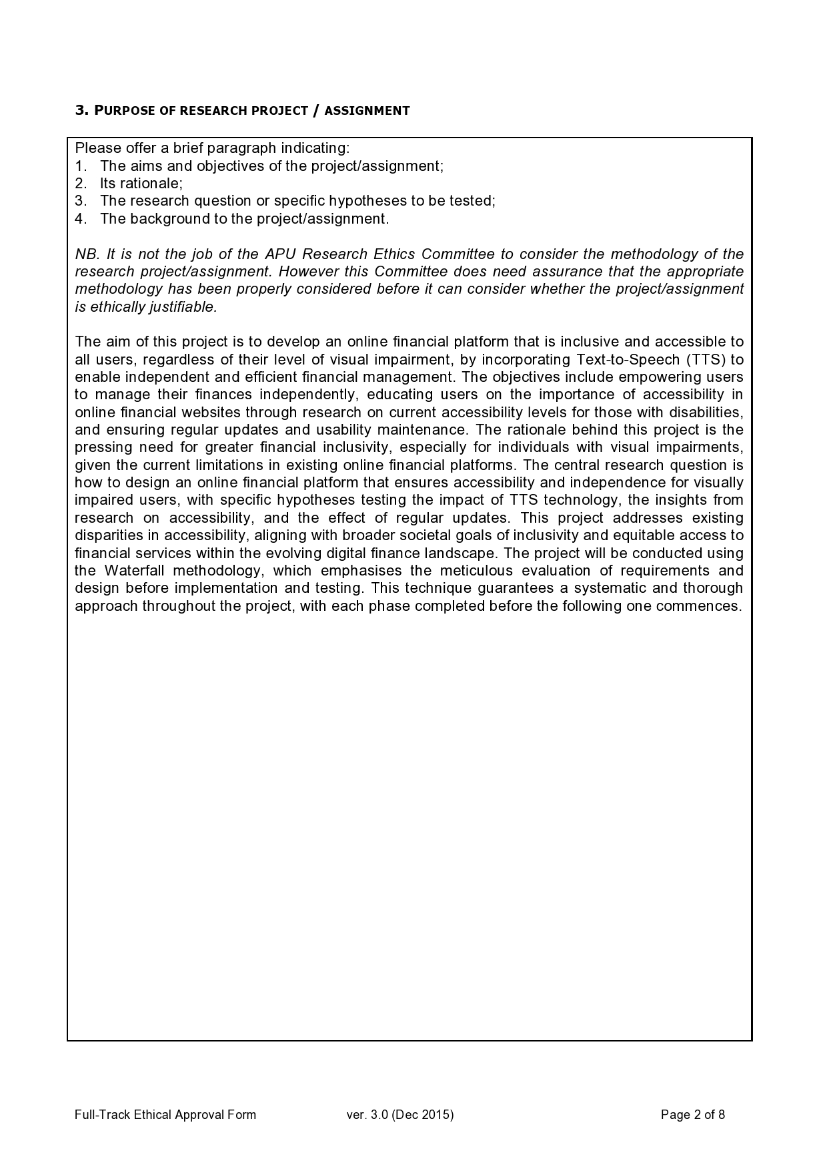

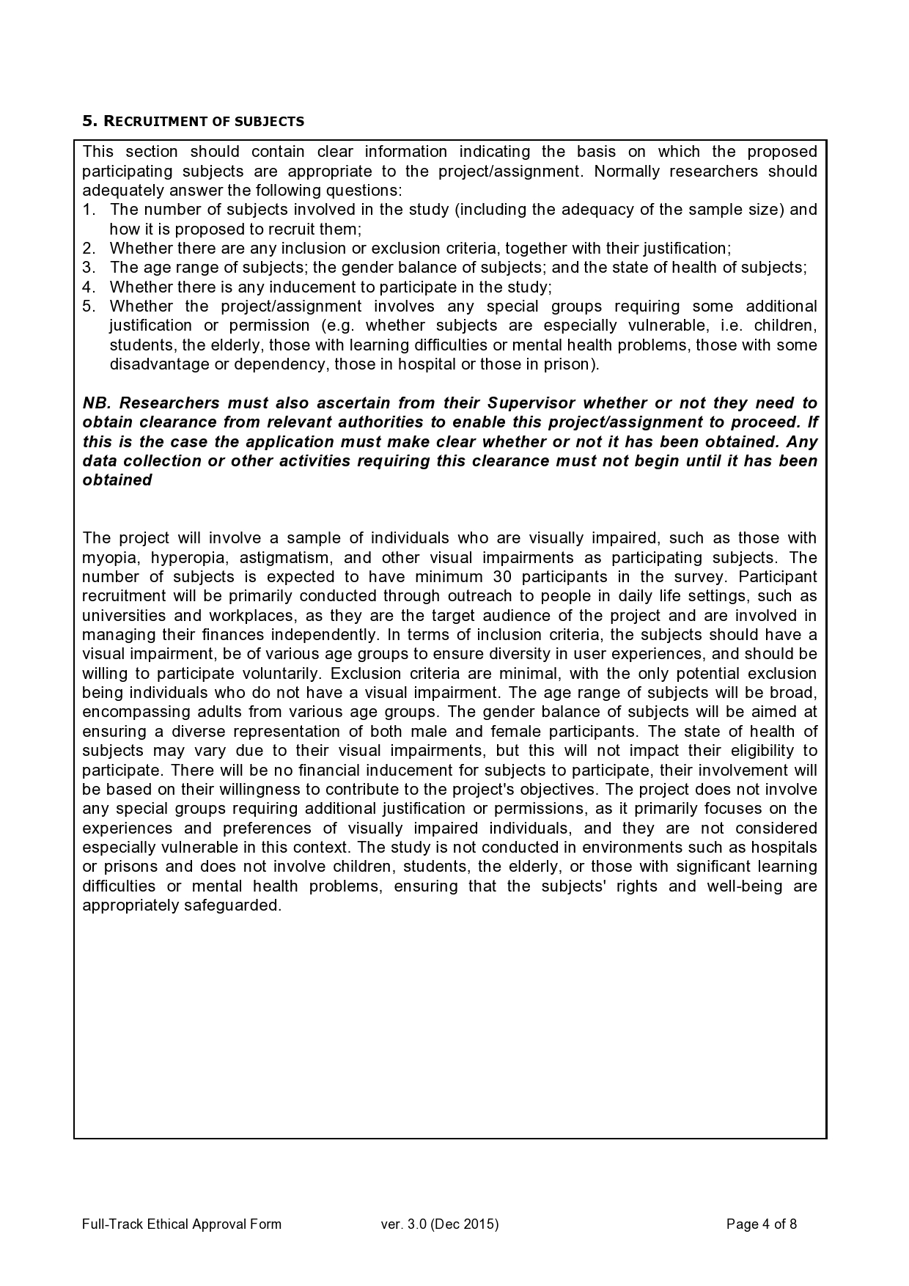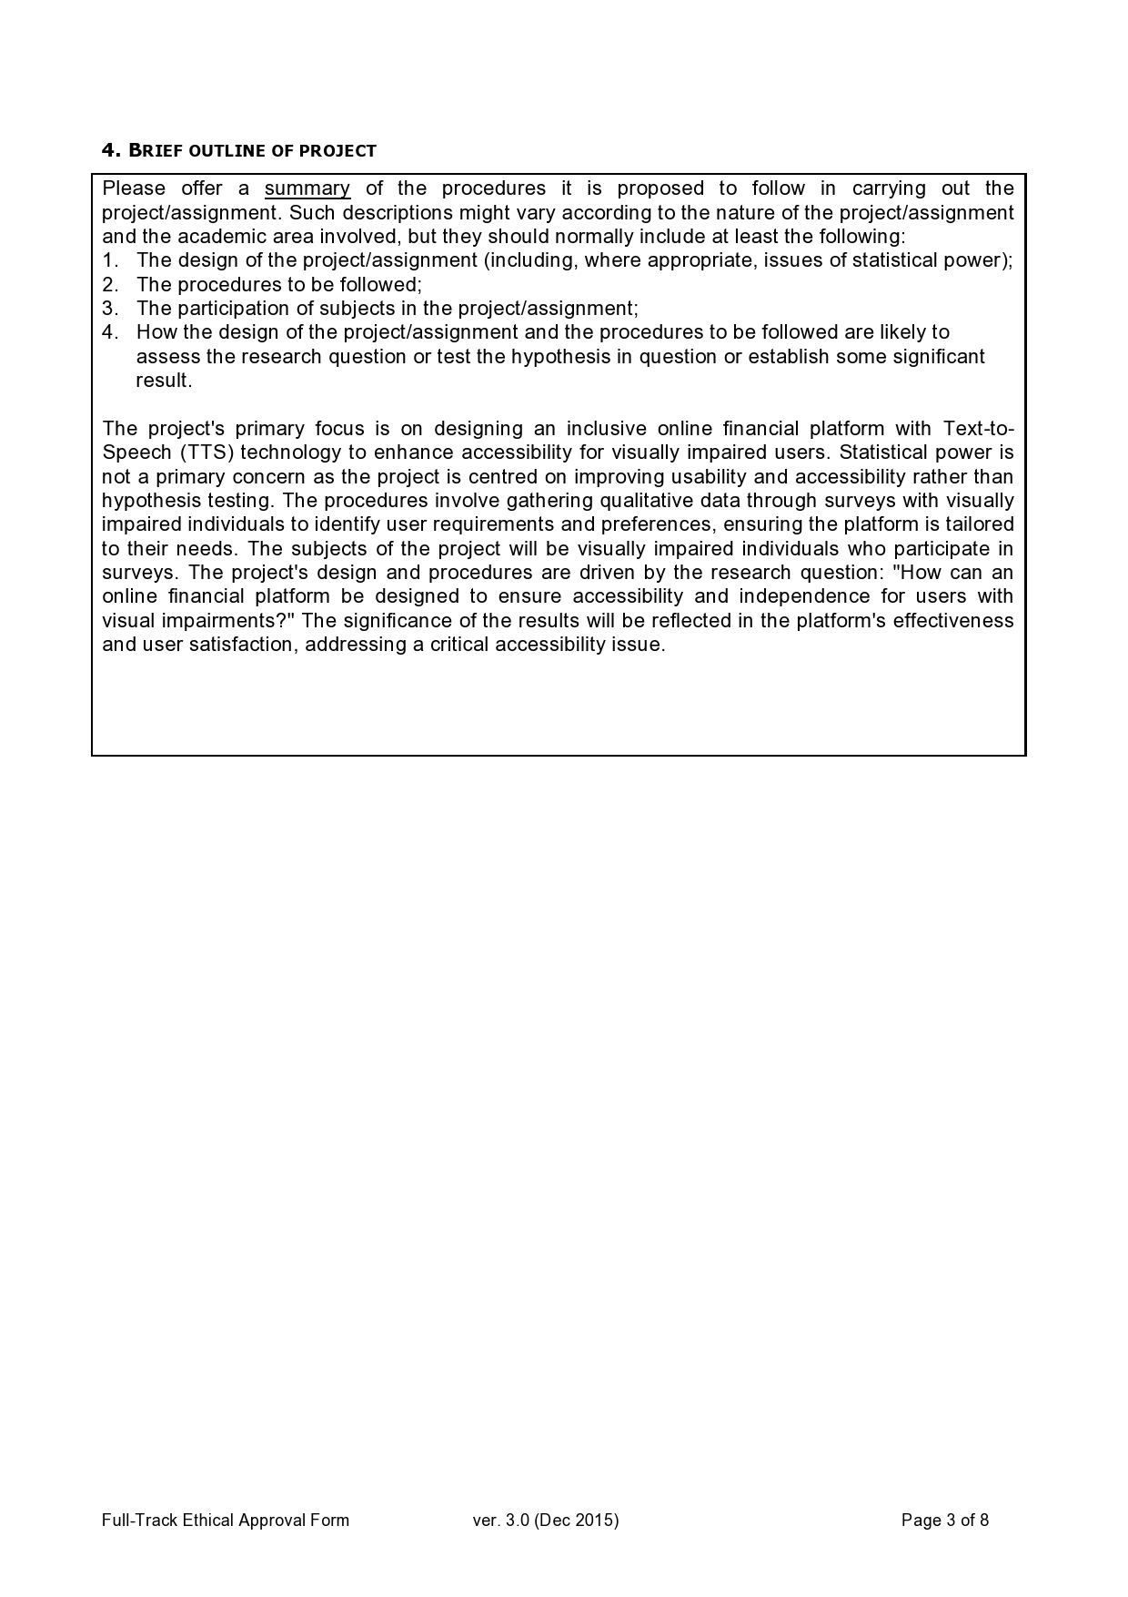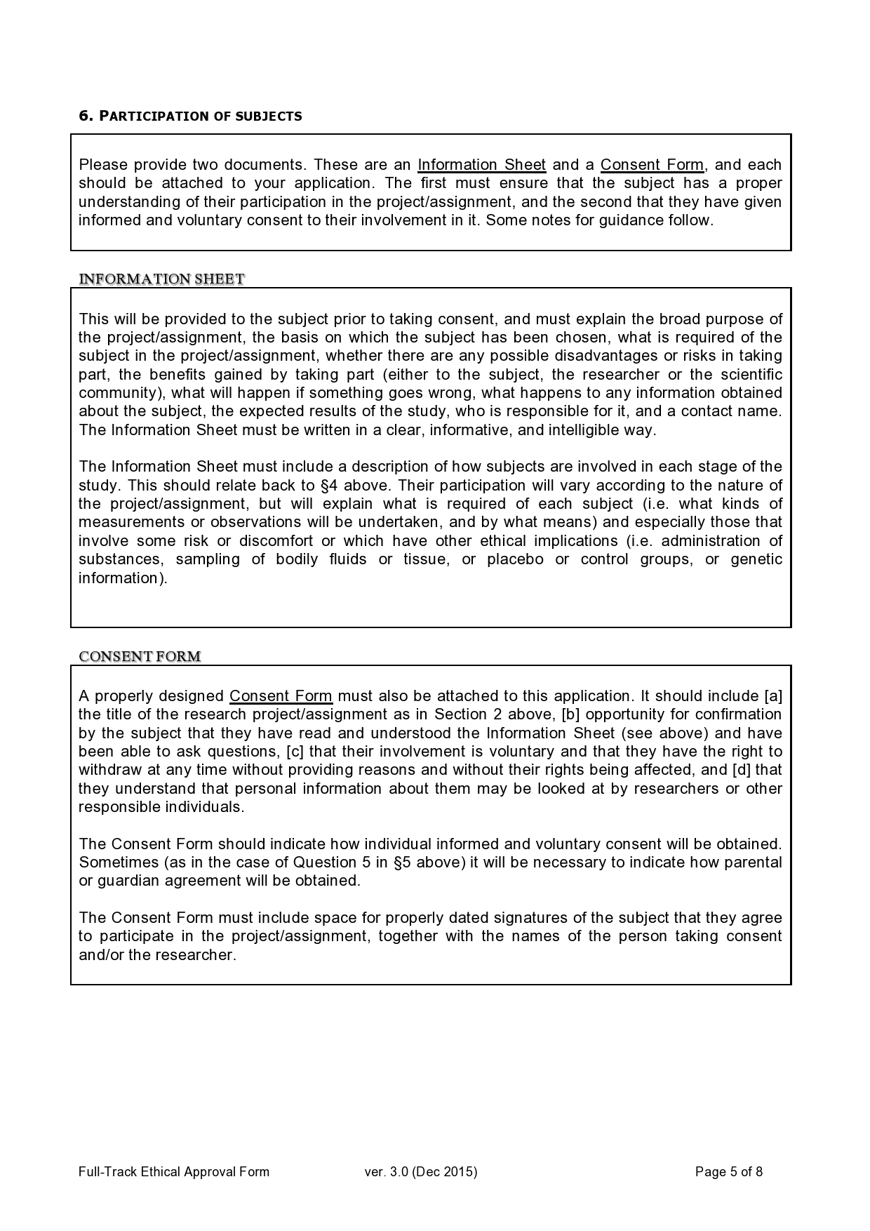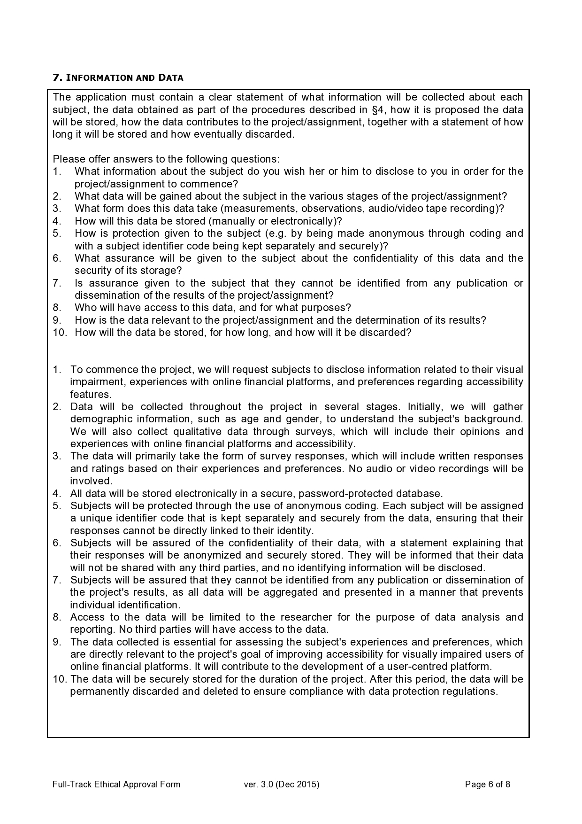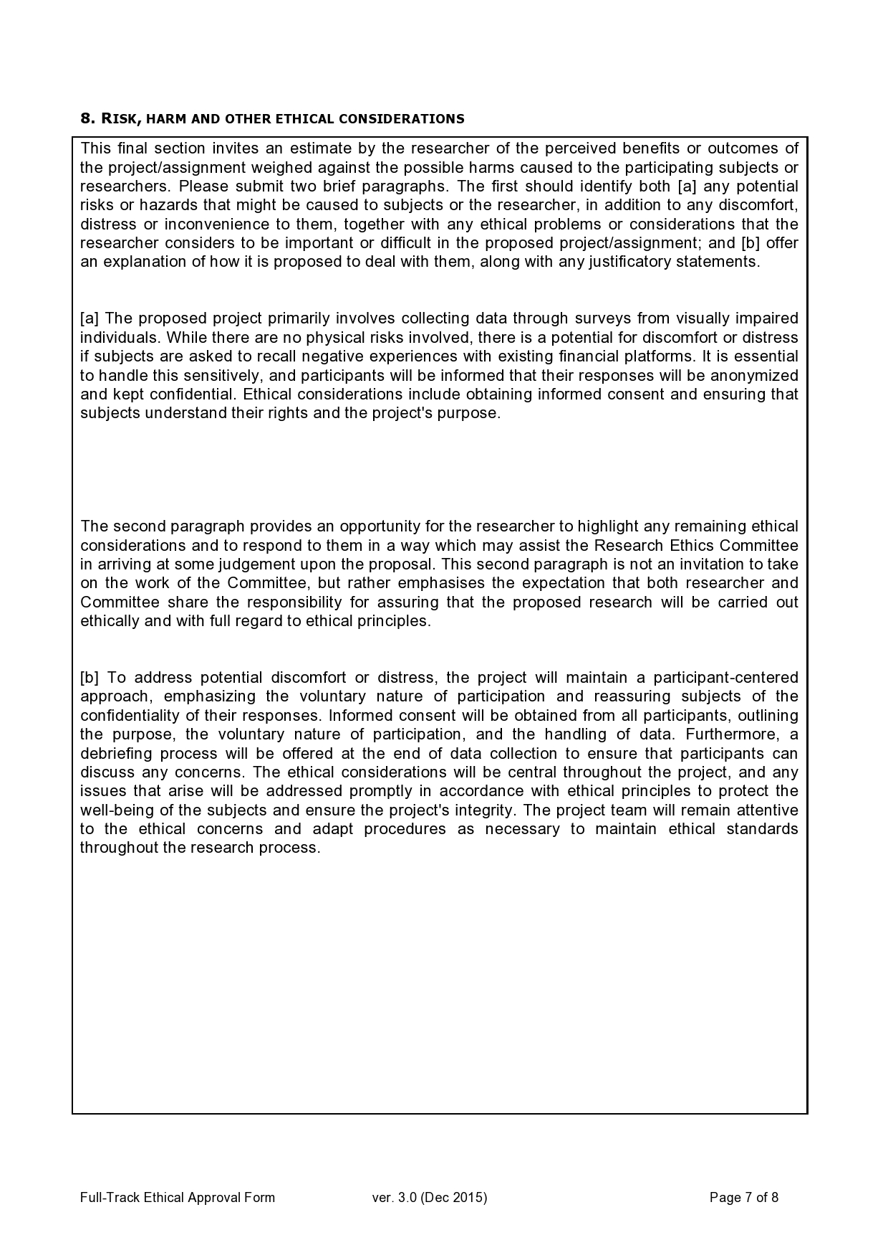

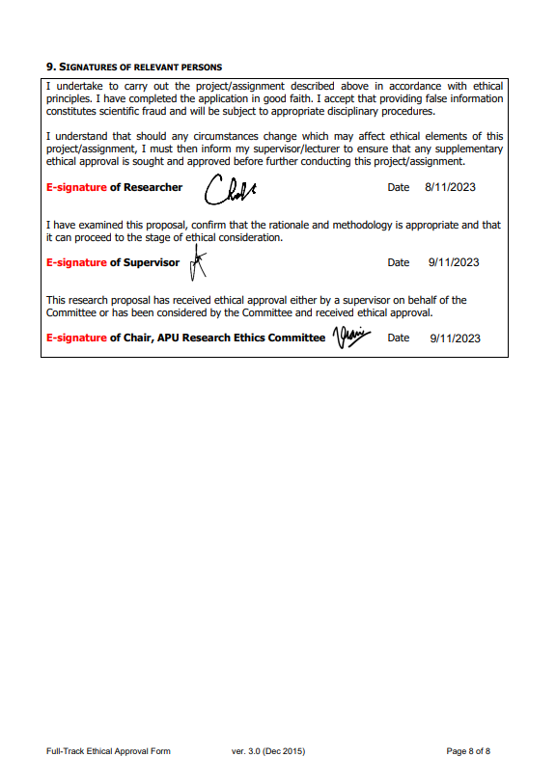

## Appendix C – Log Sheets

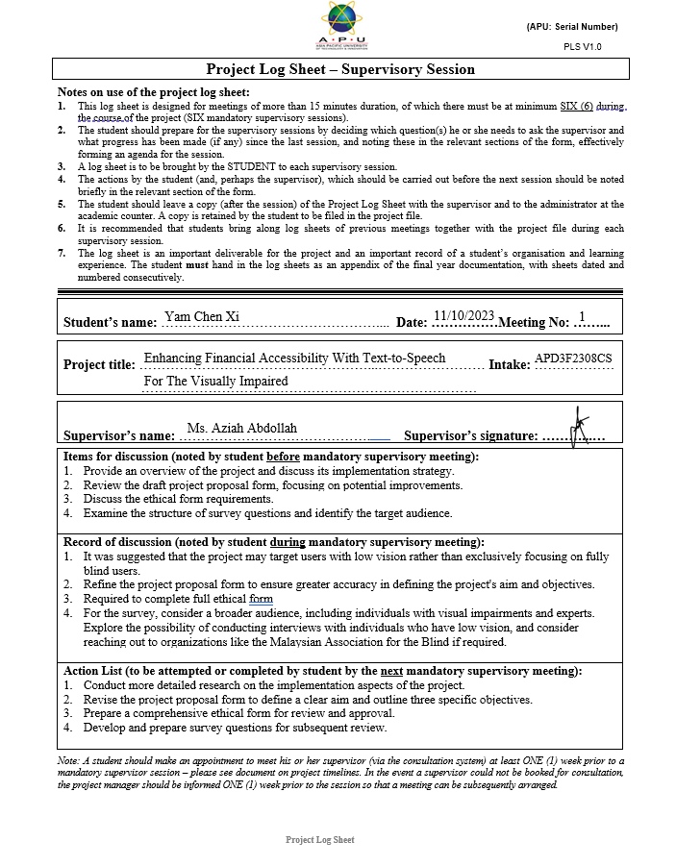

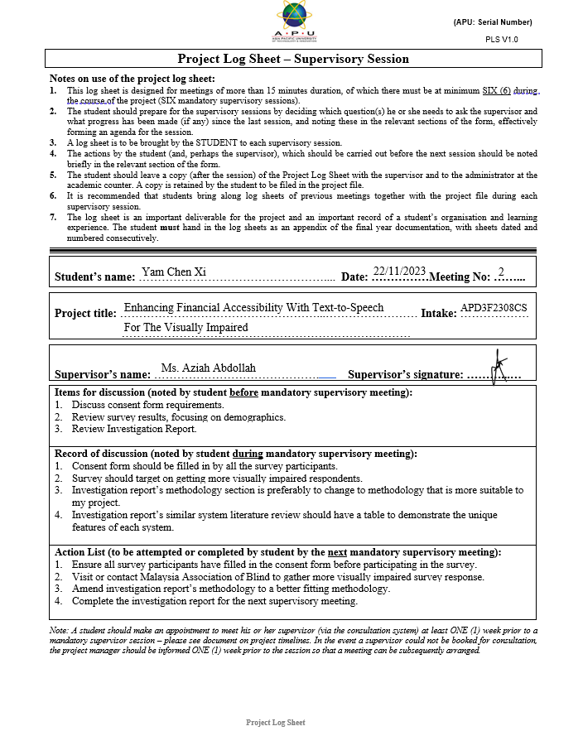

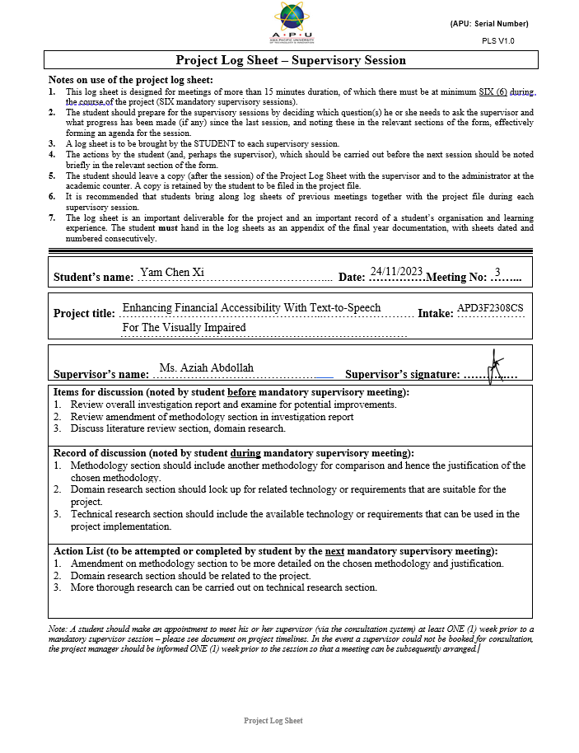

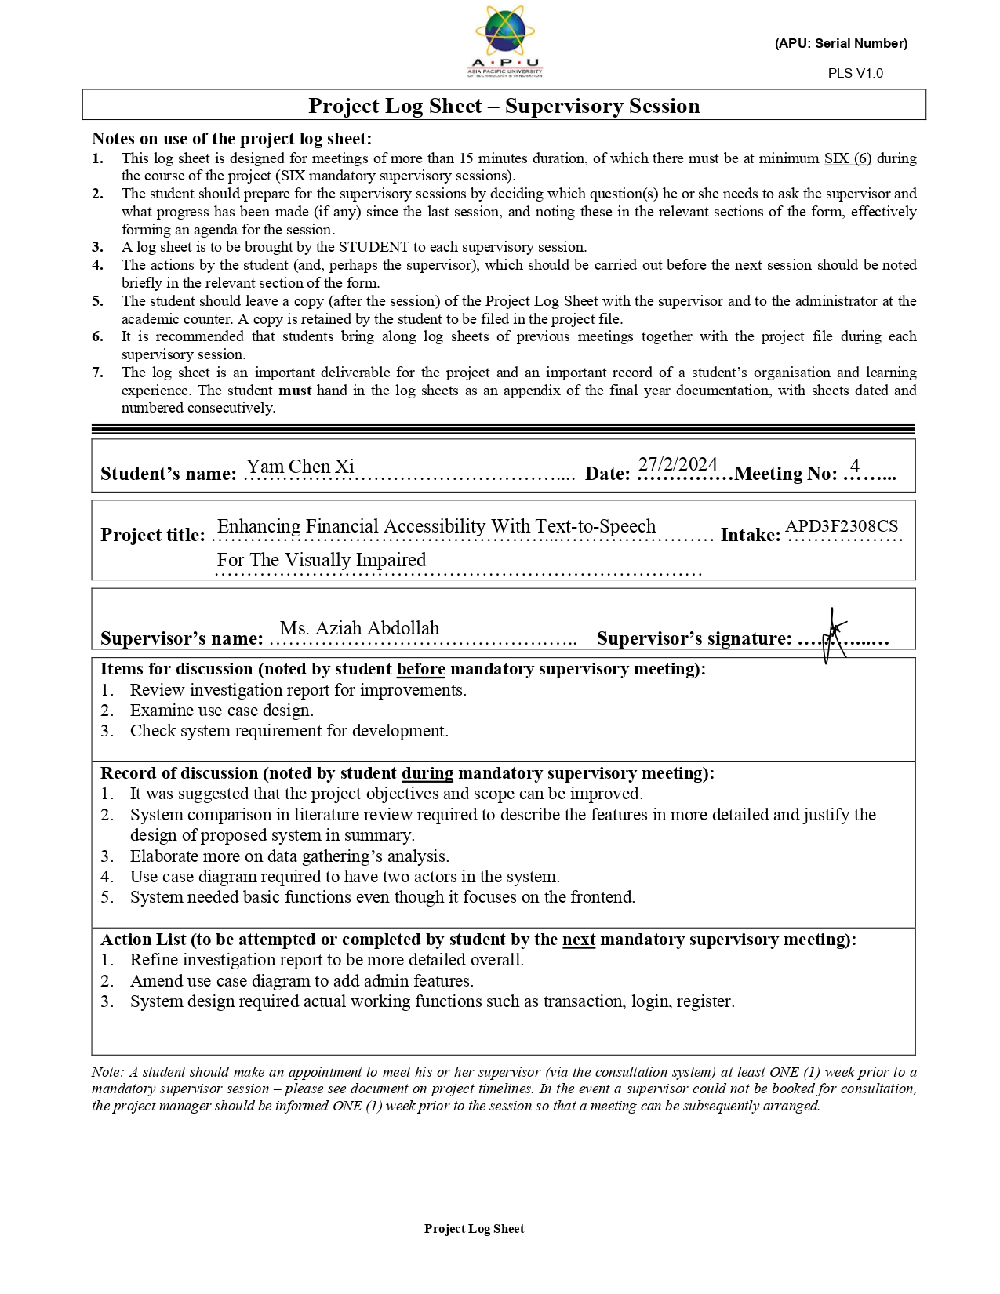

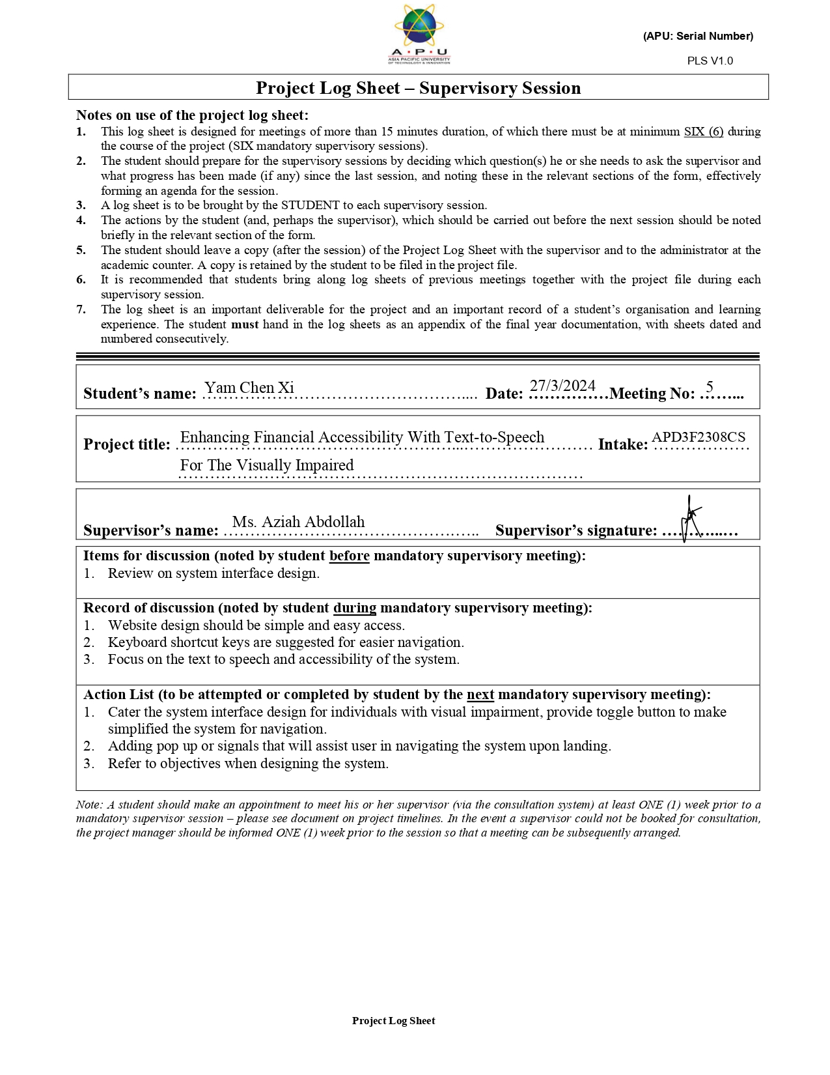

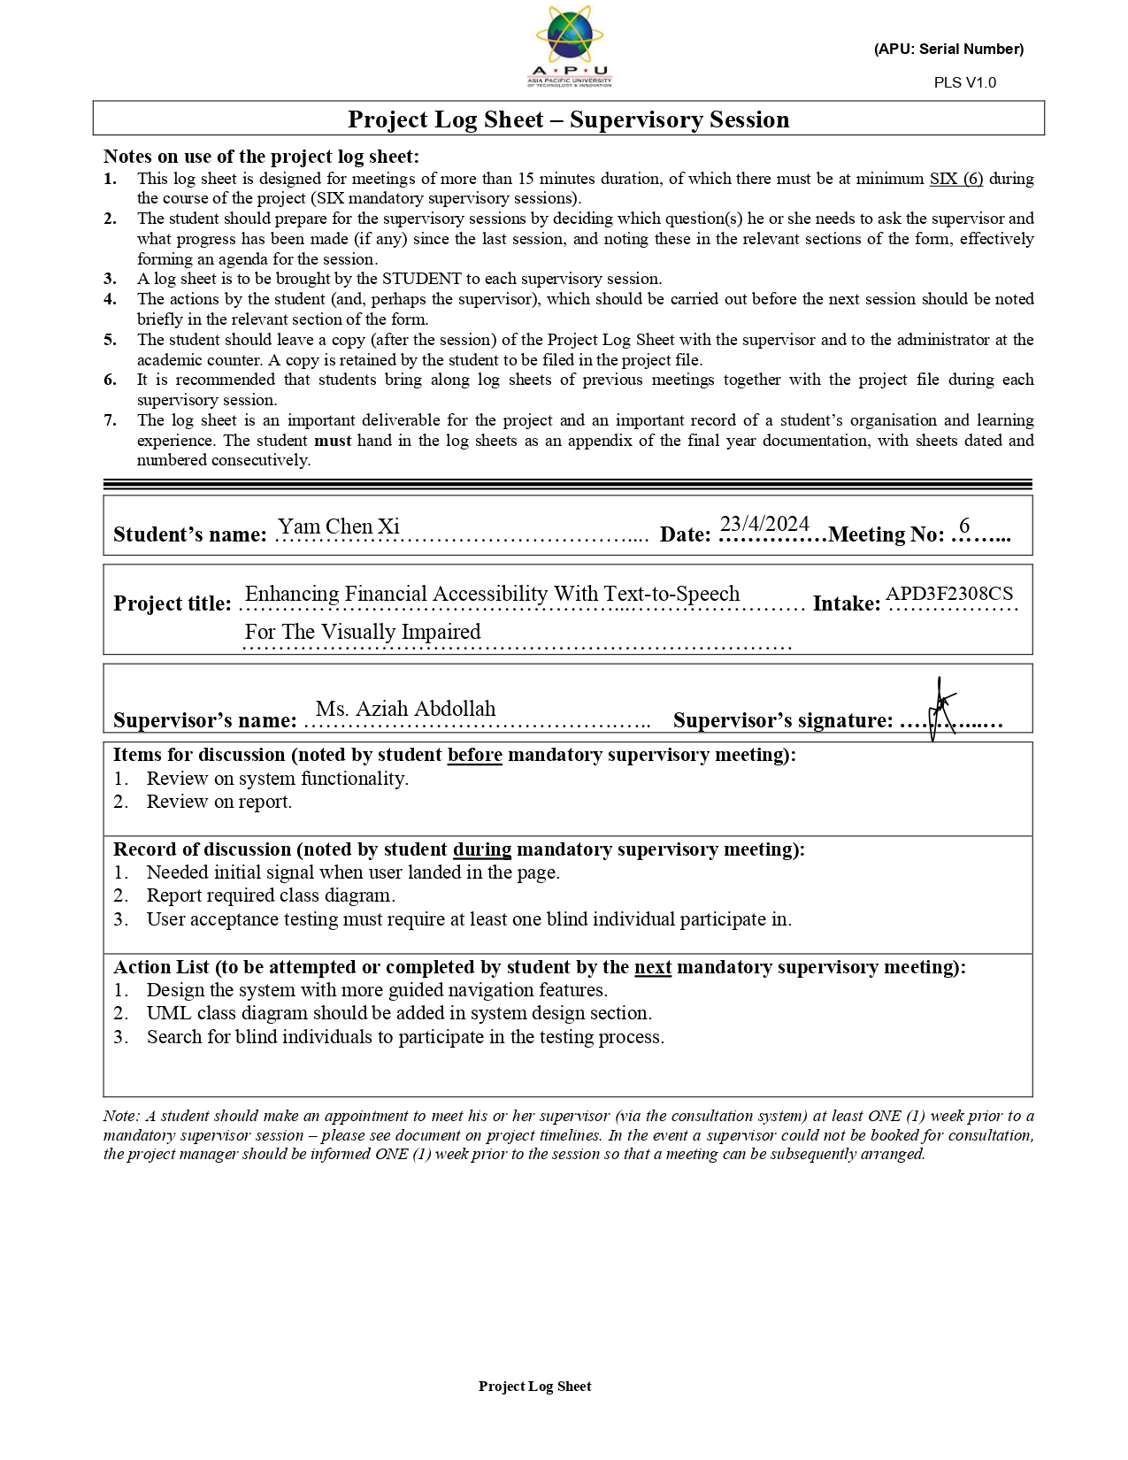

## Appendix D – Poster

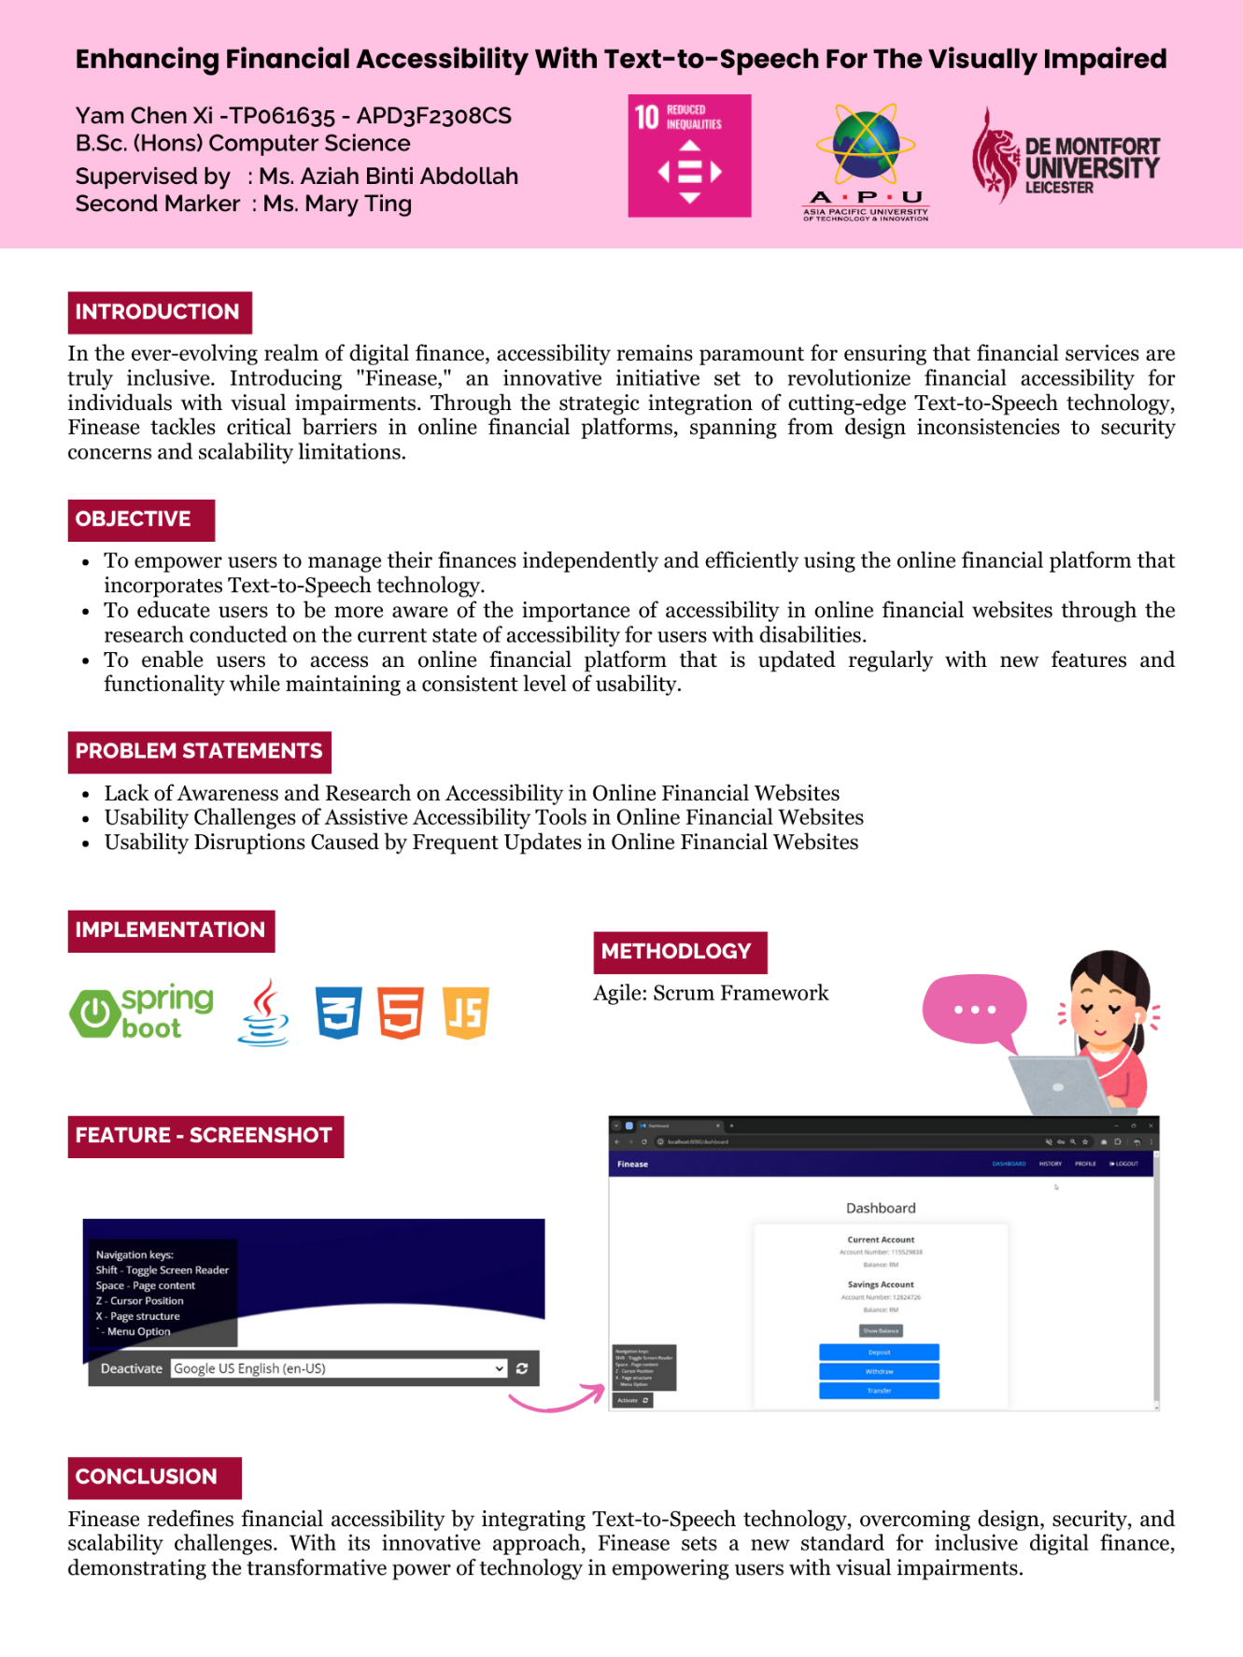

Figure 82: Finease's A3 Poster

## Appendix E – Gantt Chart

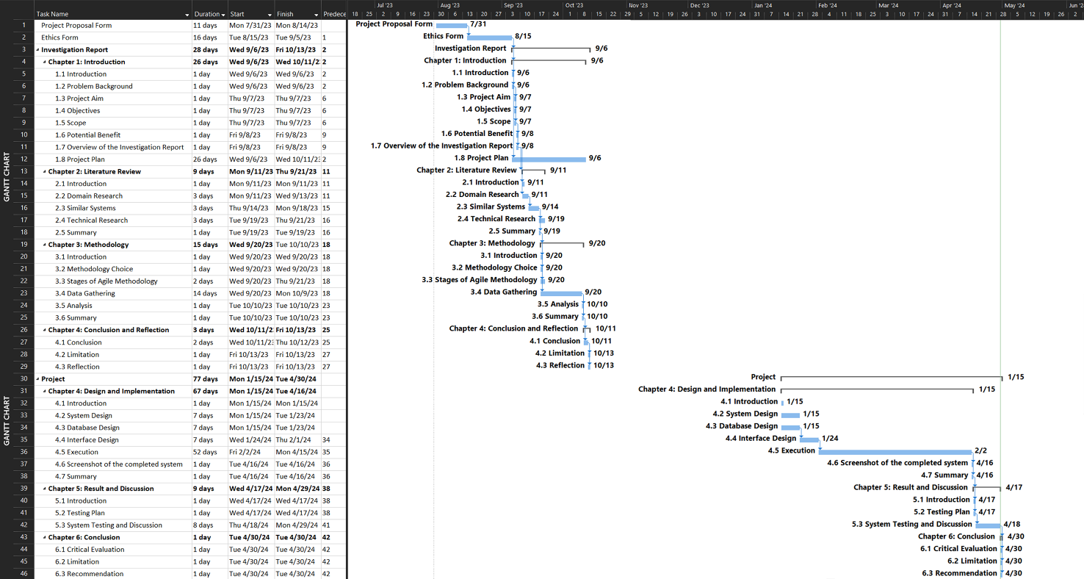

Figure 83: Gantt Chart

## Appendix F – Sample Code Implementation

**Text to speech**

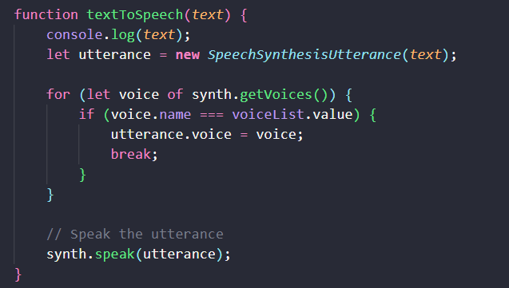

Figure 84: Screenshot of textToSpeech JavaScript code

**Keyboard Navigation**

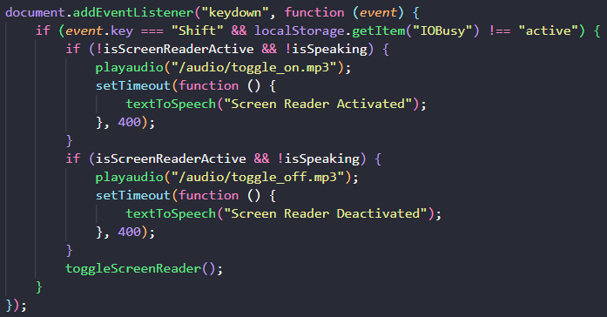

Figure 85: Screenshot of shift key toggle screen reader JavaScript code

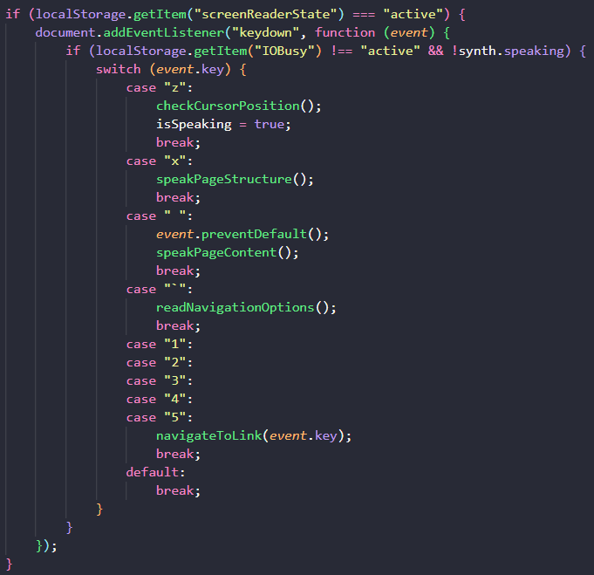

Figure 86: Screenshot of keyboard navigation JavaScript code

**Hover Event Listener**

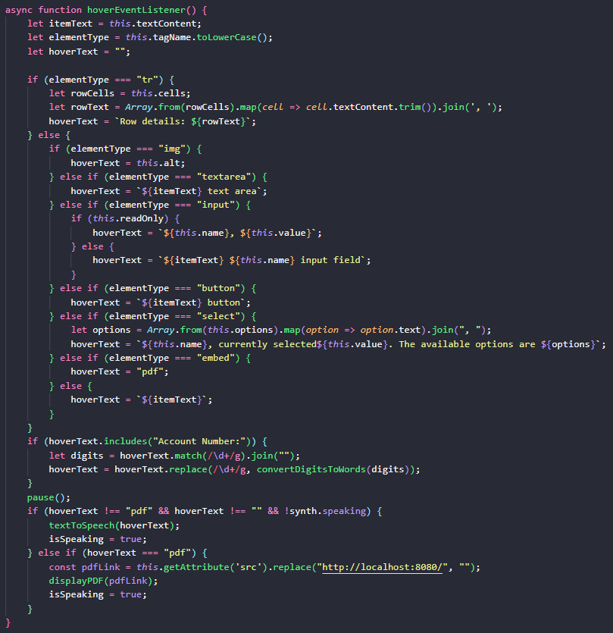

Figure 87: Screenshot of hoverEventListener JavaScript code

**Click Event Listener**

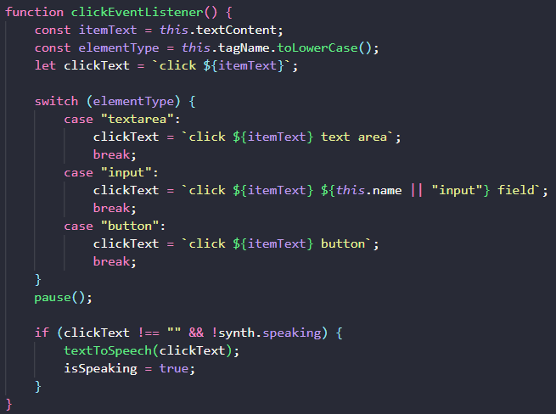

Figure 88: Screenshot of clickEventListener JavaScript code

**Focus Event Listener**

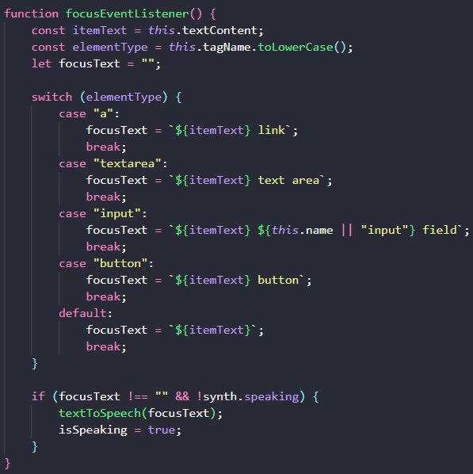

Figure 89: Screenshot of focusEventListener JavaScript code

**Display PDF**

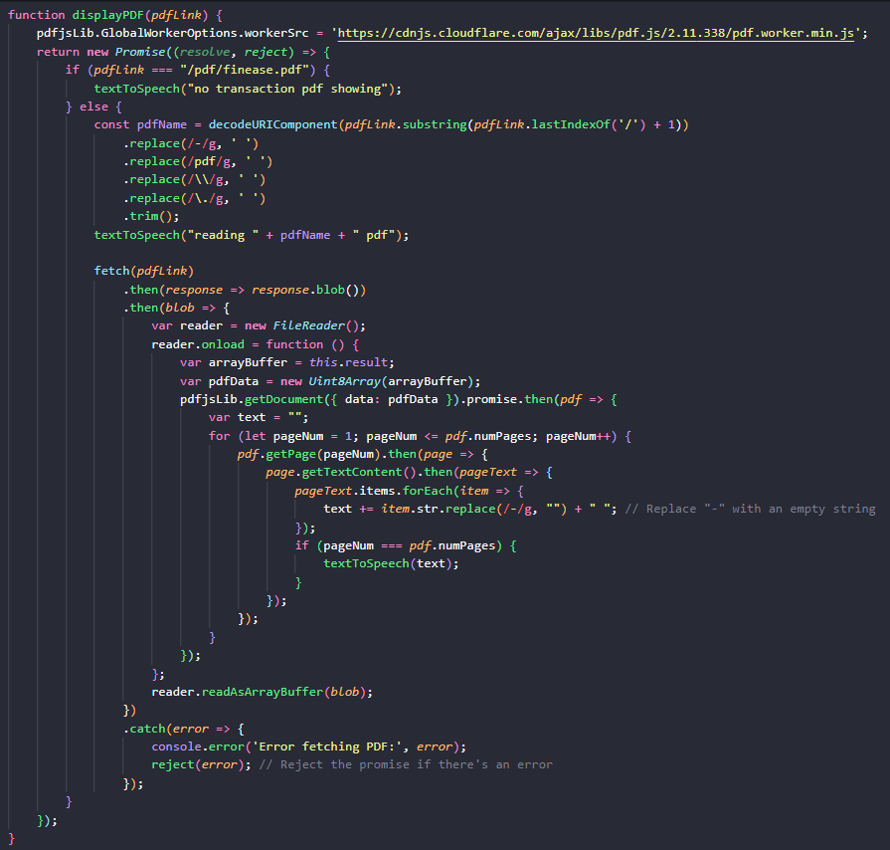

Figure 90: Screenshot of displayPDF JavaScript code

**Deposit Service**

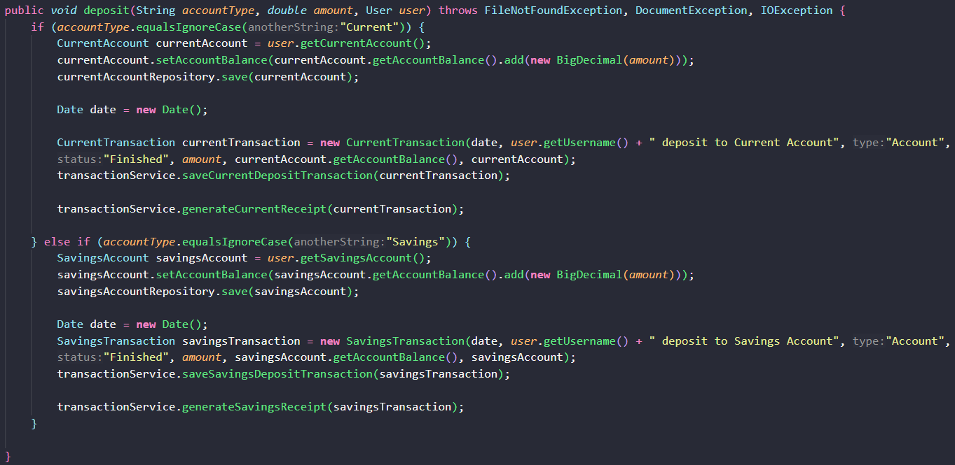

Figure 91: Screenshot of Deposit service Java code

**Withdraw Service**

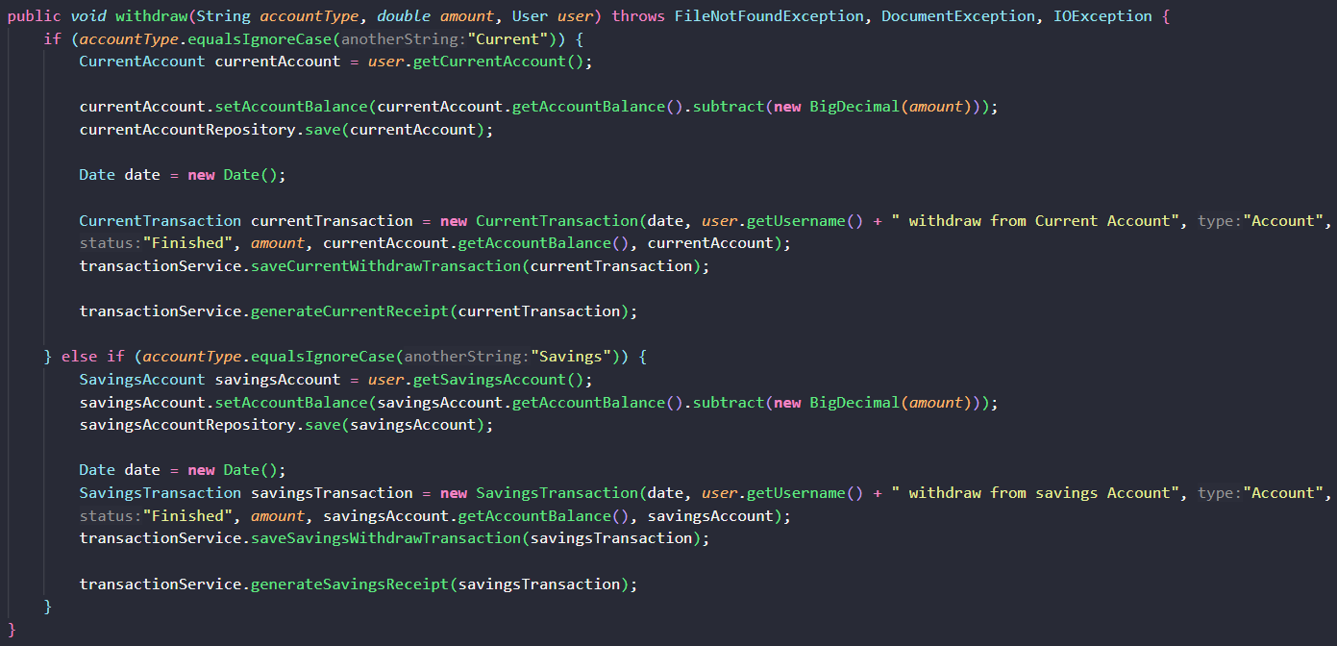

Figure 92: Screenshot of Withdraw service Java code

**Transfer Service**

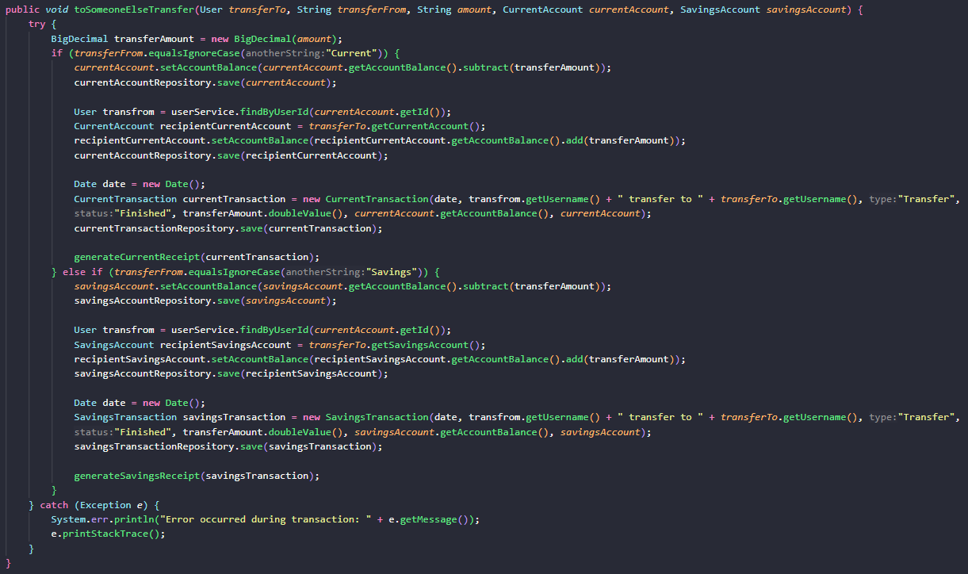

Figure 93: Screenshot of Transfer service Java code

## Appendix G – Respondence Demographic Profile

**Questionnaire Respondent**

|  |  |  |  |  |  |  |
| --- | --- | --- | --- | --- | --- | --- |
| **Participant Name** | **Age** | **Gender** | **Nationality** | **Current Education Level** | **Employment Status** | **Vision Condition** |
| Ziad Azouqah | 21 | Male | Non-Malaysian | Others | Student | Required glasses |
| Yong Chen Xi | 21 | Male | Malaysian | Tertiary education | Student | Perfect vision |
| Chia Jing Xian | 21 | Male | Malaysian | Tertiary education | Student | Perfect vision |
| Eng Kai Lun | 21 | Male | Malaysian | Tertiary education | Student | Required glasses |
| Cheong Teng Shan | 21 | Male | Malaysian | Tertiary education | Student | Required glasses |
| Yeau Jun Le | 21 | Male | Malaysian | Tertiary education | Student | Required glasses |
| Tee Kai Yau | 21 | Male | Malaysian | Tertiary education | Student | Required glasses |
| Low Kit Xheng | 21 | Male | Malaysian | Tertiary education | Student | Required glasses |
| Mak | 22 | Female | Malaysian | Tertiary education | Student | Perfect vision |
| Vincent Chin Wen Shen | 21 | Male | Malaysian | Tertiary education | Student | Required glasses |
| Gan Zi Liang | 21 | Male | Malaysian | Tertiary education | Student | Required glasses |
| Sayuj Thennat | 25 | Male | Non-Malaysian | Tertiary education | Student | Required glasses |
| Wong Du Sam | 22 | Male | Malaysian | Tertiary education | Student | Visually impaired |
| Yee mun | 21 | Female | Malaysian | Tertiary education | Student | Perfect vision |
| Yong Xuan Lyn | 18 | Female | Malaysian | Tertiary education | Student | Required glasses |
| San Wei Pin | 23 | Female | Malaysian | Tertiary education | Student | Perfect vision |
| Melissa Cordova | 29 | Female | Non-Malaysian | Secondary education | Employee | Perfect vision |
| Patipol Namdit | 22 | Male | Non-Malaysian | Tertiary education | Student | Required glasses |
| Ojasvi M Kumar | 28 | Female | Non-Malaysian | Tertiary education | Student | Required glasses |
| Kew Hui Ching | 21 | Female | Malaysian | Tertiary education | Student | Required glasses |
| James Lee | 23 | Male | Malaysian | Others | Unemployed | Blind |
| Lye Yi Jing | 21 | Female | Malaysian | Tertiary education | Student | Required glasses |
| Ng Wen Xuan | 21 | Male | Malaysian | Tertiary education | Student | Required glasses |
| Irene Ong | 21 | Female | Malaysian | Others | Unemployed | Visually impaired |
| Chee Wey Ern | 21 | Female | Malaysian | Tertiary education | Student | Visually impaired |
| Diyana Zurya | 20 | Female | Non-Malaysian | Others | Student | Visually impaired |
| Winnie Koay | 24 | Female | Malaysian | Tertiary education | Student | Required glasses |
| Nicholas Wong | 35 | Male | Non-Malaysian | Tertiary education | Unemployed | Required glasses |
| Jason | 23 | Male | Malaysian | Tertiary education | Student | Perfect vision |
| Ngeow Dey Ren | 22 | Male | Malaysian | Tertiary education | Student | Required glasses |
| Kee Xiang Er | 20 | Female | Malaysian | Tertiary education | Student | Required glasses |
| Wong Zhi Zhen | 21 | Male | Malaysian | Tertiary education | Student | Required glasses |
| Hassan Iskandar | 43 | Male | Malaysian | Tertiary education | Employee | Visually impaired |
| Adelia Safina | 33 | Female | Malaysian | Tertiary education | Employee | Blind |
| Azim | 28 | Male | Malaysian | Secondary education | Employee | Visually impaired |
| Rachel Woo | 23 | Female | Malaysian | Others | Student | Blind |
| Devayani Chandran | 42 | Female | Malaysian | Secondary education | Unemployed | Blind |
| Muhammad Firdaus | 37 | Male | Malaysian | Others | Employee | Visually impaired |
| Liew Zheng Kee | 26 | Male | Malaysian | Others | Student | Visually impaired |
| Qistina Wen | 38 | Female | Malaysian | Others | Employee | Blind |
| Zulkifli Bin Zainol | 29 | Male | Malaysian | Tertiary education | Employee | Visually impaired |

**Tester**

|  |  |  |  |
| --- | --- | --- | --- |
| **Name** | **Age** | **Occupation** | **Vision Condition** |
| Soh Myles | 22 | Student | Myopia, Astigmatism |
| Chee Wey Ern | 22 | Student | Visually impaired |
| James Lee Jun Feng | 24 | Unemployed | Blind |